Stem learning activity |  | Trebuchet data
Name::
Period::
start date::
Due Date::
Teacher::


Trebuchet data

Directions: Record the following data from your trebuchet. This information will used for calculations in the next activity. All data collected will become part of the final report.

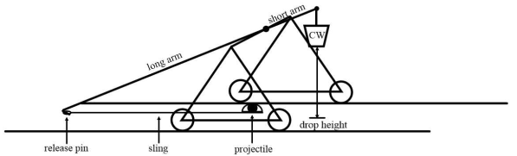
Data needed
Counterweight Mass (M_{cw)}: ______________Kg. (bucket with weight)
Drop height of bucket ( h ): ________________meters
Projectile Mass (m_{p}): _______________Kg
Total Arm Mass with sling and projectile: ______________ Kg
Total Arm length: _______________meters
Length of Short arm (from axle): _______________ meters
Mass of short arm (M_{sa}): _______________ Kg
Sling length: _______________ meters (when on release pin)
Launch Angle: _______________

