CIRCUIT PATH: Parts & comparisons
UNIT: circuits

OBJECTIVE:
Students will identify fractions as parts of a whole and compare fractions using words such as greater part, smaller part, and equal part.
Materials:
- Pencil
- Worksheet
STUDENT DIRECTIONS:
Answer the following word problems.
Word Problem 1: Series Circuit
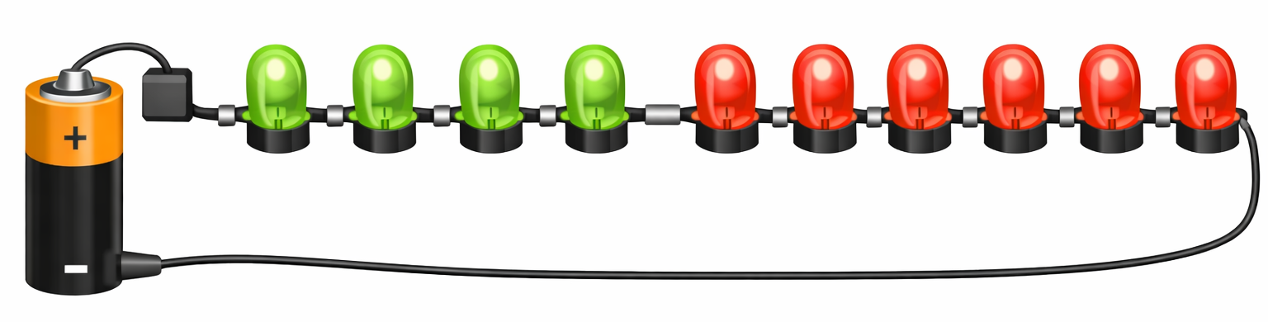
A series circuit has only one path for electricity.
All the LEDs are connected along that single path.

- Identify the Whole (count the total number of LEDs)
The whole is:

- Write the Fraction
If 4 LEDs are green, write the fraction of green LEDs in the series circuit.

Fraction:

- Compare the Fraction to the Whole

Green LEDs Red LEDs

3a. Do the green LEDs show a greater part, smaller part, or equal part of the
whole?

Answer: The green LEDs show a _____________________ of the whole.

3b. Do the red LEDs show a greater part, smaller part, or equal part of the
whole?

Answer: The red LEDs show a _____________________ of the whole.

3c. Which color of LEDs takes the greater part of the whole?

Answer: The _____________________ LEDs take the greater part of the whole.

Word Problem 2: Parallel Circuit
A parallel circuit uses 7 LEDs in total.
Some LEDs are working, and some are not.

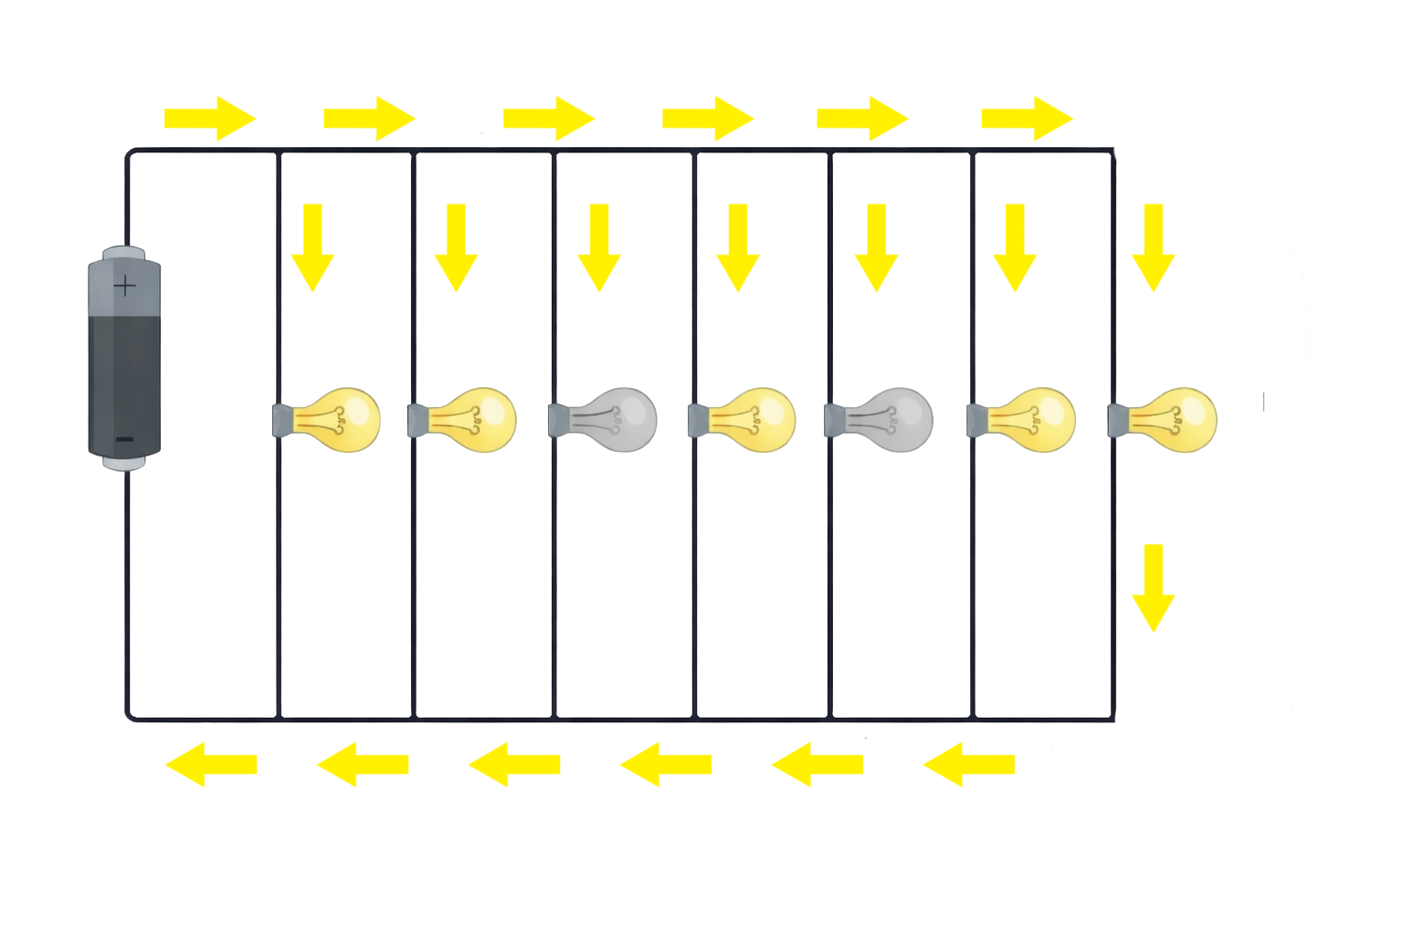

1. Identify the Whole

The whole is:

2. Write the Fraction and Compare
Write the fraction for each path and circle the fraction that uses the greater part of the LEDs.

Working LEDs Not working LEDs

