STEM Academy: General Fabrication Methods Fiberglass Freighter

Fiberglass Freighter

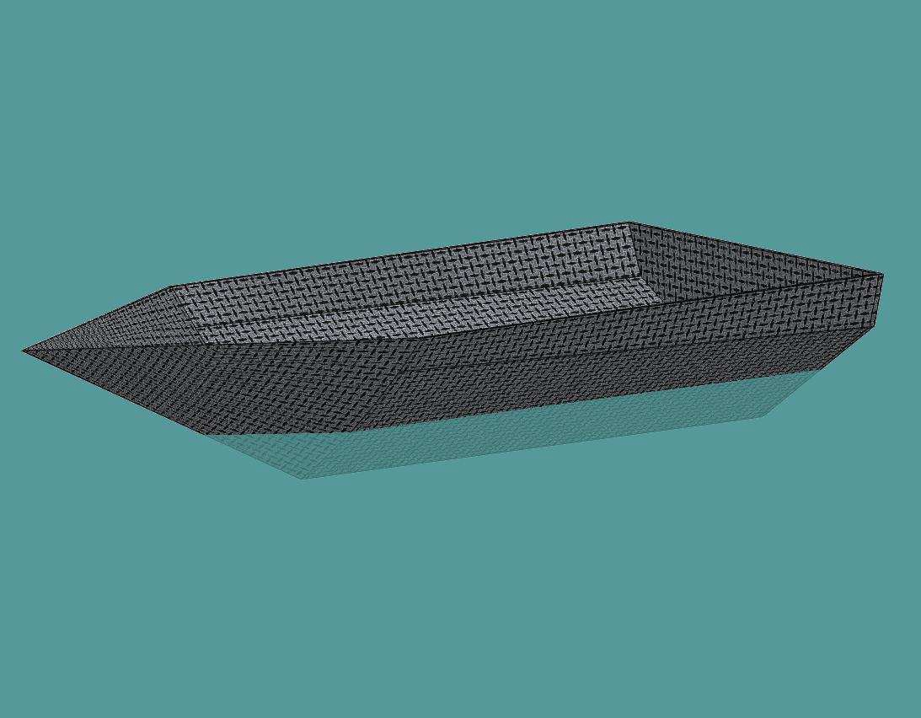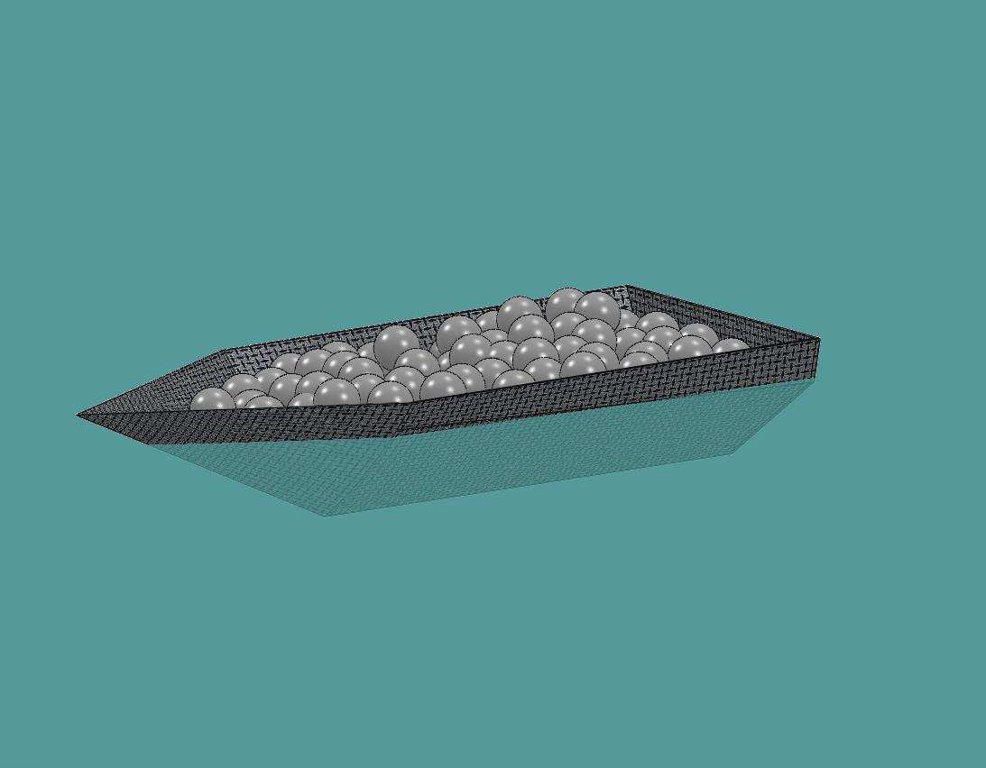Equipment

A. Bondo Knife B. Palm Sander C. Surform
D. Utility Knife
E. Scissors
F. Hacksaw
G. Combination Square
H. Marker
I. Measuring Tape

I. Marbles
J. Scrap Paper
Materials

A. Fiberglass Matting
B. Resin
C. Styrofoam
D. Release Agent
E. Brushes
F. Mixing Cup
G. Gloves
H. Stir Stick

1

STEM Academy: General Fabrication Methods Fiberglass Freighter

Drawing 1: Hull Cross Sections

S-Bottom
Chine

Shallow Vee

Deep Vee

Round Flat

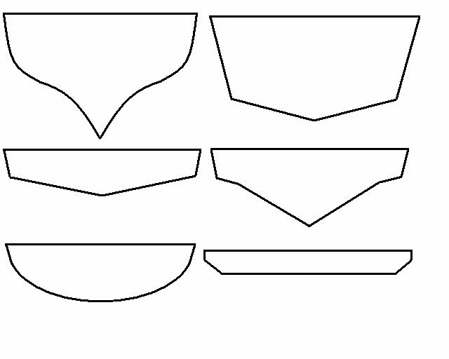2

STEM Academy: General Fabrication Methods Fiberglass Freighter

Drawing 2: Styrofoam Block

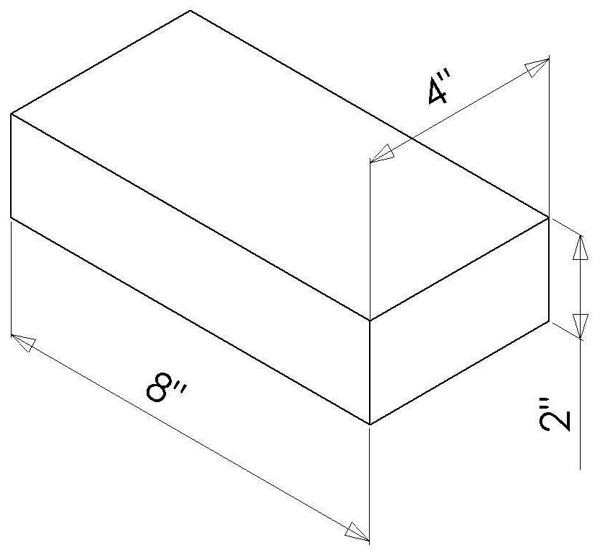3

STEM Academy: General Fabrication Methods Fiberglass Freighter

Step 1: Layout and cut a Styrofoam Block using a Combination Square, Marker,
Hacksaw, and the dimensions found in Drawing 2: Sytrofoam Block (page 4).

A. Use the Combination Square and Marker to mark out a 4” x 8” rectangle on a sheet of styrofoam as shown in Figure 1.

Note: Using a Combination Square will ensure a rectangle with perpendicular edges.

B. Use a Hacksaw to cut the styrofoam block out.

Note: Be sure not to cut the table with the Hacksaw when cutting out the block. The Hacksaw blade is designed to cut in one direction only. Most of the time it is set up to cut when the user pulls the saw towards them. To cut the styrofoam, push and pull the saw across the styrofoam. Relax on the push stoke and put a small amount of downward pressure on the pull stroke. Once the blade is almost all the way through the styrofoam, slow
the sawing action down and continue to cut the styrofoam through.

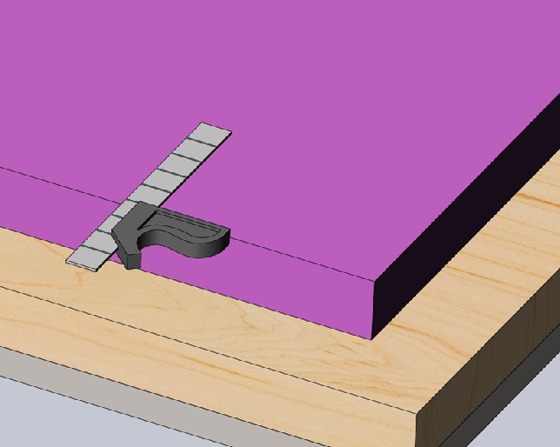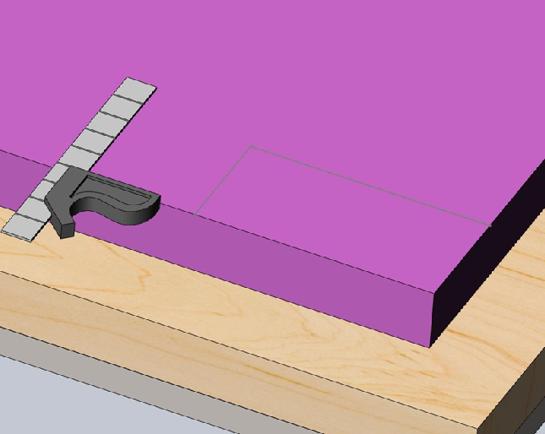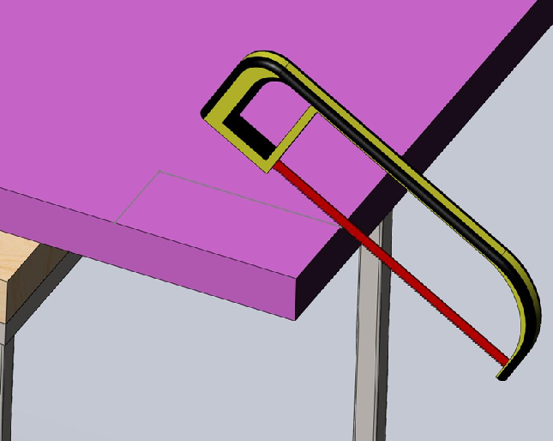Figure 1: Layout and cut a block- (1) Use a combination square to mark out the lines. (2) Finished layout of the block. (3) Cut the block out using a hacksaw.

4

STEM Academy: General Fabrication Methods Fiberglass Freighter

Step 2: Design the hull of a freighter. Layout and shape the hull plug with a Surform,
Marker, Palm Sander, and Combination Square.

Note: A plug is the mold around which the fiberglass matt is formed during the process of creating a hollow fiberglass object. When designing a plug keep in mind Negative Draft. Negative draft is when the sides of the plug are angled slightly outward so the plug can be pulled out of the boat hull
after it is completed. Think of ice cube trays, for the ice to come out, the walls of the tray have to have negative draft.

A. Consult with your design team and use your creativity to design a boat hull. There are examples of different hull cross sections in Drawing 1 (page 3), use these merely as a guideline.
Note: The more freight the boat can hold without sinking, the better the hull design. The goal is to design a hull under material constraints that can carry the most freight.

B. Once a consensus on a hull desing is reached, sketch out the design of the boat on the 4” x 8” styrofoam block. An example of a boat hull sketch is shown in Figure
2(1-2).
C. When the stetch is complete, use a Surform to shave away the unwanted styrofoam.

Note: When the sketch in Figure 2 is shaped with a Surform, it will look like Figure 3.

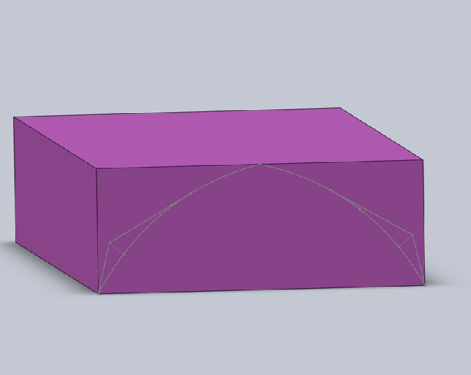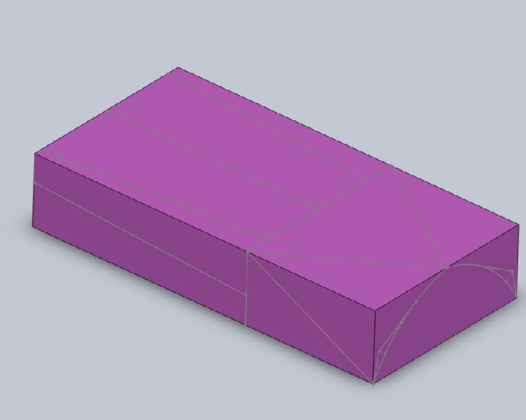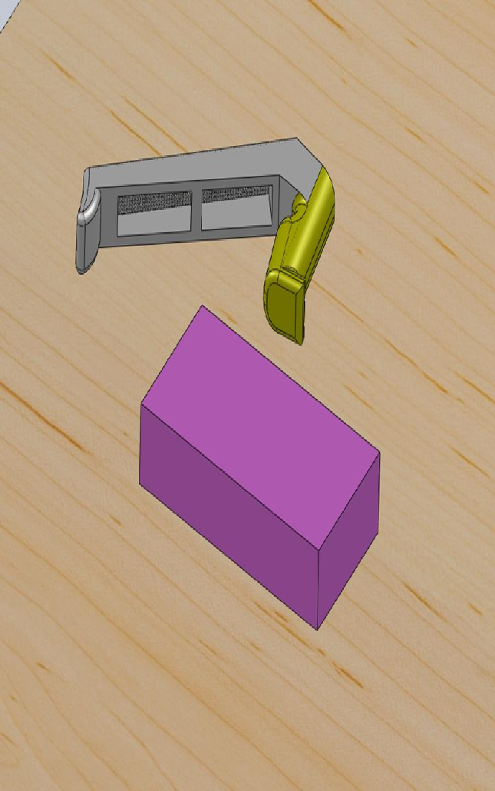D. After the hull plug is shaped with the Surform, use a Palm Sander to take out all of the rough spots and make the hull plug smooth.

Figure 2: Layout and cut a block- (1) Use a combination square to mark out the lines. (2) Finished layout of the block. (3) Cut the block out using a hacksaw.

5

STEM Academy: General Fabrication Methods Fiberglass Freighter

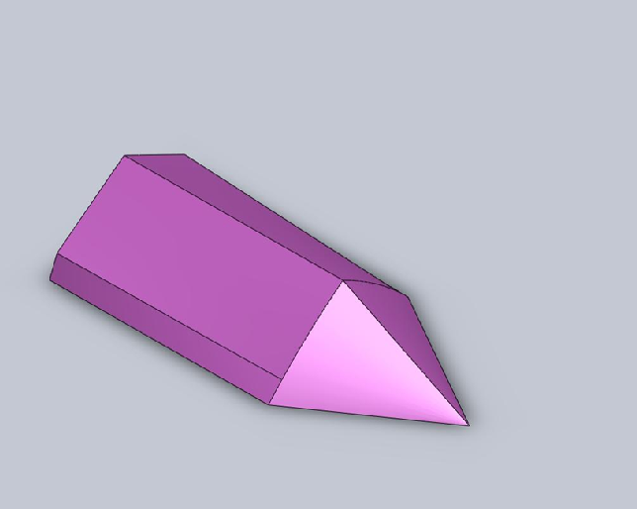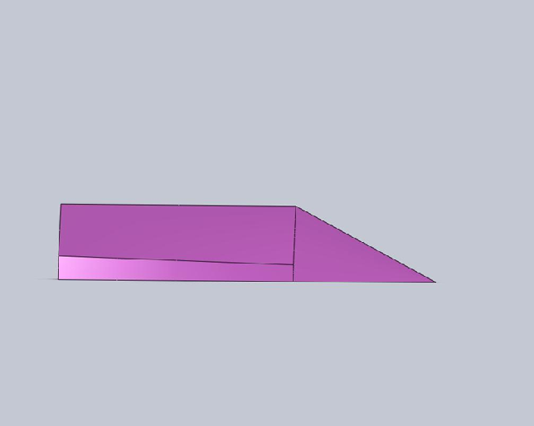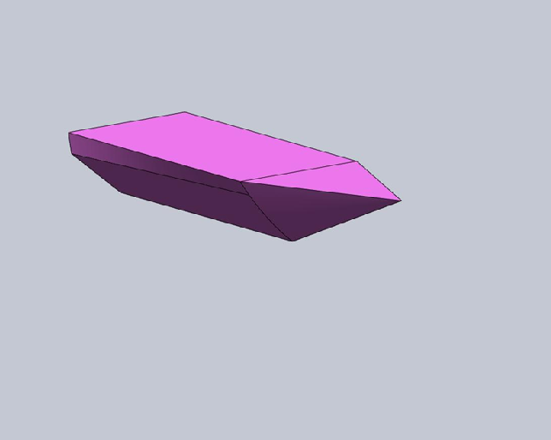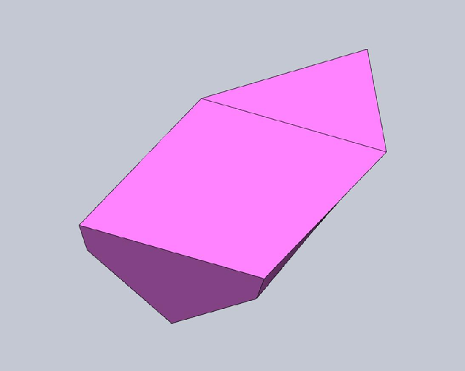Figure 3: Finished hull plug.

6

STEM Academy: General Fabrication Methods Fiberglass Freighter

Step 3: Place scrap paper or cardboard under the plug to prepare for application of the resin.

Step 4: Once the plug is finished, it is ready for the application of Resin. Follow the directions on the manufacturer’s label and carefully and mix the recommended amount to cover the plug using a Mixing cup, Gloves, and Stir Stick.

Note: When working with Resin you should be very careful not to spill any out of the mixing cup. Resin is applied to the plug so that it can be then be covered with release agent, allowing it to not bond with the fiberglass.

A. With the Resin mixed, carefully pour it over the plug
B. Use a Bondo Knife to gently work the resin onto the plug making sure to cover all of the area where the fiberglass matting will touch. Try to make a nice smooth film with the resin.
C. Allow the Resin to set for the amount of time recommended by instructions on
the the manufacturer’s label.
D. When done applying the Resin, wash off the bondo knives with a small amount of Acetone in a small container. Use the acetone sparingly, a small amount of Acetone is needed to clean the knives. Allow the acetone to evaporate or dispose of properly.

Step 5: After the resin hasset, sand the plug smooth with the Palm Sander.

Note: The plug needs to be very smooth so the resin on the fiberglass matting does not seep into rough edges, bonding the fiberglass to the plug

Step 6: Cut out a 8” x 12” piece of Fiberglass Matting using a Tape Measure and Scissors.

Note: If the plug is resined directly on the table, the fiberglass hull will be permanatly bonded to the table, ruining it as well as the table.

7

STEM Academy: General Fabrication Methods Fiberglass Freighter

Step 7: Form the fiberglass matting over the plug using Scissors.

A. Center the fiberglass matting over the plug as shown in Figure 4(2).
B. Use Scissors as needed to cut the fabric where the fabric needs to be folded over itself.
C. Figures 5-7 are a visual representation on how the example hull would be layed out with fiberglass fabric. Modify the procedure to the needs of your plug.
D. Whenever a cut is made in the fabric resulting in a corner, there will be a tiny hole. This hole is a place of weakness in the fiberglass. To strengthen the corner, place a small piece of fiberglass matting over the corner as shown in Figure 6(1). Any matting that is extra should not be cut off, just leave it on the paper as shown
in Figure 9(2).

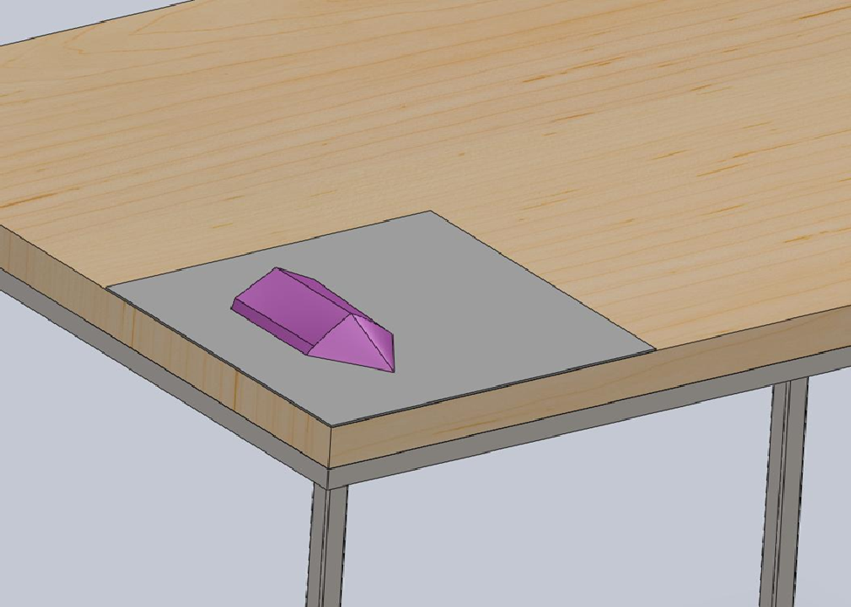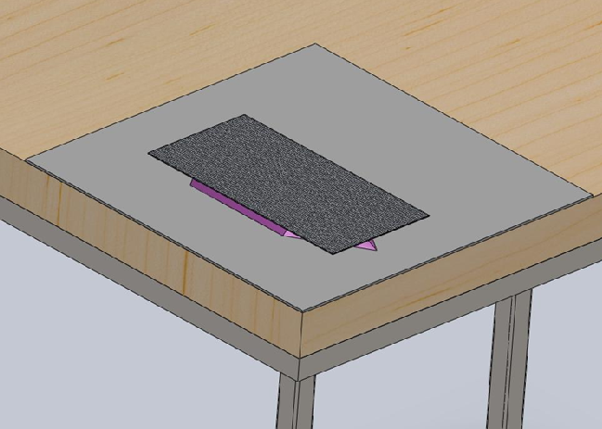Figure 4: Prepare the plug for the matting- (1) Place scrap under the plug to prepare for application of the resin. (2) Center the matting over the plug.

1 2

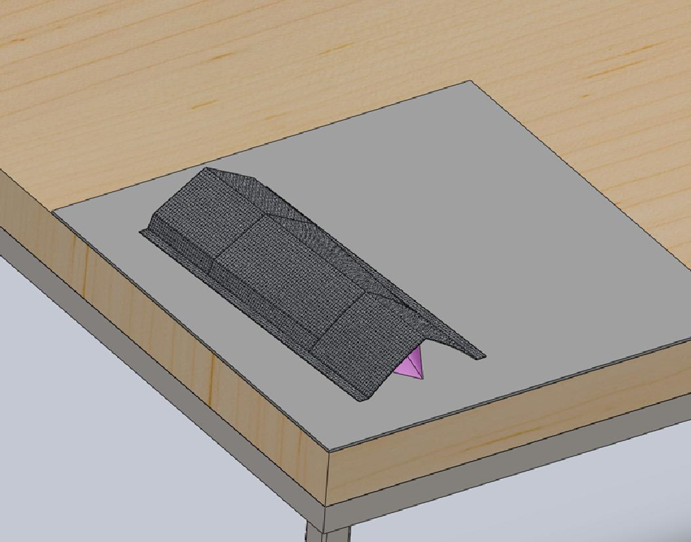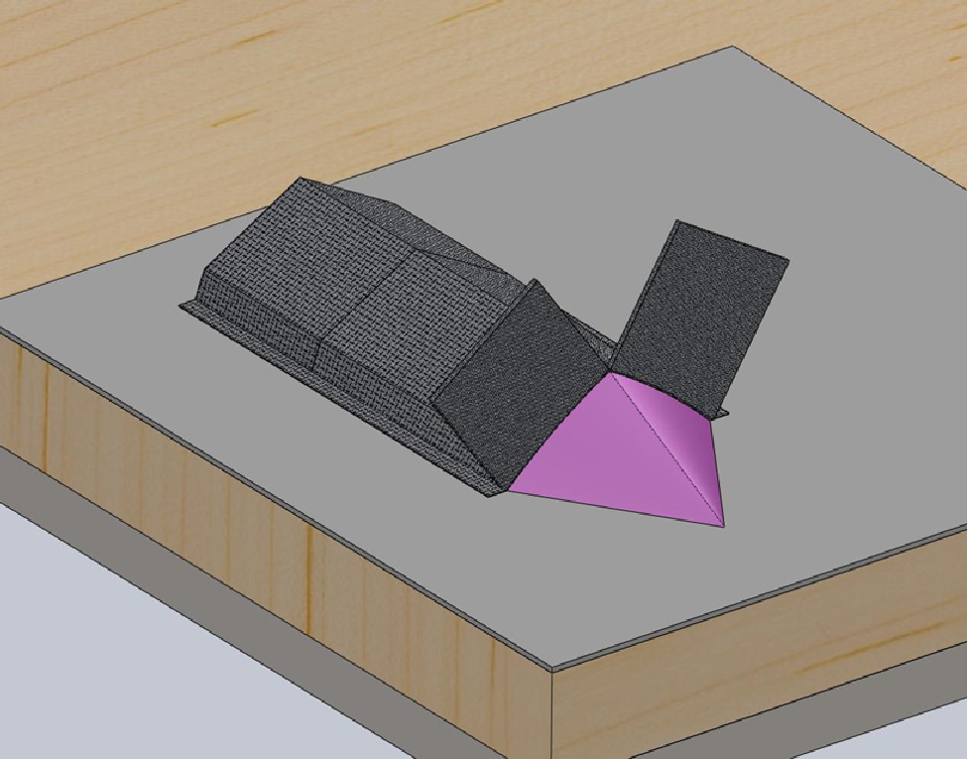Figure 5: Preparing the bow- (1) Fold the matting over the plug. (2) Cut the matting down the center of the bow to make two flaps.

8

STEM Academy: General Fabrication Methods Fiberglass Freighter

1 2

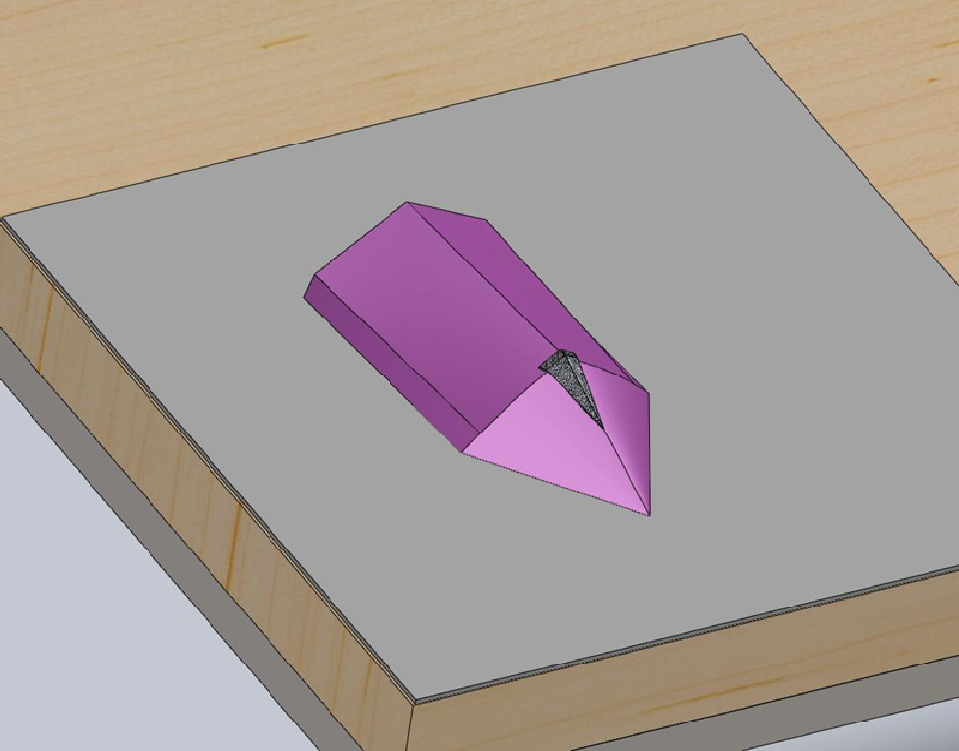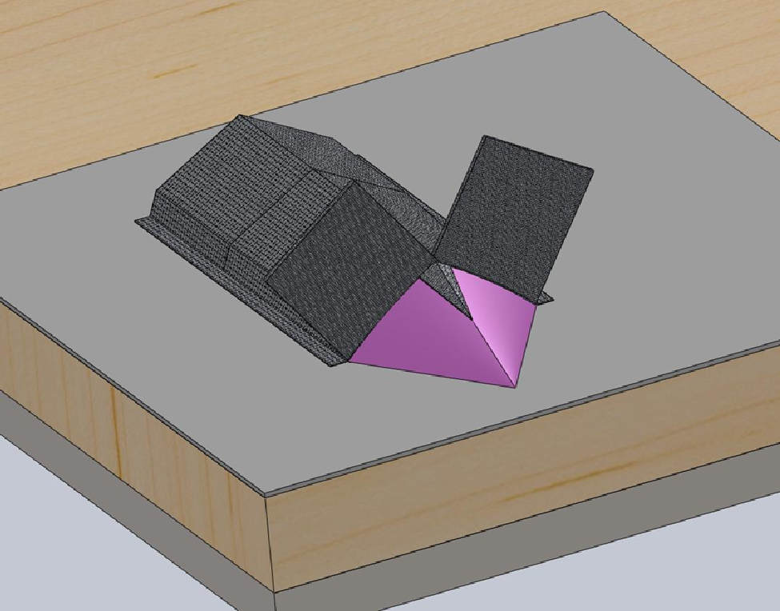Figure 6: Strengthening a corner- (1) This is an example of a corner that needs to be strengthened by cutting a small piece of matting cover the corner. It is placed in between the plug and the rest of the matting.

1 2

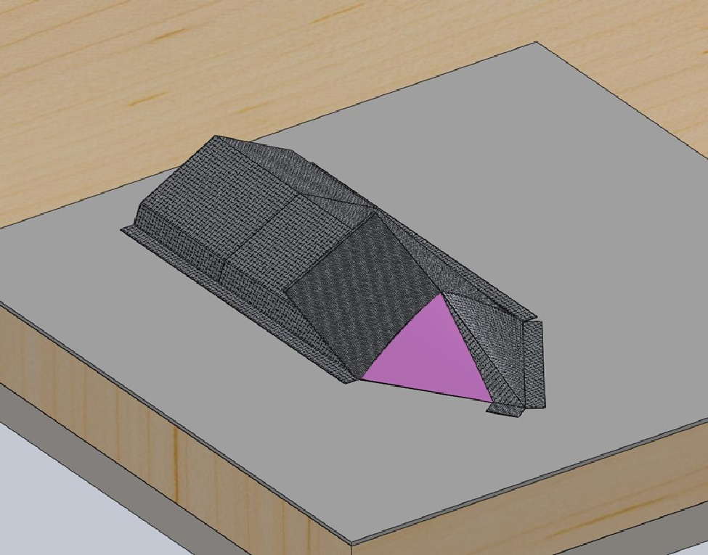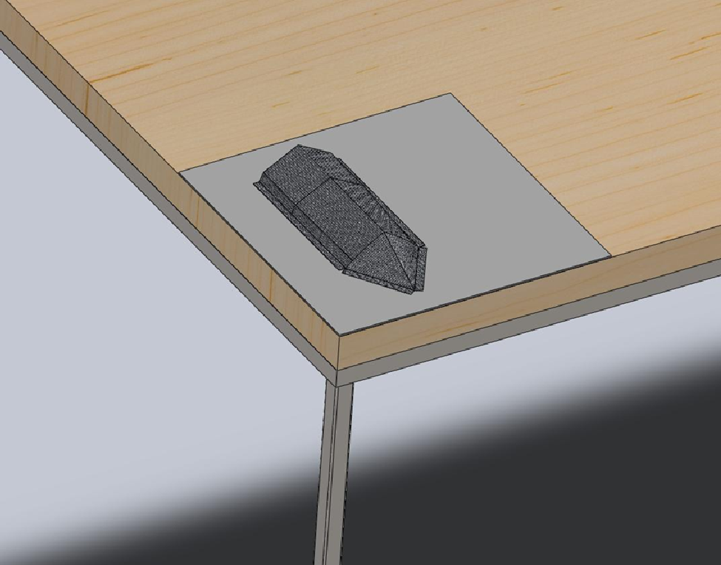Figure 7: Finish folding the bow- (1) Fold the bow flaps over each other, cutting where necessary to allow the matting to lay flat against the plug.

9

STEM Academy: General Fabrication Methods Fiberglass Freighter

1 2

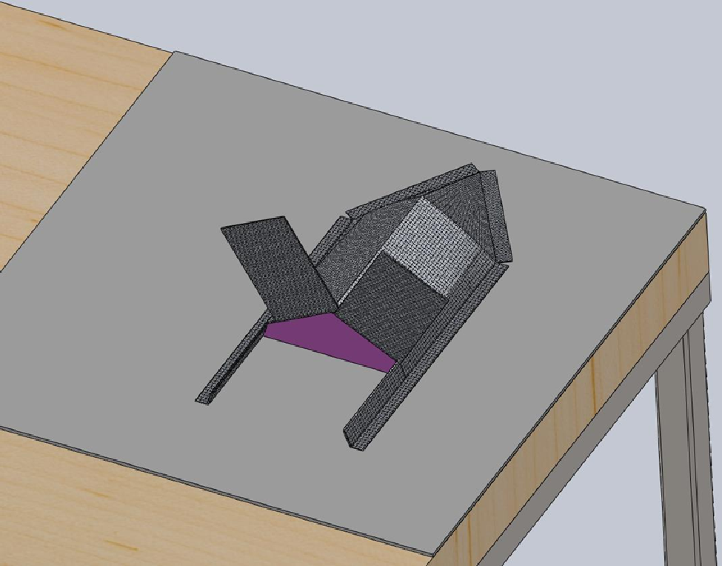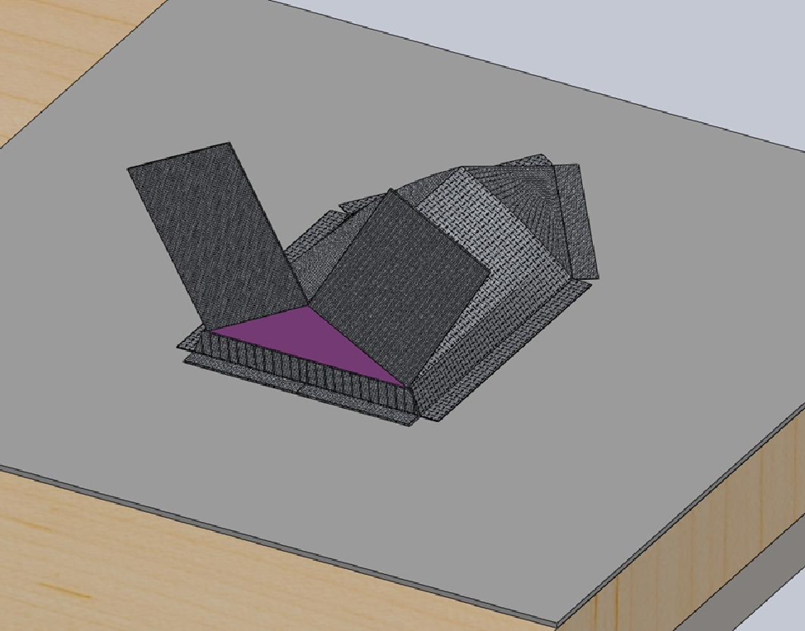Figure 8: Preparing the stern- (1) Cut the stern matting into several pieces that can be folded over one another. (2) Fold the bottom pieces in first so they will be coverd up by the bigger bottom flaps.

1 2

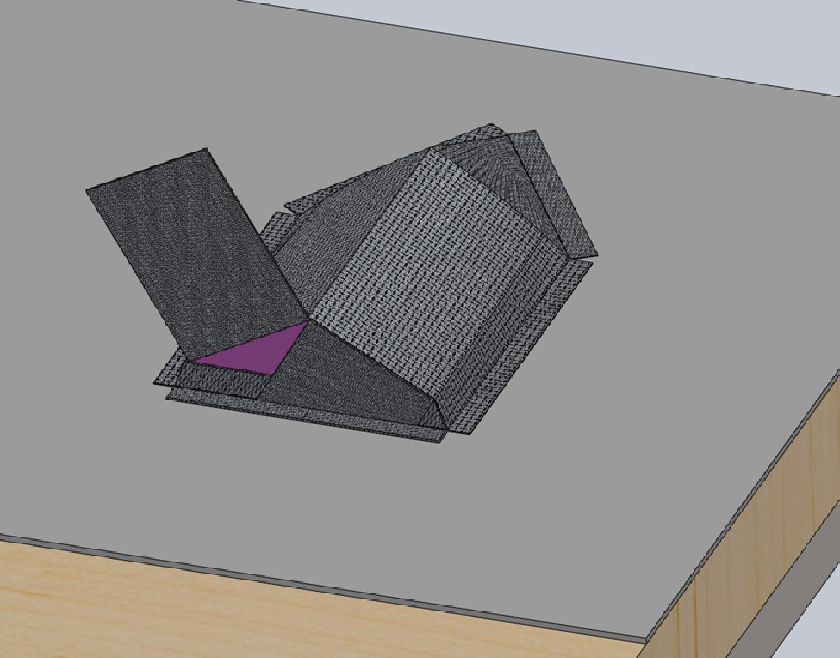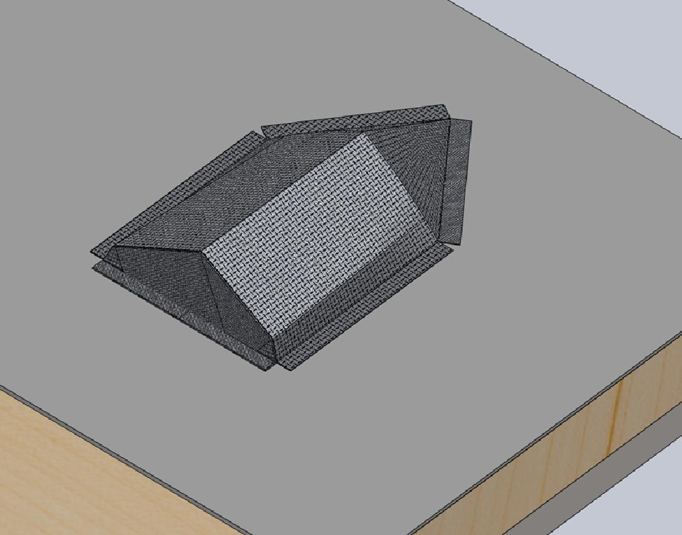Figure 9: Finish folding the stern- (1) Fold one flap down and cut excess off. (2) Fold the second flap down to finish matting the plug. Leave extra matting around the plug. This will be cut off after the resin dries.

10

STEM Academy: General Fabrication Methods Fiberglass Freighter

Step 8: After the fiberglass has been fitted to the plug, remove the fiberglass matting and apply the Release Agent to the plug. Follow the directions on the manufacturer’s label carefully and apply the recommended amount to the plug using using a Mixing cup, Gloves, and a Brush.

Note: Release Agent is used to form a barrier between the resin applied to the fiberglass and the resin. If release agent is not used, the fiberglass will bond to the plug, and the plug will have to be cut out.

Step 9: Once the release agent is on the plug, place the fiberglass matting back on the plug in the position it was before. It is ready for the application of Resin. Follow the directions on the manufacturer’s label carefully and mix the recommended amount using a Mixing cup, Gloves, and Stir Stick.

Note: When working with Resin you should be very careful not to spill any out of the mixing cup.

E. With the Resin mixed, carefully pour it over the fiberglass matting
F. Use a Bondo Knife to gently work the resin into the fiberglass making sure to cover all of the matting. The Bondo Knife also helps take out all of the wrinkles in the fabric. No matting fibers or wrinkles should be showing after the Resin is correctly applied. The matting should get a clear look to it if done properly.
G. Allow the Resin to set for the amount of time recommended by instructions on the the manufacturer’s label.
H. When done applying the Resin, wash off the bondo knives with a small amount of Acetone in a small container. Use the acetone sparingly, a small amount of Acetone is needed to clean the knives. Allow the acetone to evaporate or dispose
of properly.

11

STEM Academy: General Fabrication Methods Fiberglass Freighter

Step 10: After the resin has set, use a Utility Knife, to cut away the extra matting that has bonded to the paper.
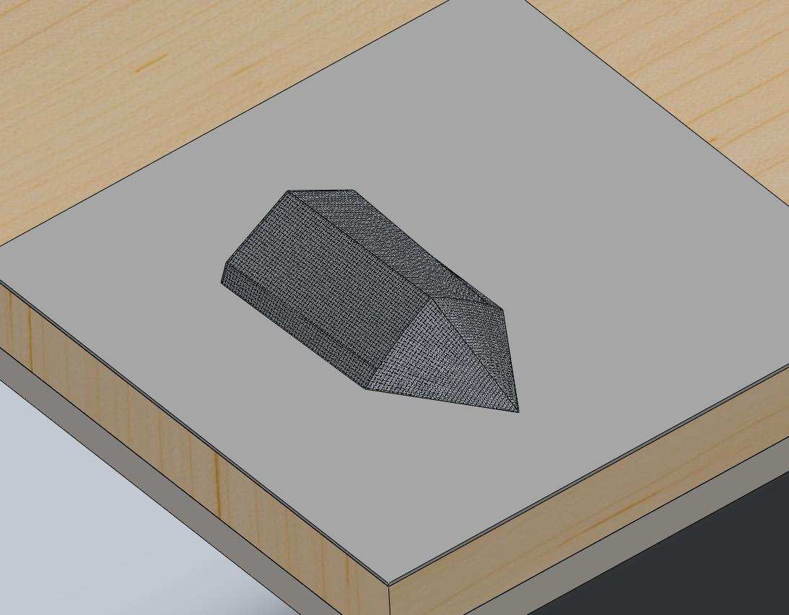Note: Be sure not to cut too deep and cut into the table when cutting the extra matting.

Figure 10: Finished piece with excess edges removed.

12

STEM Academy: General Fabrication Methods Fiberglass Freighter

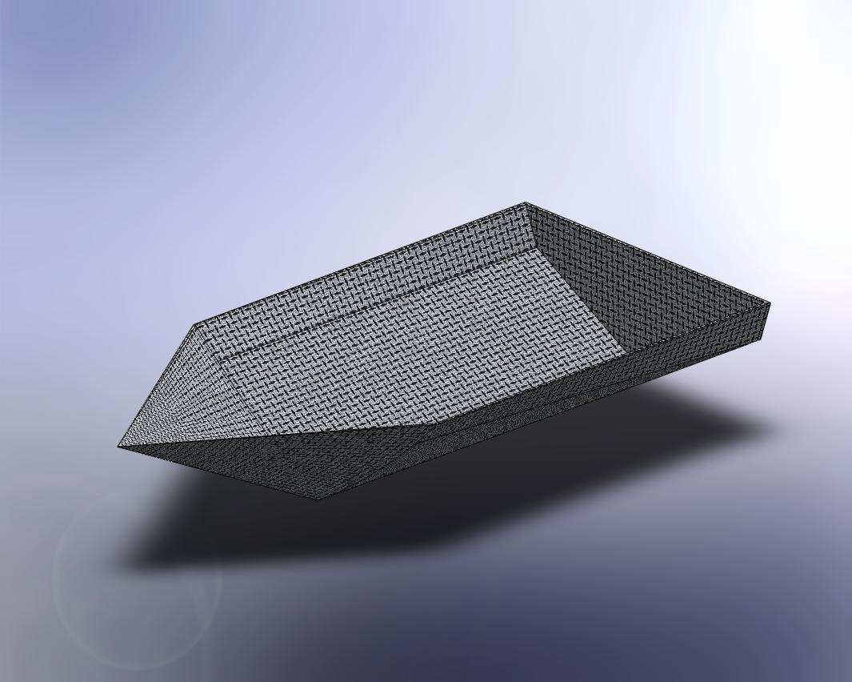Step 11: Remove the plug. If necessary, cut away the plug if it bonds to the fiberglass.

Figure 11: Finished piece with excess edges removed.

Step 12: With the fiberglass hull completed, test to see if it is able to float in water. Any holes in the fiberglass will allow water in, causing your boat to sink.

Figure 12: Finished piece floating in water.

13

STEM Academy: General Fabrication Methods Fiberglass Freighter

Step 13: Test to see how much freight the freighter hull can hold.

A. Float your boat in water.
B. Slowly add marbles or ball bearings to the freighter until it sinks. Count them as they are added to the boat
C. Report how much freight the freighter hull can hold to your instructor.

Figure 13: Finished piece loaded with freight.

14

