STEM Academy: General Fabrication Methods Pencil/Pen Holder

**Pencil/Pen Holder**

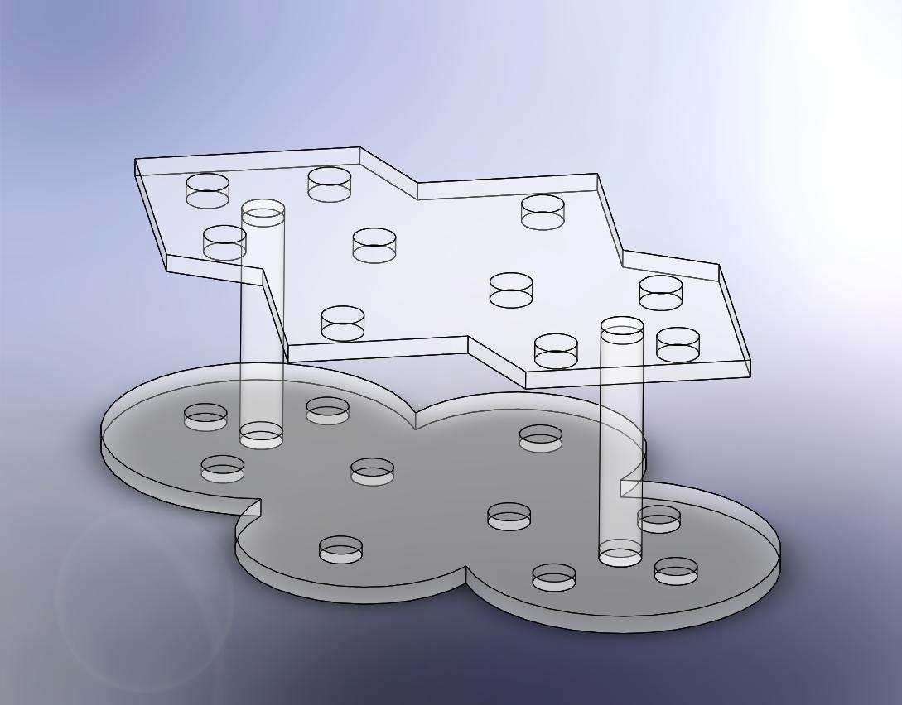

**Equipment**

A. Band Saw

B. Drill Press

C. Combination

Square

D. Tape Measure

E. Compass

F. Safety Glasses

G. Self Locking Pliers

H. Two Bar Clamps

**Materials**

A. 1/4" Acrylic sheet

B. 1/2" Acrylic Dowel

Rod

C. 1/2" Drill Bit

D. Epoxy

E. Stir Sticks

F. Packing Tape

G. Mixing Cup

1

Sf EM Academy: General Fabrication Methods Pencil/Pen Holder

Drawing 1: Top Piece- Side 1(View #1)

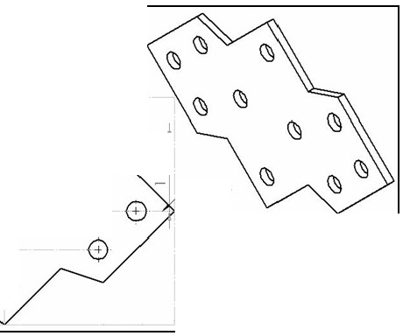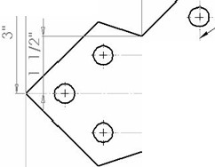

*4* 1/2"

3" 1 5/8"

Y Axis

,-----

0· "

X Axis

0 0·

0·

2

STEM Academy: General Fabrication Methods Pencil/Pen Holder

Drawing 2: Top Piece- Side 1 (View #2)

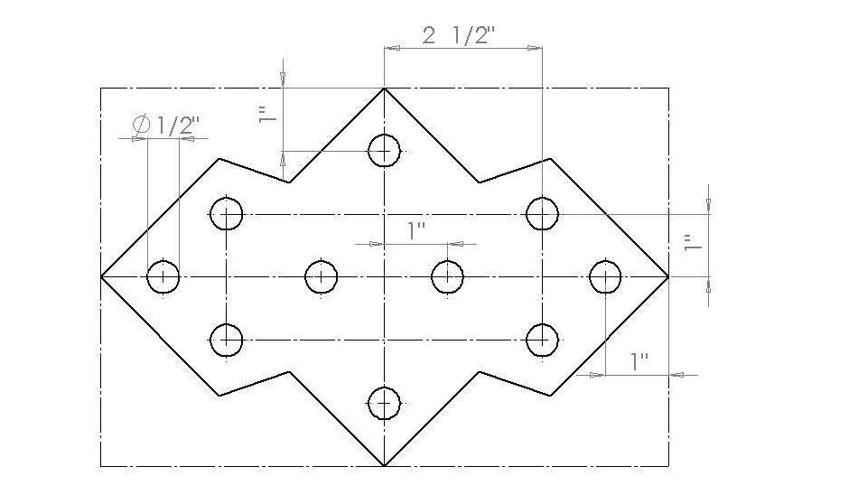

3

STEM Academy: General Fabrication Methods Pencil/Pen Holder

Drawing 3: Top Piece- Side 2

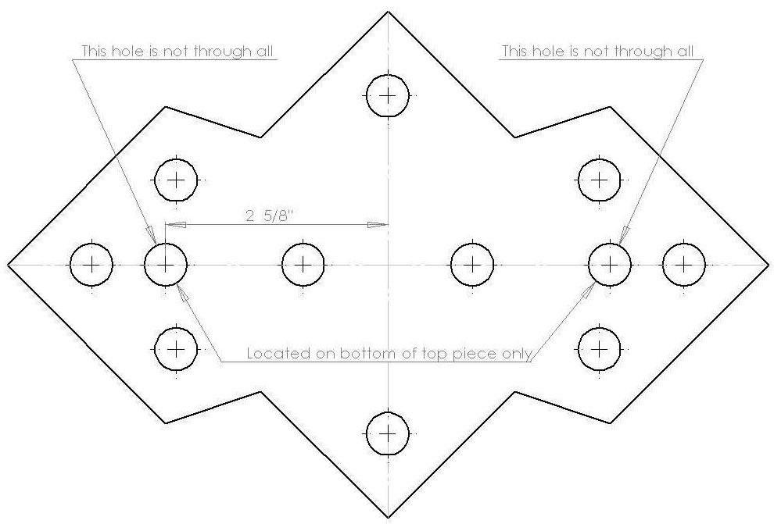

4

STEM Academy:General Fabrication Methods Pencil/Pen Holder

**Drawing 4: Bottom Piece- Side 1(View #1}**

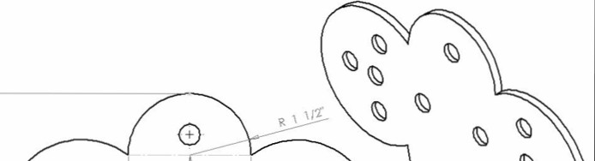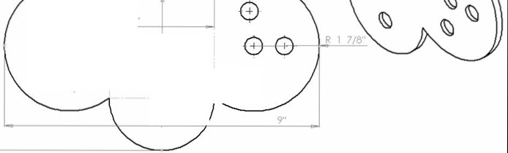

0 3 0

00 0 "' 0

0 0

0 9"

STEM Academy: General Fabrication Methods Pencil/Pen Holder

**Drawing 5: Bottom Piece- Side 1(View #2)**

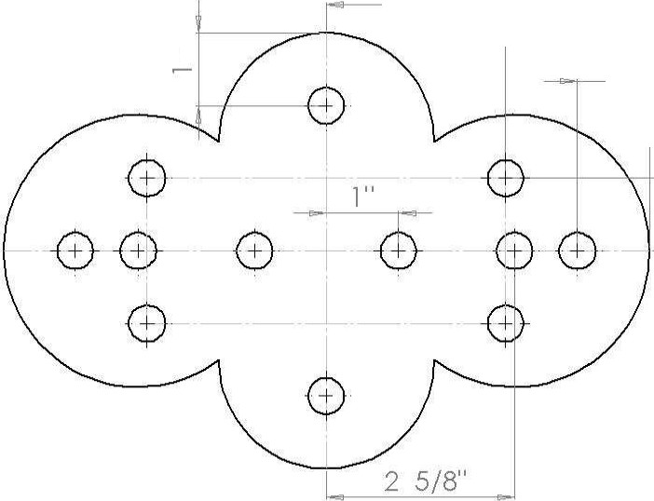

2 1 /2"

: 1"

-

..--

6

STEM Academy: General Fabrication Methods Pencil/Pen Holder

**Instructor’s note:**

**Pair down 30”x36” sheet of acrylic into strips that are 30”x9”.**

**A.** Before drawing on acrylic, place strips of packing tape everywhere a line is to be drawn, or cut is to be made.

Note: Covering the acrylic with packing tape before allows you to make non-permanent markings on the work piece. This type of tape also contains oils which act as a lubricant on the saw blade while it cuts through the plastic. This keeps the blade from getting hot and melting the plastic. Melting the acrylic could melt the kerf back together, melt the crisp edges of the kerf, or discolor the plastic.



**B.** For Instructions on how to use the band saw to cut the acrylic, refer to the student manual.

7

STEM Academy: General Fabrication Methods Pencil/Pen Holder

**Step 1:** To lay out a 6”x9” acrylic pieces, place **Packing Tape** on acrylic where marks will be made and then mark lines using a **Marker** and a **Combination Sqaure**. See Figure 2.

Note: Covering the acrylic with packing tape allows you to make non- permanent markings on the work piece. This type of tape also contains oils which act as a lubricant on the saw blade while it cuts through the plastic which keeps the blade from getting hot and melting the acrylic. Melting the acrylic could melt the kerf back together, melt the crisp edges of the kerf, or



discolor the plastic. See Figure 1 for what a kerf is.

Figure 1: A kerf is the gap in material left by the blade of a saw.

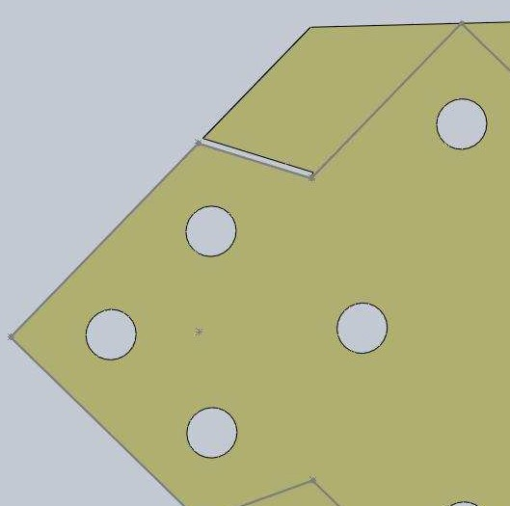

**A.** Measure 6” from one end of the acrylic strip with the ruler on the **Combination Square** and place a strip of **Packing Tape** perpendicular across the sheet of acrylic at this point. Center the piece of tape at the 6” location.

**B.** Measure and draw a small mark 6” from the same edge using the ruler on the

**Combination Square** and **Marker.**

**C.** Draw a line across the piece and in the center of the packing tape using the

**Combination Square** and **Marker**.

Note: Using the **Combination Square** ensures that the resulting work piece will have sides that are perpendicular to each other.



8

STEM Academy: General Fabrication Methods Pencil/Pen Holder

Figure 2: Laying out the piece- (1) Locate piece of acrylic and Combination Square. (2) Place piece of Packing Tape 6” from end of Acrylic sheet. (3) Draw a line across the acrylic sheet using the Combination Square. (4) Work piece after finishing Step 1.

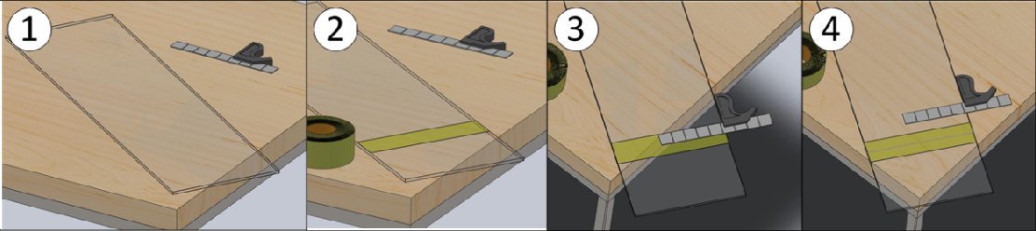

9

STEM Academy: General Fabrication Methods Pencil/Pen Holder

**Step 2:** Cut out the 6”x9” piece using the **Band Saw**.

**A.** Make sure everyone in the group has **Safety Glasses** on.

**B.** Remove all objects from the table on the Band Saw.

**SAFETY WARNING:** Before starting the saw, make sure the work piece AND ALL objects are removed from the table of the band saw. Objects, including the acrylic sheet can become pinched between the blade and the table and thrown from the machine, possibly hurting others nearby.



**C.** Turn on the **Band Saw**. Place the arcrylic sheet on the table of the **Band Saw** and align the band saw blade with the line drawn on the Packing Tape in Step 1C as shown in Figure 3.

Note: When making a cut with a band saw, the blade should be offset to the side opposite of the desired piece. Due to the width of the saw blade, if you



cut down the center of the drawn line, your piece will be half the blade’s width

smaller than what you measured.

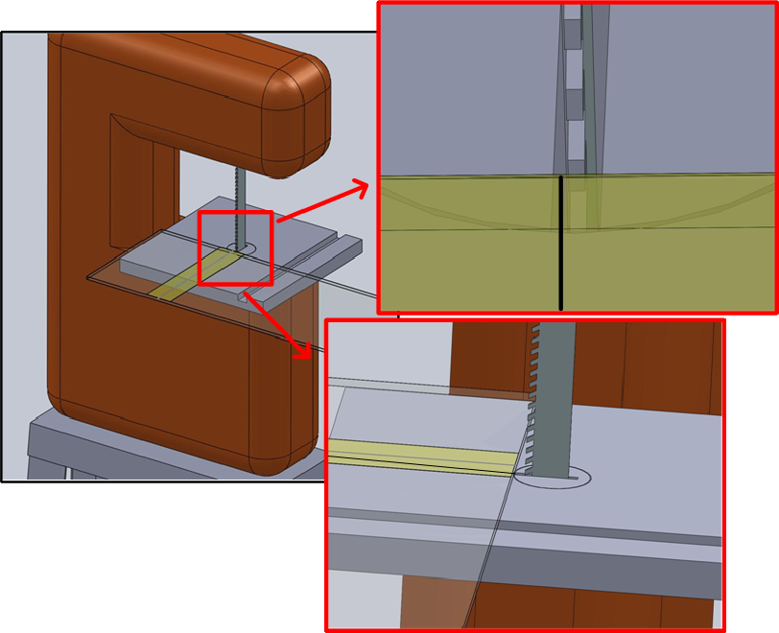

Figure 3: The line to be cut should be off-set from the blade to ensure that the resulting work piece will be the desired dimension.

**SAFETY WARNING:** Keep your fingers as far away from the blade as possible while mantaining a firm grasp of the acrylic strip.



10

STEM Academy: General Fabrication Methods Pencil/Pen Holder

**B.** Slowly bring the arcylic sheet into contact with the Blade of the Band Saw

**C.** Slowly feed the acrylic into blade until piece is fully cut.

**Step 3:** Repeat Step 1 and Step 2 one more time to end up with two 6”x 9” pieces of acrylic.

**Pitfall Prevention:** It is important not to mark both pieces in Step 1 before cutting. Due to the width of the saw blade, if both lines are marked at once, the



first cut will throw off the second mark by the width of the blade.

11

STEM Academy: General Fabrication Methods Pencil/Pen Holder

**Step 4:** Layout the top piece **Side 1** using **Packing Tape**, a **Combination Square**, a **Marker** and the dimensions found in **Drawing 1** and **2**.

**A.** Cover each 6”x9” piece completely with strips of **Packing Tape** as shown in Figure

4(1).

**B.** Draw out edges found in **Drawing 1** and **2** on the same 6”x9” piece using a **Marker** and the **Combination Square**. Both drawings are of the same piece, same side, and are symmetrical about the X and Y axis.

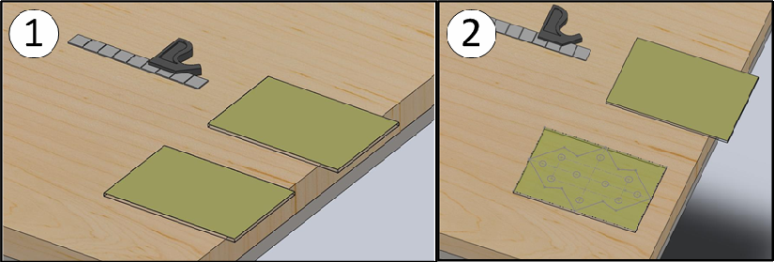

Figure 4: laying out Side 1-(1) Cover both work pieces with strips of Packing Tape. (2) Draw out the edges found in Drawings 1 and 2 on the work piece.

**Step 5:** Layout the top piece **Side 2** using **Packing Tape**, a **Combination Square**, a **Marker** and the dimensions found in **Drawing 3**.

**A.** Use the same procedure used in Step 4 to mark out hole locations on **Side 2** of piece one.

These holes are drilled only part way through the top piece and are where the acrylic dowels will be inserted.

12

STEM Academy: General Fabrication Methods Pencil/Pen Holder

**Step 6:** Layout the bottom piece **Side 1** using a **Combination Square**, **Packing Tape**, **Compass**,

**Marker** and the dimensions found in **Drawing 4** and **5**.

Note: **Side 1** on the bottom piece is the only one that requires machining. **Side**



**2** of the bottom piece is left untouched throughout the project.

**A.** Start by locating the center square shown in **Drawing 4**. Going off of this, use a **Compass** to mark out each of the partial circles. If all measuring and cutting has been done corectly, each partial circle should lie tangent to the edge of the acrylic it is closest to it.

**B.** There are two ways to mark out the hole locations in the bottom piece. The first method is

to follow the same procedure used to mark out the hole in the top piece using **Drawing 5**. The second option takes advantage of the transparency of the materials being used. To do this, align the bottom piece on top of the already drawn out top piece and simply copy the hole locations by eye. The former method is more accurate than the latter assuming both

6”x9” acrylic pieces are exactly the same in shape

13

STEM Academy: General Fabrication Methods Pencil/Pen Holder

**Step 7:** Drill all ten holes drawn on the top piece **Side 1** using **Drill Press**, **1/2” Drill bit**, and a

**Bar Clamp**.

**A.** Chuck up the **1/2” Drill bit** into the drill chuck.

**B.** Before clamping material onto **Drill Press** table, make sure the drill bit passes through the center of the **Drill Press** table as shown in Figure 5(1).

**C.** Adjust the height of the tabel so when the chuck is all the way up, there is about 2-3”

of clearance between the **Drill Press** table and the tip of the drill bit.

**D.** Clamp the piece onto the drill press table, aligning the hole to be drilled with the drill bit as shown in Figure 5(2).

Note: It may be necessary to put a piece of scrap of wood under the acrylic while drilling. For practice, it might be wise to drill a hole in the scrap pieces of the arcylic that surround the drawings on the piece. If the back of the acrylic breaks out as the drill bit punches through, add a scrap piece of material under the acrylic each time to prevent this from happening. See Figuer 5(3).



**E.** With all objects away from the drill bit and safety glasses on, turn on the drill press and slowly lower the bit into the acrylic. Do not use force to push the bit through the material, go slowly.

**D.** Once the hole is drilled, raise the chuck and turn off the drill press.

**E.** Reclamp the piece for every hole and repeat the procedure for the remaining holes as shown in Figure 6.

Figure 5: Set up for the first hole- (1) Make sure drill bit passes through the table. (2) Align the drill bit with the acrylic and clamp. (3) If necessary, place scrap wood under the piece.

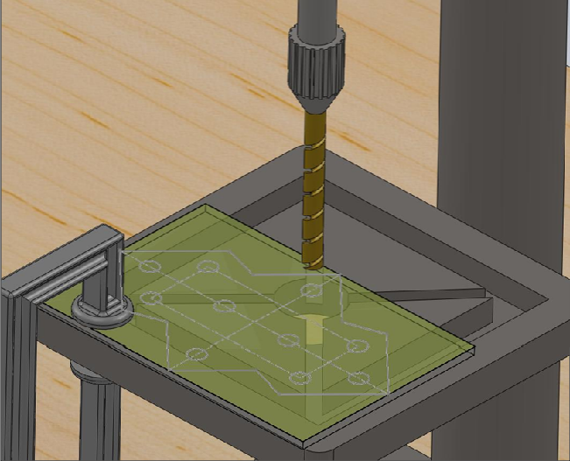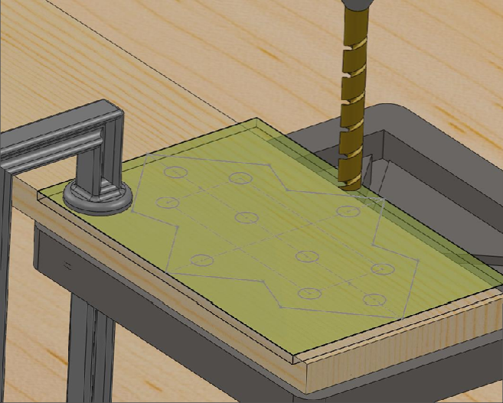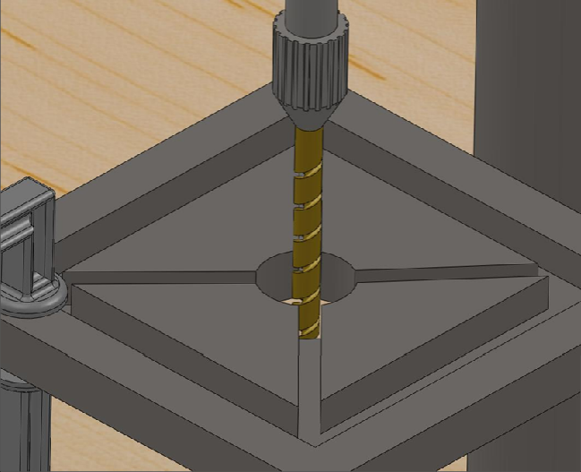

14

STEM Academy: General Fabrication Methods Pencil/Pen Holder

Figure 6: All holes drilled in top piece Side 1

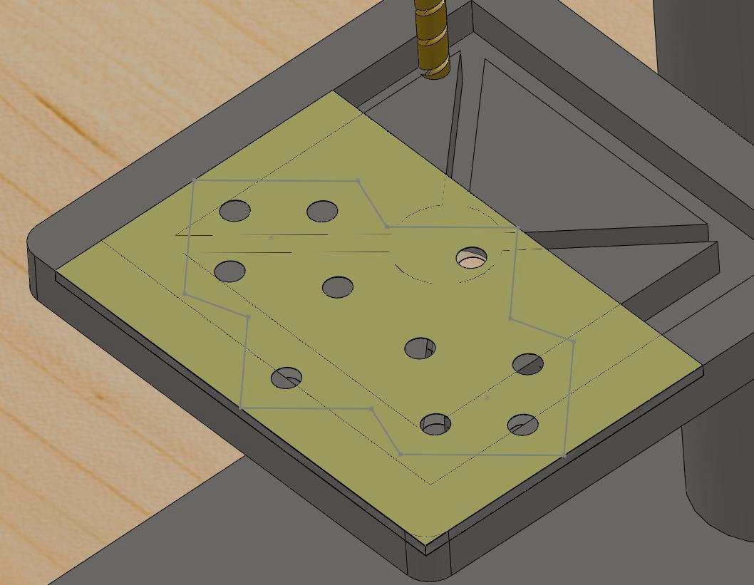

15

STEM Academy: General Fabrication Methods Pencil/Pen Holder

**Step 8:** Drill the two holes on the top piece, **Side 2,** to a blind depth of 1/8”.

**A.** Use standard drilling procedure learned in previous steps to set up for drilling

**B.** Drill both holes to a blind depth of 1/8”. Be careful not to drill too deep and drill through the piece.

Note: Holes may be drilled deeper than 1/8” as long as they are both drilled to the same depth and are not drilled though to the other side.



**Step 9:** Drill all 12 holes drawn on bottom piece **Side 1** to a blind depth of 1/8”

**A.** Use standard drilling procedure learned in previous steps to set up for drilling

**B.** Drill all 12 holes to a blind depth of 1/8”. Be careful not to drill too deep and drill through the piece.

Note: Holes may be drilled deeper than 1/8” as long as they are all drilled to the same depth and are not drilled though to the other side.



Figure 7: All holes drilled in top piece Side 1

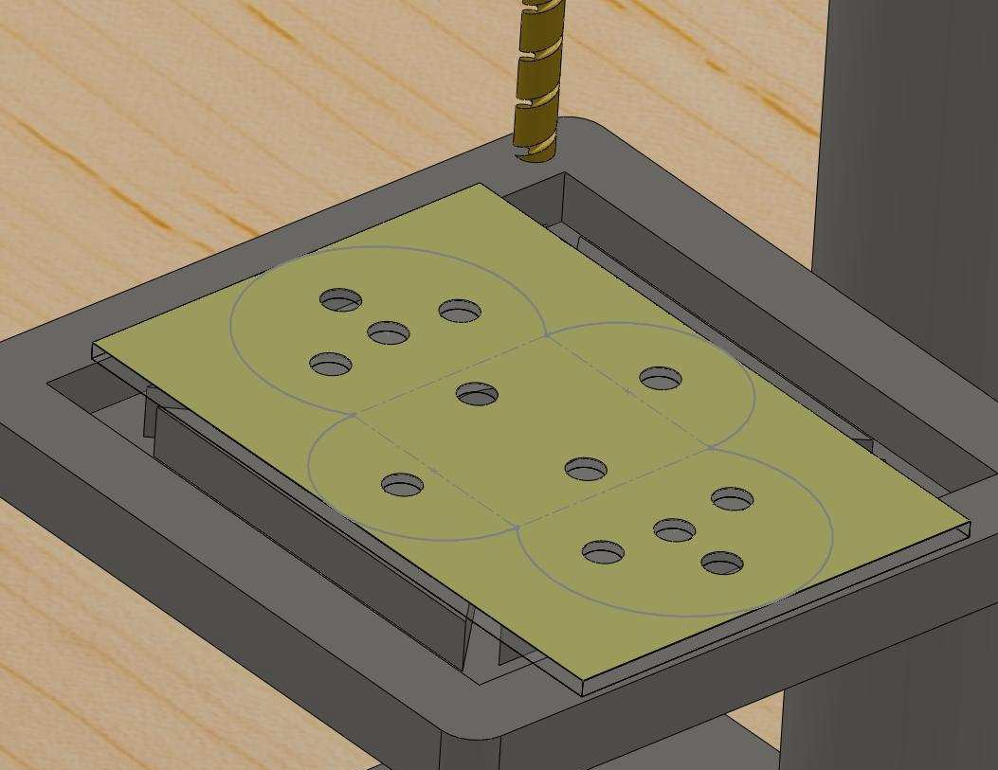

16

STEM Academy: General Fabrication Methods Pencil/Pen Holder

**Step 10:** Cut out top piece with the band saw.

**A.** When cutting out the piece, be sure to cut on the proper side of the line as shown in

Figure 8.

**B.** First, cut off lines as shown in Figure 9(1).

**C.** To make the inside cuts, first make the cut shown in Figure 9(2) and then make the next cut shown in Figure 9(3), then without moving the piece, turn off the band saw and wait for it to stop. Then, remove the piece and make the next cut.

**D.** Repeat until the top piece is completely cut out as shown in Figure 10. Then, remove

the tape.

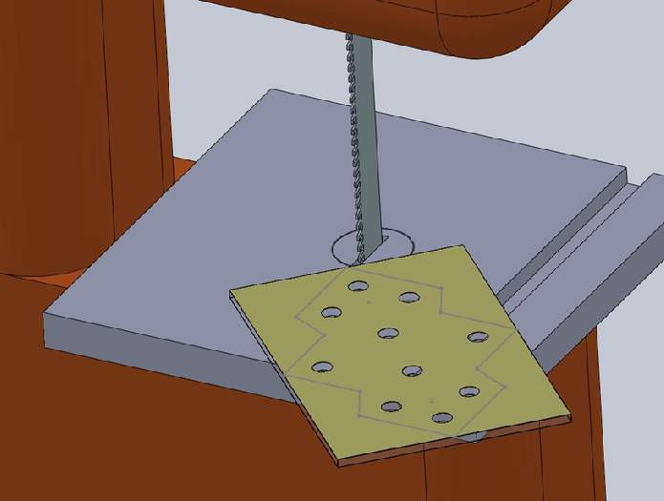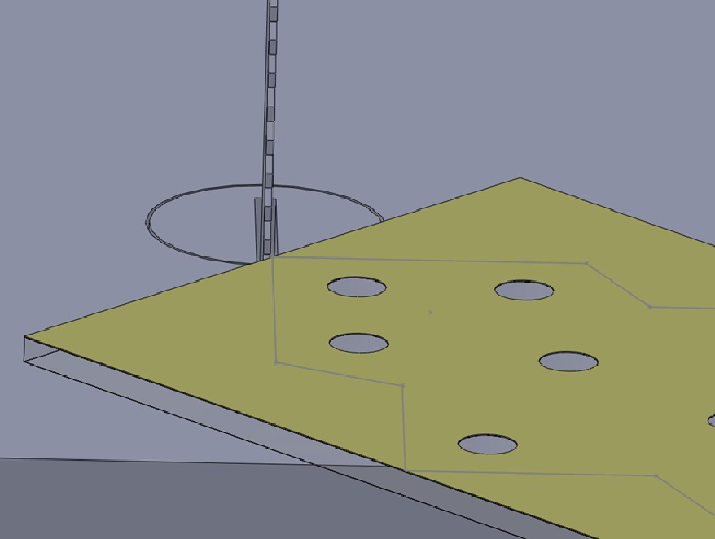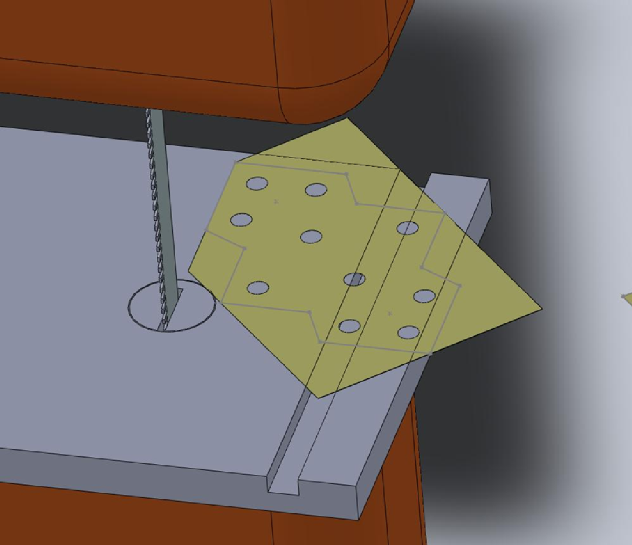

Figure 8: Cut off edge with blade aligned on the outside of the line

1 2 3

Figure 9: Cut off edge with blade aligned on the outside of the line

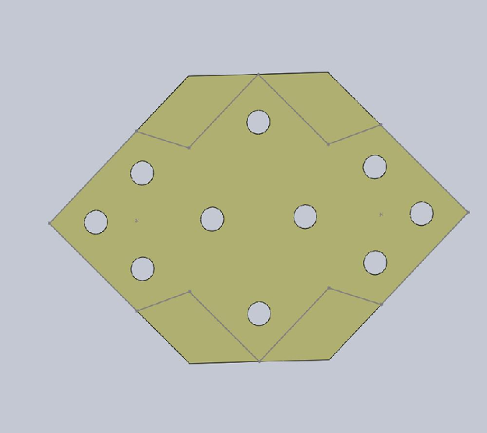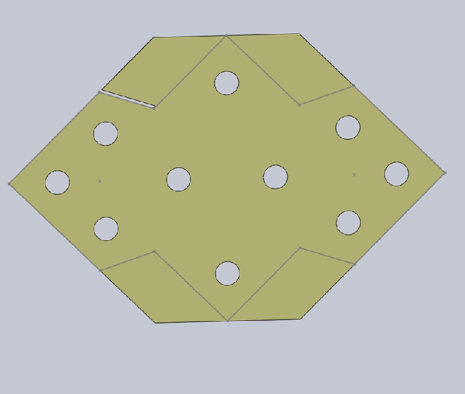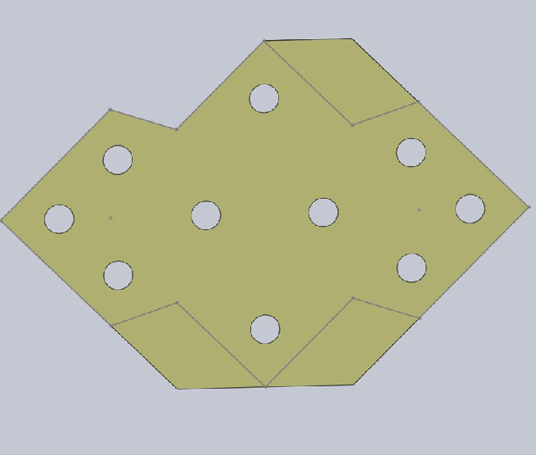

17

STEM Academy: General Fabrication Methods Pencil/Pen Holder

Figure 10: Top piece cut out with tape removed.

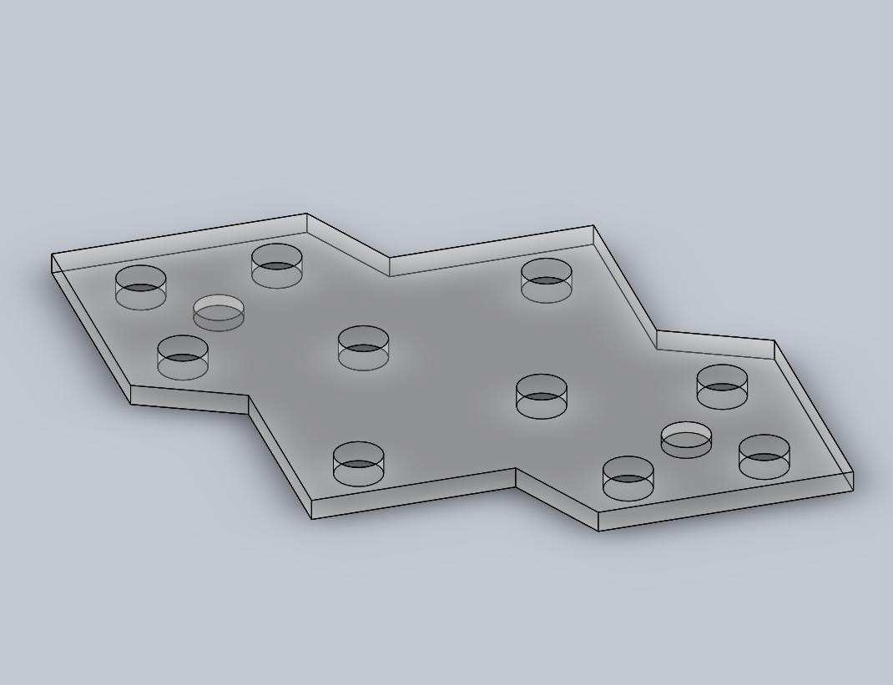

18

STEM Academy: General Fabrication Methods Pencil/Pen Holder

**Step 11:** Cut out top and bottom piece with the band saw.

**A.** When cutting out the piece, be sure to cut on the proper side of the line.

**B.** For curved cuts with a band saw, smaller cuts are taken until desired cut is completed. The depth of the saw blade and the radius of curvature of the cut determine how many sub cuts are needed. Cuts done with a tight curvature require more sub cuts than a large curve. See Figure 11 for the first cut to be done.

**C.** Continue to make sub cuts until bottom piece is completely cut out as shown in

Figure 12.

Figure 11: Cutting out piece with the band saw- (1) Positioning for the first cut. (2) First cut complete. (3) Second cut, notice it only leaves a kerf. (4) Third cut which removes the desired piece.

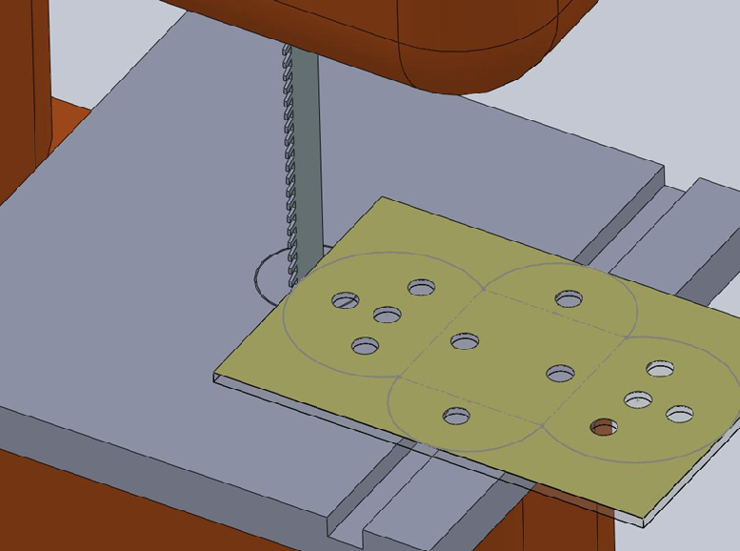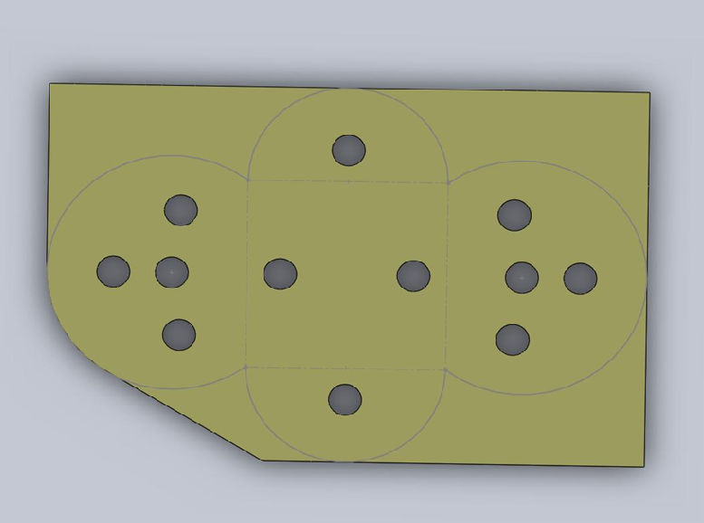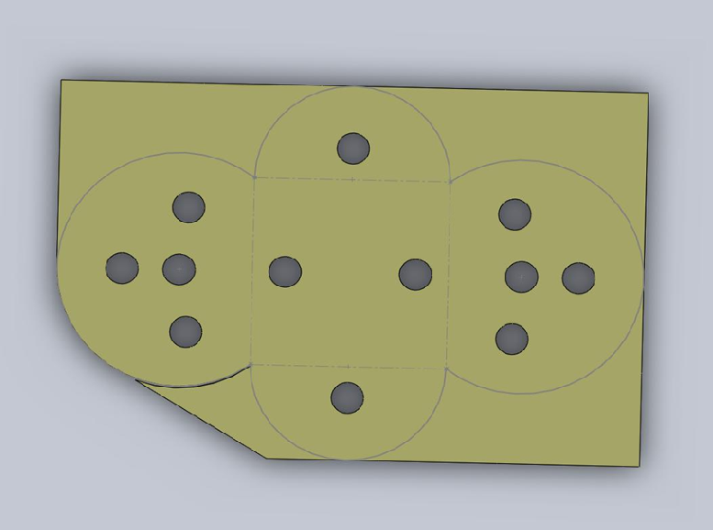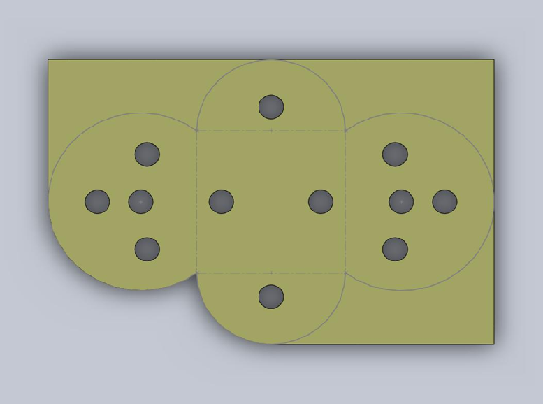

19

STEM Academy: General Fabrication Methods Pencil/Pen Holder

Figure 12: Bottom piece completely cut out with tape removed

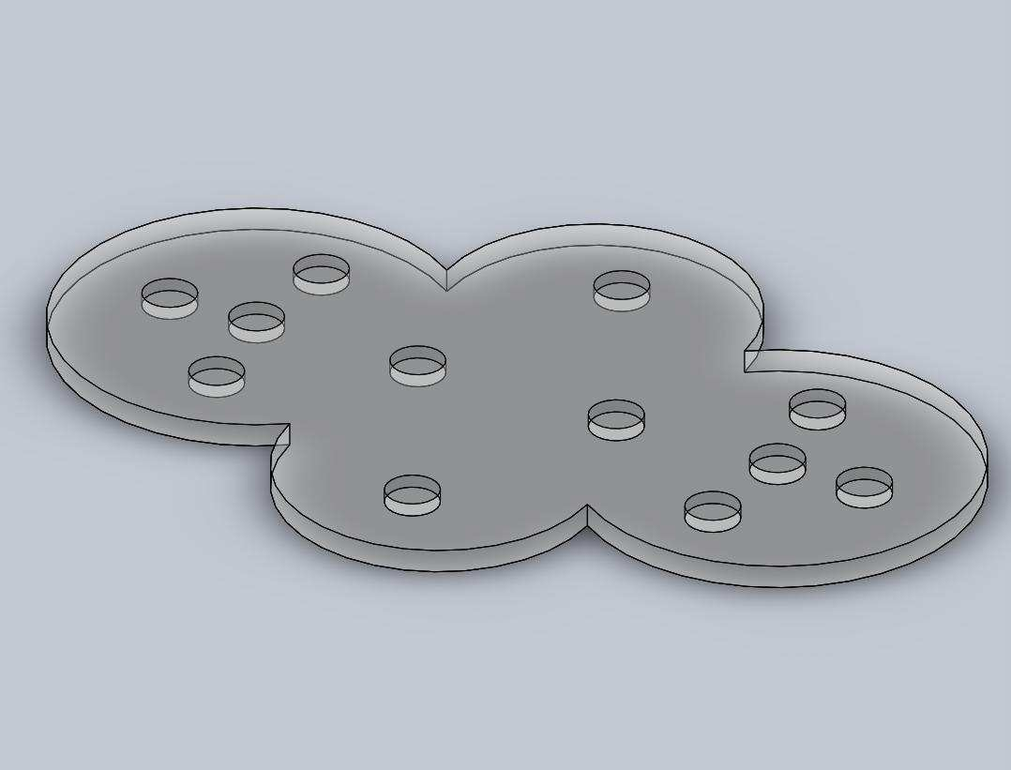

20

STEM Academy: General Fabrication Methods Pencil/Pen Holder

**Step 12:** Measure out and cut two 3” sections of 1/2" acrylic rod using a **Tape Measure**, **Marker**,

**Self Locking Pliers**, and **Band Saw**.

**A.** Using a **Tape Measure** and a **Marker**, mark out one 3” section of 1/2" acrylic rod.

Pitfall prevention: It is important not to mark both pieces in Step 12A before cutting. Due to the width of the saw blade, if both lines are marked at once, the first cut will throw off the second mark by the width of the blade.

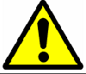

**B.** Use the **Self Locking Pliers** to gently grip onto one end of the dowel rod as shown in Figure 13(2), do not do it tight enough to put dent marks in the acrylic. This is done because when cutting round objects with a **Band Saw**, the downward pull of the blade has a tendency to make the material spin out of control. By holding onto the rod with **Self Locking Pliers** while cutting the piece prevents this from happening.

**C.** Repeat Step 12A and Step 12B.

Figure 13: Cutting the rods- (1) Acrylic rod. (2) Lightly grip the rod with the pliers. (3) Two

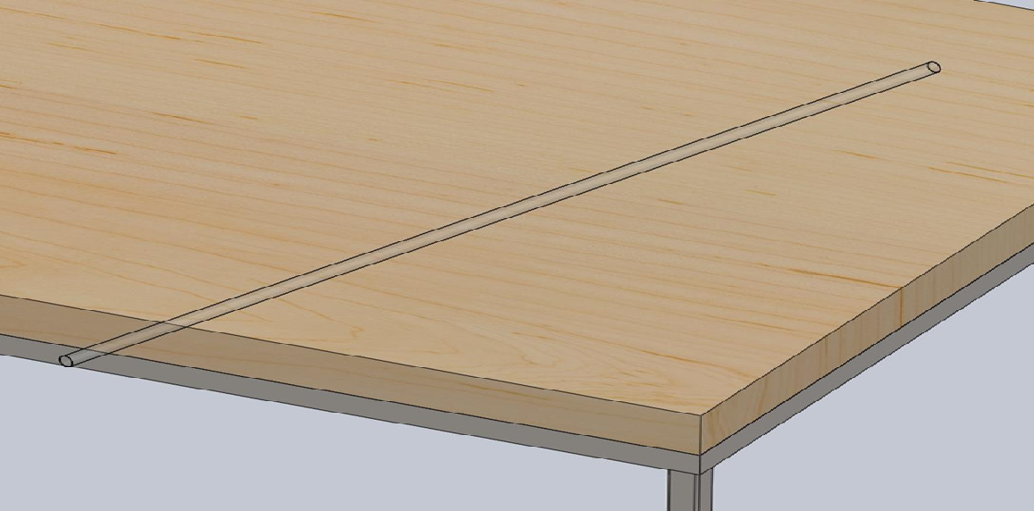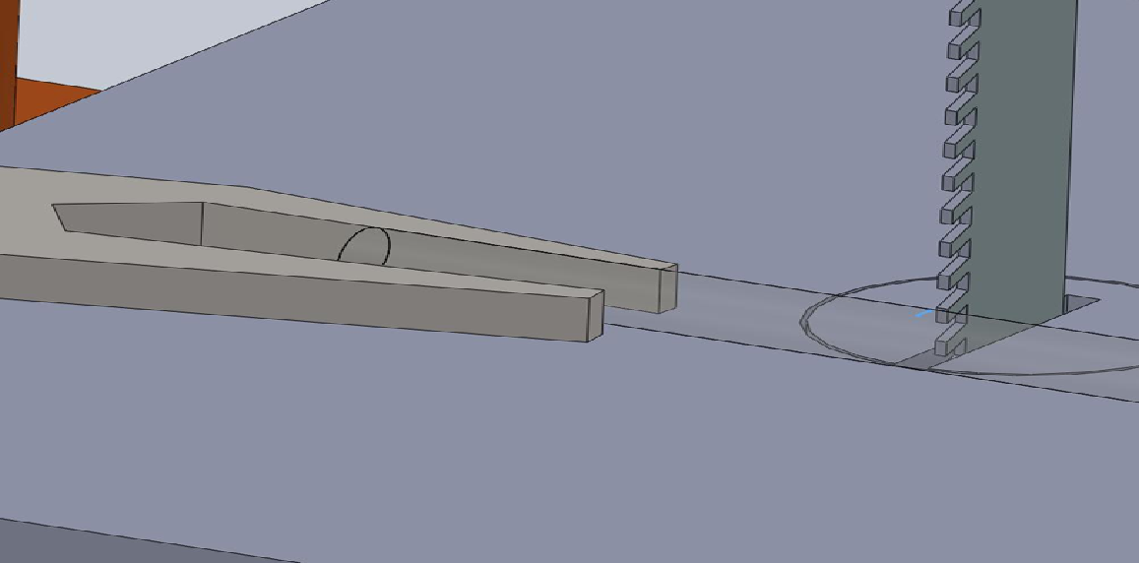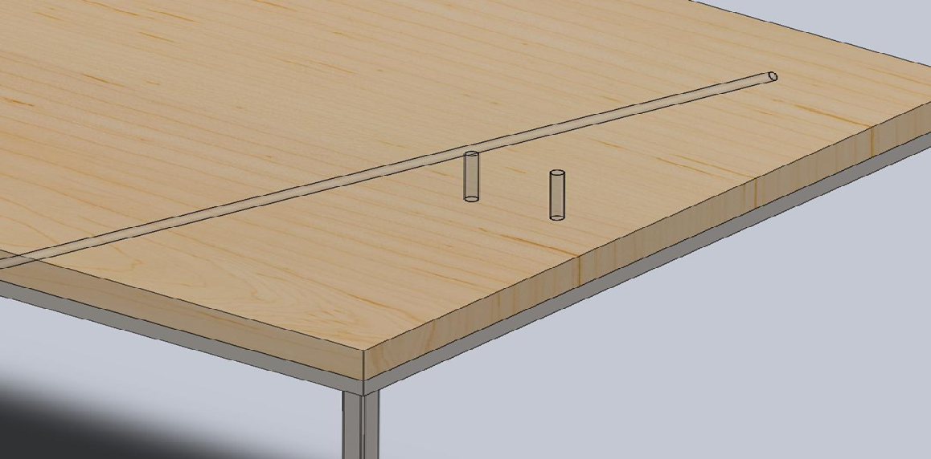

3” pieces.

21

STEM Academy: General Fabrication Methods Pencil/Pen Holder

**Step 13:** Before gluing assembly together, dry fit the pieces together to make sure they fit.

**A.** If the pieces do not fit, make adjustments so the pieces fit nicely. Refer to Figure 14.

Figure 14: Dry fitting the pieces together before gluing

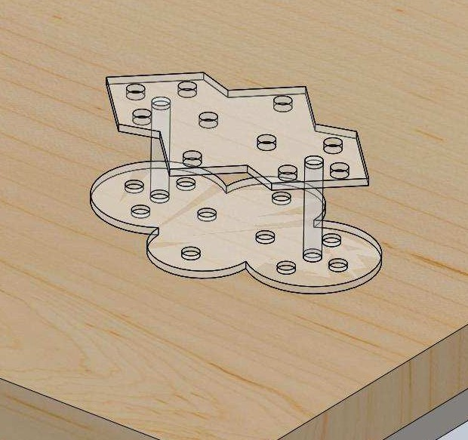

22

STEM Academy: General Fabrication Methods Pencil/Pen Holder

**Step 14:** Glue the three pieces together using a **Stir Stick**, **Mixing Cup**, two **Bar Clamps** and

**Epoxy**.

**A.** Before starting the epoxy operation, make sure the work area is covered with newspaper or other scrap paper. This is done to ensure that the epoxy does not bind permanently to the table on which you are working.

**B.** To epoxy the pieces together, carefully read the directions on the epoxy bottles.

Failure to follow the directions carefully and mixing the correct proportions will result in the epoxy not setting properly and weak joints. For this project only mix enough epoxy to completely fill two of the holes drilled to a blind depth of 1/8”. This is not an exact measurement, so use your best judgment to mix only enough epoxy for the project at hand. Any excess epoxy will be wasted.

**C.** Mix the **Epoxy** in a **Mixing Cup**, with a **Stir Stick**. To mix the **Epoxy**, stir it with a gentle circular motion. Try to minimize the amount of air bubbles created while stirring. The air bubbles are hard to get out of the liquid epoxy and will result in voids

in the glued joint, which weakens the joint.

**D.** Put a small amount of glue in the proper holes in the top piece **Side 2** and the bottom piece **Side 1**. Too much glue in the holes is messy, yet too little creates a weak joint. Remember that the dowel will take up the majority of the space in the hole when it is inserted.

**E.** Once glue is in the proper holes, assemble the dowels, top, and bottom pieces together.

Wipe away any excess glue. Clamp the pieces together as shown in Figure 15. Allow the project to sit clamped as long as directed on bottle.

Figure 15: Clamp with 12” bar clamps and allow glue to cure

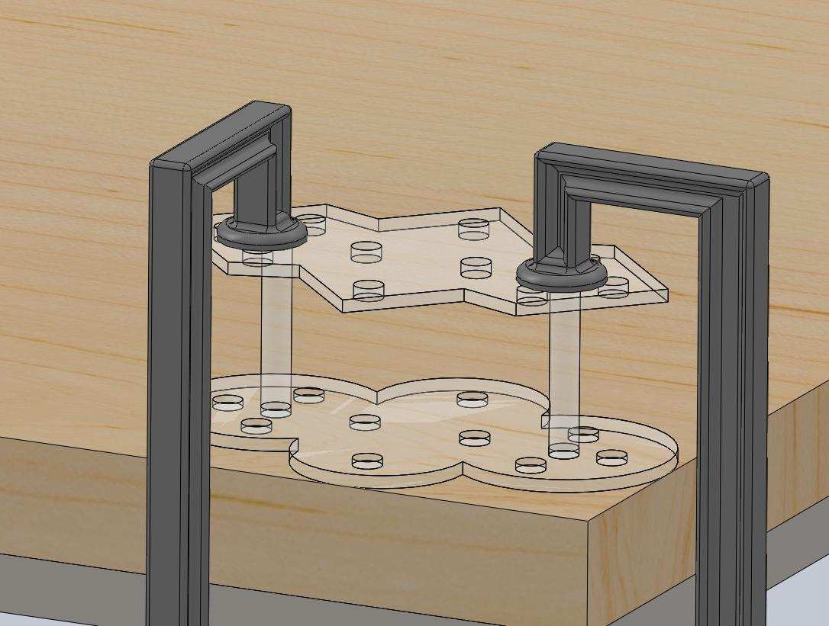

23

STEM Academy: General Fabrication Methods Pencil/Pen Holder

Figure 16: Final project



24