STEM Academy: General Fabrication Methods Large Project Assembly Methods

**Large Project**

**Assembly Methods**

**Equipment**

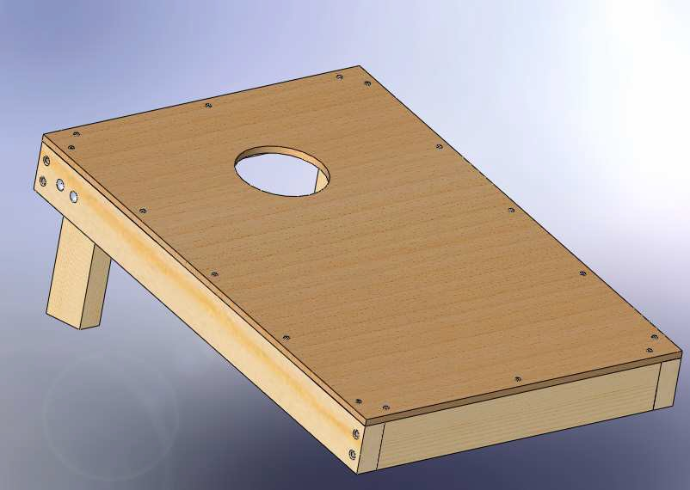

A. Tape Measure B. Circular Saw C. Miter Saw

D. Jig Saw

E. Power Drill

F. Speed Square

G. Chalk Line

H. Hammer

I. 7/16” Socket and

Ratchet

J. 7/16” Wrench

K. Bar Clamp L. Compass M. Marker

K. Sand Paper 80 grit

**Materials**

A. Three 2” x 4” x 8’ Lumber

B. 1/2" CDX Plywood

C. 1/4” x 4” Carriage

Bolts

D. 1/4” Washers, Lock

Washers and Nuts

E. 1/4”x3” Lag Bolt

F. 8 Penny Nails

G. Wood Glue

H. 3/4” Spade Bit I. 3/16” Twist Bit J. 1/16” Twist Bit

1

STEM Academy: General Fabrication Methods Large Project Assembly Methods

Prerequisites:

Complete Wood Techniques before starting this project. Procedures for layout and cutting are not explicit in this module.

Note:

This module outlines how to make one-half of the bag’s equipment. Repeat the module to make the other half of the equipment. Both halves can be made at the same time as they are

exactly the same.

2

STEM Academy: General Fabrication Methods Large Project Assembly Methods

Drawing 1: Exploded View

3

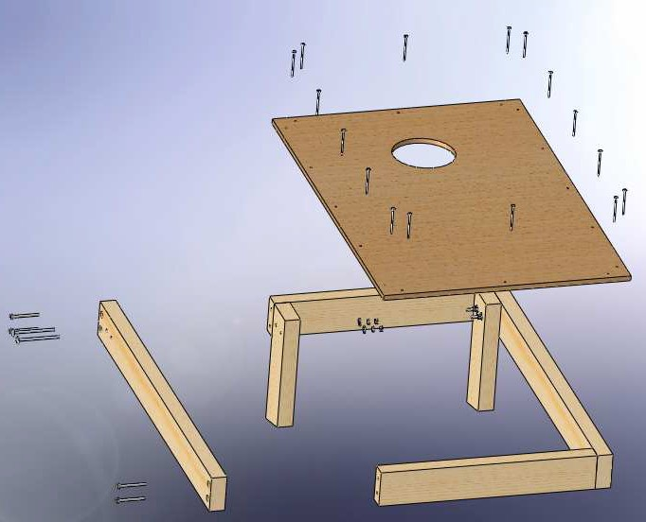

STEM Academy: General Fabrication Methods Large Project Assembly Methods

Drawing 2: Leg Dimensions

4

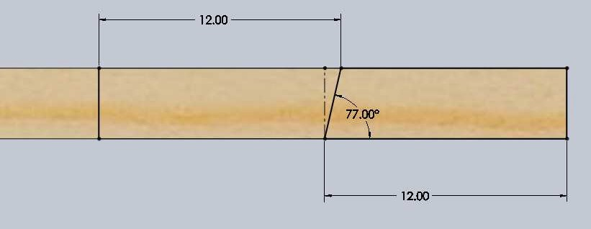

STEM Academy: General Fabrication Methods Large Project Assembly Methods

Drawing 3: Plywood Layout

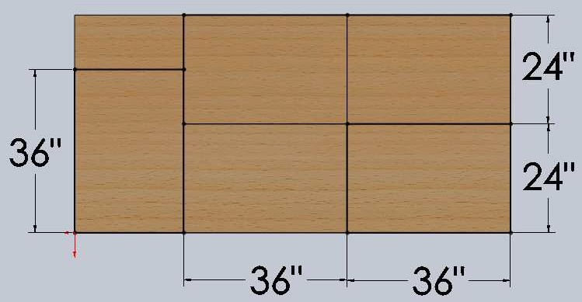

5

STEM Academy: General Fabrication Methods Large Project Assembly Methods

Drawing 4: Countersink Layout

6

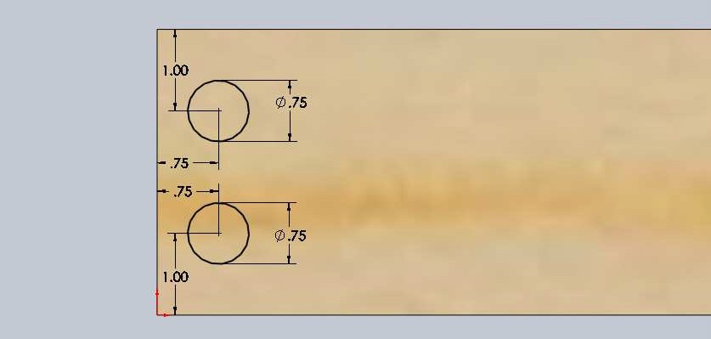

STEM Academy: General Fabrication Methods Large Project Assembly Methods

Drawing 5: Nail Locations

7

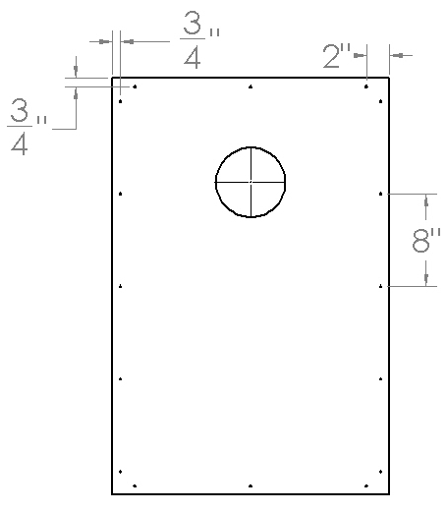

STEM Academy: General Fabrication Methods Large Project Assembly Methods

**Step 1:** Layout and cut two 2” x 4” x 3’ pieces from stock lumber using the **Speed Square**, **Miter**

**Saw**, and a **Marker**.

Note: These pieces will make up the sides of the structure.



**Step 2:** Layout and cut two 2” x 4” x 21” pieces from stock lumber using the **Speed Square**,

**Miter Saw**, and a **Marker**.

Note: These pieces will make up the sides of the structure.



**Step 3:** Layout and cut two leg pieces from stock lumber using the **Speed Square**, **Miter Saw**,

**Marker**, and the dimensions in **Drawing 2: Leg Dimensions** (page 6).

Note: Lay out and cut one leg at a time in order to take in account the width of the blade.



**A.** Mark off a 12” section of the stock lumber.

**B.** Set the **Miter Saw** at 13° and cut the piece so the longer side remains 12” for the first leg.

**C.** Set the **Miter Saw** back to 0° and cut the second leg so the longer side remains 12”.

Note:, If this procedure is used, only one cut is needed to make the 13° angle cuts for both legs instead of cutting two 12” sections and then cutting the



angles. It also eliminates cutting error and ensures identicle leg angle cuts.

8

STEM Academy: General Fabrication Methods Large Project Assembly Methods

**Step 4:** Cut out a 36” x 24” piece of **1/2" CDX Plywood** using a **Chalk Line**, **Tape Measure**,

**Marker**, and a **Circular Saw**.

Note: Refer to the **Drawing 3** (page 7) for the layout of the plywood piece to maximize the 36” x 24” pieces from the 4’ x 8’ stock piece of plywood. You do not need to lay out all of the pieces on the plywood sheet, just the one you need. When cutting out the pieces, cut directly on the lines.



**A.** Using the **Tape Measure** and **Marker**, make a small mark at 36” from one edge on both sides of the plywood as shown in Figure 1(1). Then do the same for the 24” side as shown in Figure 1(1).

**B.** Use the **Chalk Line** to snap a line completing the lay out as shown in Figure 1(2).

**C.** Use the **Circular Saw** to cut the piece out.

Note: Cut directly on the lines. The plywood is only 48” wide and in order to get the most out of each 4’ x 8’ sheet, cutting on the line will make each 24”



piece only half a blade’s width off.

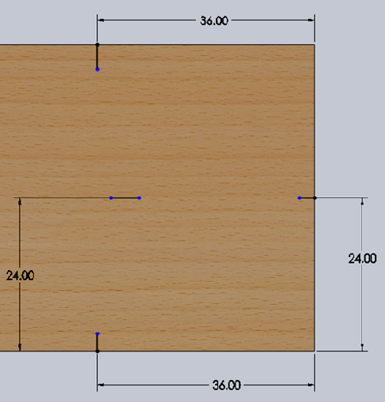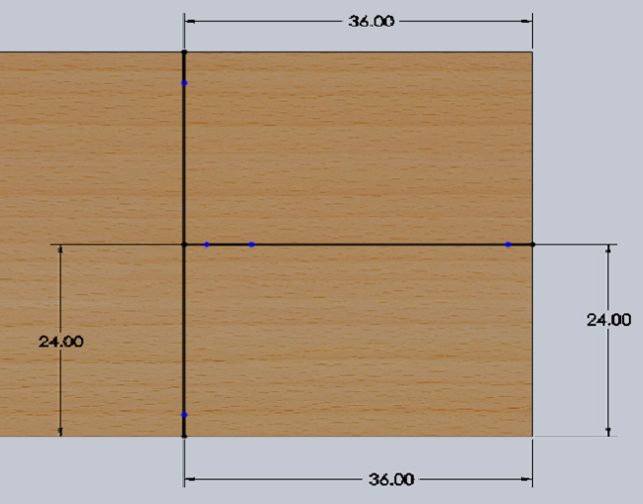

1 2

Figure 1: Layout of the plywood piece- (1) Mark the edges of the plywood where the lines will be created. (2) Use the chalk line to snap a line across the entire piece.

9

STEM Academy: General Fabrication Methods Large Project Assembly Methods

**Step 5:** Lay out and cut a 6” diameter hole in the piece created in Step 4, located 9” from the 24” side and 12” from the 36” side using a **Tape Measure**, **Compass**, **Power Drill**, **3/4" Spade Bit**, and a **Jig Saw**.

**A.** Locate the center of the hole with a **Tape Measure**, set the **Compass** for a radius of

3” and draw the hole.

**B.** Drill a hole through the center of the circle with a **Power Drill** and a **3/4" Spade Bit**.

Note: Make sure not to drill into any other surfaces that lay behind the plywood when drilling the hole.



**C.** Cut out the 6” diameter hole using the **Jig Saw**. Insert the jig saw blade into 3/4” hole and start cutting in an outward circle until you are cutting out the circle as shown in Figure 2.

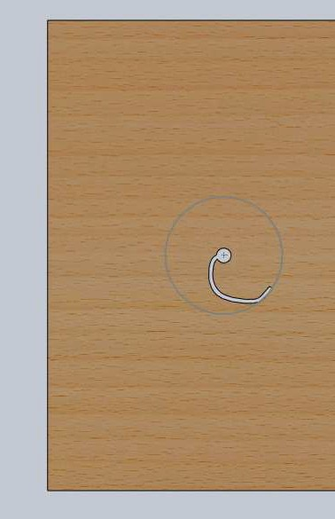

Figure 2: Cutting out the hole with a jig saw

**Step 6:** Countersink holes 1/2" deep for lag bolts in the two pieces cut out in Step 1 using a **Power Drill**, **3/4” Spade Bit**, **Marker**, **Tape Measure**, and the dimensions found in **Drawing 4: Counter Sink Layout** (page 8)

**A.** Mark out the hole locations as shown in **Drawing 4: Counter Sink Layout** (page 8)

on both ends of the pieces using a **Tape Measure** and **Marker**.

**B.** Using a **Power Drill** with a **3/4” Spade Bit** drill out all eight countersink holes to a depth of 1/2".

10

STEM Academy: General Fabrication Methods Large Project Assembly Methods

**Step 7:** Set up the 2” x 4” frame and drill 3/16" pilot holes 3” deep through the center of all of the countersink holes drilled in Step 6, and insert **1/4" x 3” Lag Bolts** with **1/4" Washers**, using a **Power Drill**, **3/16” Twist Bit**, **7/16” Wrench**, **7/16” Socket**, and a **Ratchet**.

**A.** Position the countersunk piece with a 2” x 4” x 21” piece cut in Step 2 as shown in

Figure 3(1).

**B.** Have one person hold the two boards tight together while another drills the 3/16” pilot holes 3” deep through the center of the countersink holes using a **3/16” Twist Bit** and a **Power Drill**.

**C.** Before letting go of the pieces, insert **1/4" x 3” Lag Bolts** with **1/4" Washer** on it into

the holes with a **7/16” Wrench**, **7/16” Socket** and **Ratchet**.

**D.** Repeat this process for the three remaining corners.

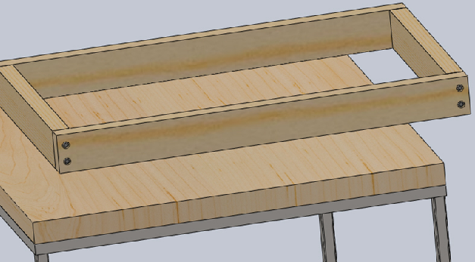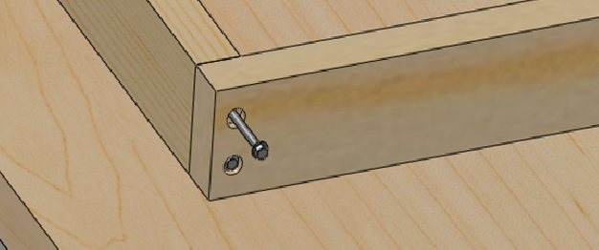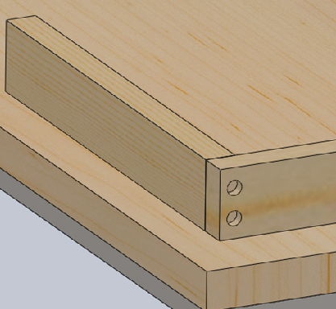

1

2

3

Figure 3: Assembly of the frame- (1) Line up the correct pieces as shown and have one person hold them in place. Drill the holes through the center of each counter sink. (2) Insert lag bolts with washers into the

holes and screw them in tight with the socket and ratchet. (3) Finished frame.

11

STEM Academy: General Fabrication Methods Large Project Assembly Methods

**Step 8:** Attach legs to one end of the frame using a **1/4" Twist Bit**, **Power Drill**, **Tape Measure**, **Marker**, **Bar Clamp**, **1/4” Carriage Bolts**, **1/4" Washers**, **1/4” Lock Washers, 1/4” Nuts**, **Hammer**, **7/16” Socket**, and a **Ratchet**.

**A.** Clamp legs onto frame in the correct orientation using a **Bar Clamp** as shown in

Figure 4(1).

**B.** Layout hole centers as shown in Figure 4(2) using a **Tape Measure**, and a **Marker**.

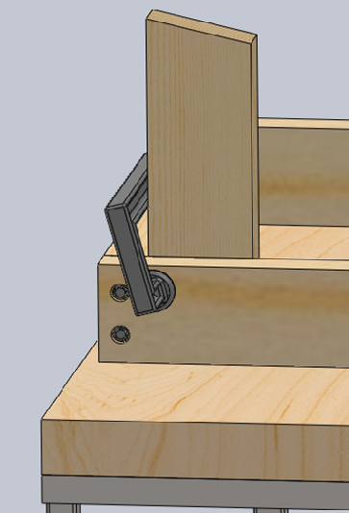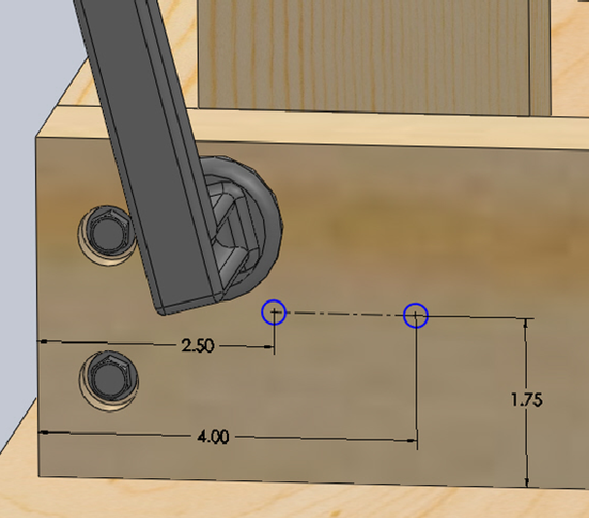

Figure 4: Attaching the legs- (1) Clamp leg onto the frame in the correct orientation (2) Mark hole locations on the frame.

**C.** Drill the holes through the two boards using a **1/4" Twist Bit** and a **Power Drill** as shown in Figure 5(1).

Note: If the bit does not reach all the way through the legs while clamped, drill both holes while clamped, then unclamp and finish drilling holes through all.



**D.** Attach the legs using **1/4” Carriage Bolts**, **1/4" Washers**, **1/4” Lock Washers,** and

**1/4” Nuts**. Use a **Hammer** to pound the **1/4” Carriage Bolts** into the holes as shown in Figure 5(1). Use a **7/16” Socket** and a **Ratchet** to snug down the nuts.

Note: Place the washer on first, and then the lock washer, and then the nut.



Snug the nut down until the head of the carriage bolt head and the washer starts to press into either side of the wood.

12

STEM Academy: General Fabrication Methods Large Project Assembly Methods

Figure 5: Attaching the legs- (1) 1/4” holes drilled into the frame and leg. Insert the carriage bolts and fasten them with the proper hardware, socket, and ratchet. (2) Finished assembly of legs and frame.

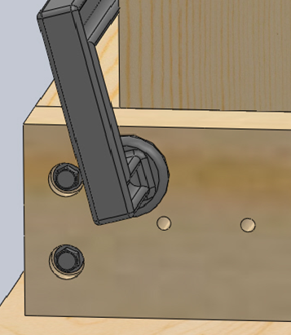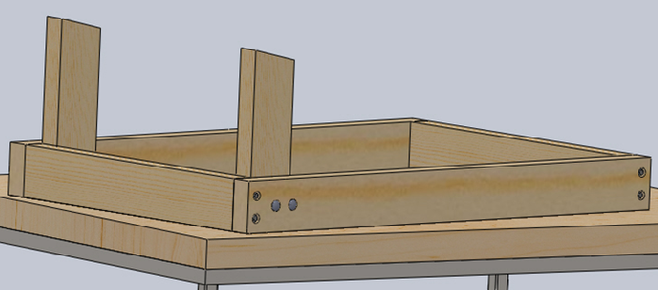

13

STEM Academy: General Fabrication Methods Large Project Assembly Methods

**Step 9:** Attach the top piece 36” x 24” plywood with **Wood Glue** and **8 Penny Nails**, using a

**Hammer**, **2 Bar Clamps**, **Tape Measure**, and **Marker**.

**A.** Mark out nail holes as shown in **Drawing 5: Nail Locations** (page 9). All nails are

3/4” from the edges. They start 2” from each side and are all 8” apart.

**B.** Follow the directions on the **Wood Glue** bottle to apply glue to frame. Apply a bead

of glue to the entire top of the wood frame and smear with your finger to cover the top of the frame with glue. Only enough glue should be applied to smear and cover the top of the frame. Wash the glue off your fingers right away.

**C.** Place the plywood top on the frame with the hole on the same side as the legs and clamp in place with two **Bar Clamps**.

**D.** Using a **Hammer**, pound all of the 8 **Penny Nails** into the correct locations until the

heads of the nails are flush with the top of the plywood.

Note: Pressure is needed to activate the glue. The nails help clamp the plywood to the frame while the glue activates and bonds the two pieces together. With the combined strength of the nails and the glue, it should prevent the plywood from coming off.



Figure 6: Final assembly

14

STEM Academy: General Fabrication Methods Large Project Assembly Methods

**Step 10:** Repeat Steps 1-9 over to complete two assemblies. Rules for playing the game can be found at [http://www.playcornhole.org/rules.shtml.](http://www.playcornhole.org/rules.shtml)

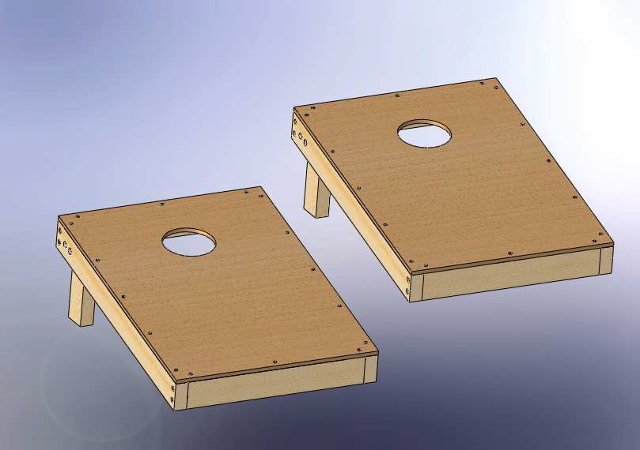

Figure 7: Two final assemblies

15