STEM Academy: General Fabrication Methods Sweat Soldering

**Sweat Soldering**

**Equipment**

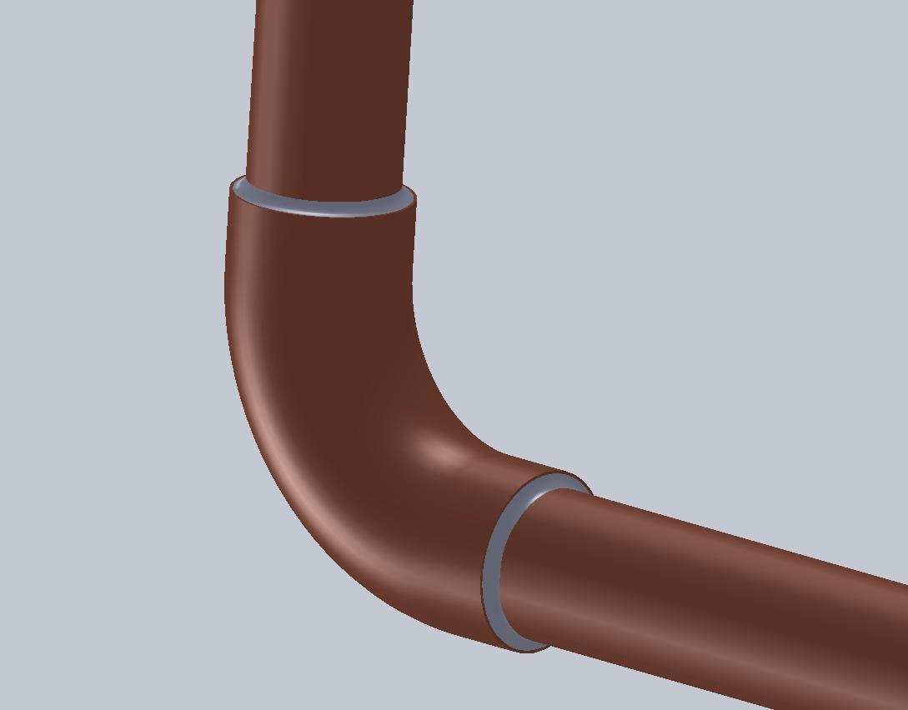

A. 1" Brass Craft Pipe

Cutter

B. 12" Bar Clamp C. Tape Measure D. Propane torch

nozzle

E. Propane canister

14 oz

F. Propane sparker

G. Safety glasses

**Materials**

A. 1/2" Copper Pipe

B. Emery Cloth

C. Flux

D. Plumbing Solder

E. 1/2" 90º Copper

Elbows

F. Flux Brush

1

STEM Academy: General Fabrication Methods Sweat Soldering

Drawing 1: Complete Dimensions

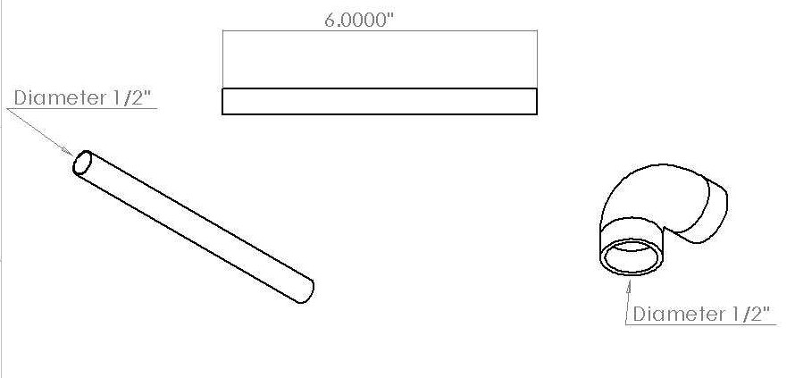

2

STEM Academy: General Fabrication Methods Sweat Soldering

**Step 1:** Lay out and cut four six-inch sections of 1/2” copper pipe using the **Tape measure**,

**Marker**, **Pipe Cutter,** and the dimensions found in **Drawing 1** (page 3).

**A.** Make a mark with a **Marker** six inches away from the edge of the pipe. Using the

**Pipe Cutter,** cut the pipe at the mark. While spinning the pipe cutter around the pipe

to make the cut, be sure the pipe is held stationary. If need be, lightly clamp the pipe to the table.

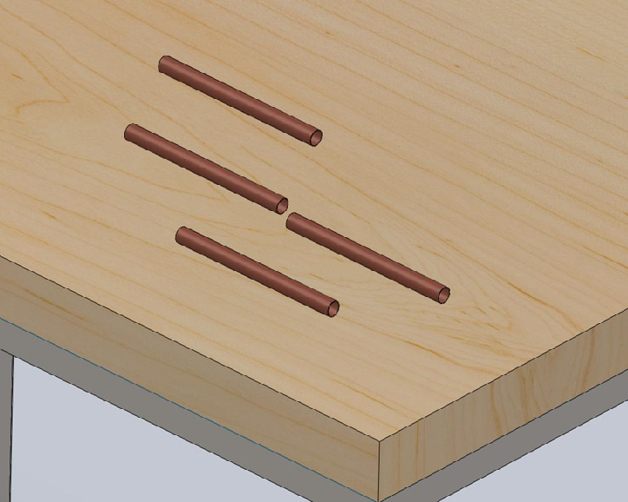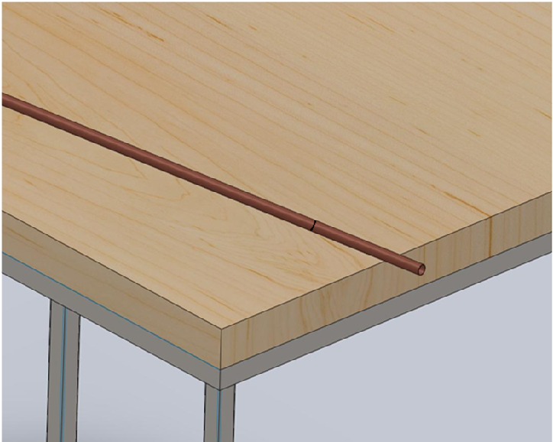

Figure1: Mark and cut the sections using a marker and pipe cutter.

**Step 2:** Debur each end of the pipe with a file.

Note: Deburing takes the sharp edges off the ends of the pipe. This makes the ends smooth which allows a better fit into the 90º fittings



**Step 3:** Using the **Emery Cloth,** rub each of the outside ends of the pipe and the insides of each

90º fitting.

Note: Emery cloth is a cloth that has emery glued into it that acts as an abrassive. Rubbing the copper with an emery cloth removes the impurities that have accumulated on the pipe and inside the fittings. If the pipe is soldered



without removing the impurities, the joint will not hold together.

3

**Step 4:** Assemble the four six-inch pipes and four **90º Copper Elbows** into a square as shown in

Figure 2.

Note: Make sure all fittings are snug together and in one plane. To get the pieces all in the same plane, simply put them on the work bench and press down on all the pieces until they all touch the table at the same time. After this



is done, make sure they are all still snug.

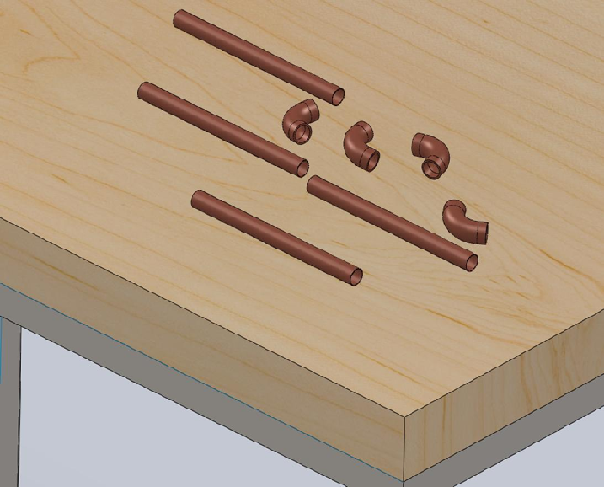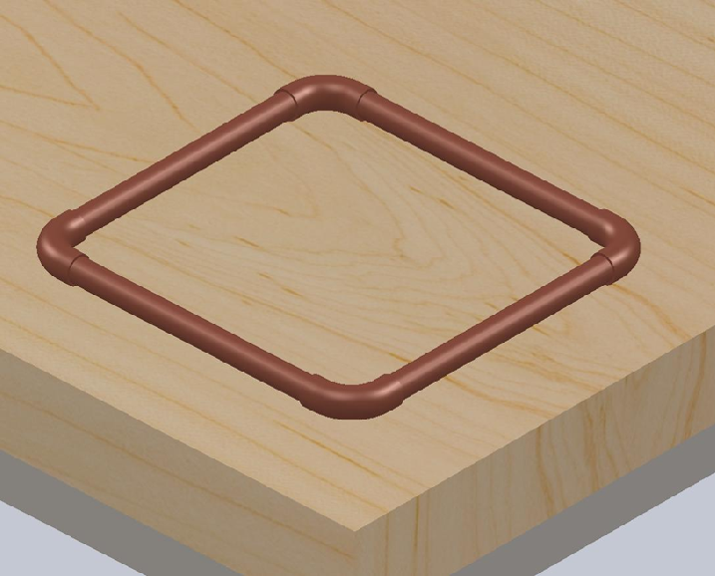

Figure 2: Assemble all the pieces- Make sure they are all in the same plane and snug.

**Step 5:** Clamp the square down using the **Bar Clamp** to table in the vertical position for soldering the first joint.

**A.** The joint that is to be soldered should always be in the position as shown in Figure 3.

This will allow gravity help the solder seep down into the joint.

**B.** Make sure the joint is far enough from the table that you will not burn the table with the propane torch during soldering.

Note: Make sure the parts stay in the same plane and do not come loose as you are setting it up for soldering.



**Step 6:** Apply flux to the joint to be soldered with the **Flux Brush**.

Note: Apply flux sparingly, apply enough to cover the entire joint without globbing. Flux is used to remove any remaining oxides from the metal and



makes the solder and metal easier to dissolve into each other.

Figure 3: Setting up for soldering- The joint to be soldered should be in the position as shown in the figure.

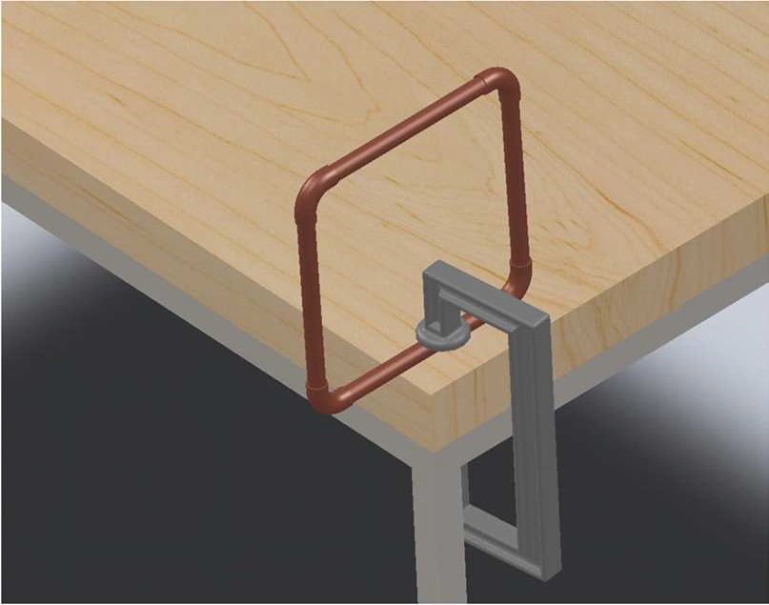

**Step 7:** Solder the joint using the **Propane Torch** and **Plumbing Solder**.

**A.** Put on **Safety Glasses**

**B.** Read through and completely understand the remaining procedure before lighting the torch. Refer to Figure 4 for lighting the torch and to Figure 5 for soldering the joint.

**C.** Make sure all you have the pipe fluxed and everything ready to go before starting the propane torch. When lighting the torch, point it away from yourself and any objects near you. To light the propane torch, first slowly turn the black gas knob counter clockwise until you hear a slight hiss. Then hold the **Propane Sparker** near the end of the torch and strike it by sqeezing the hadle until the flame starts. Once the flame is going adjust the knob until the flame is a blue cone.

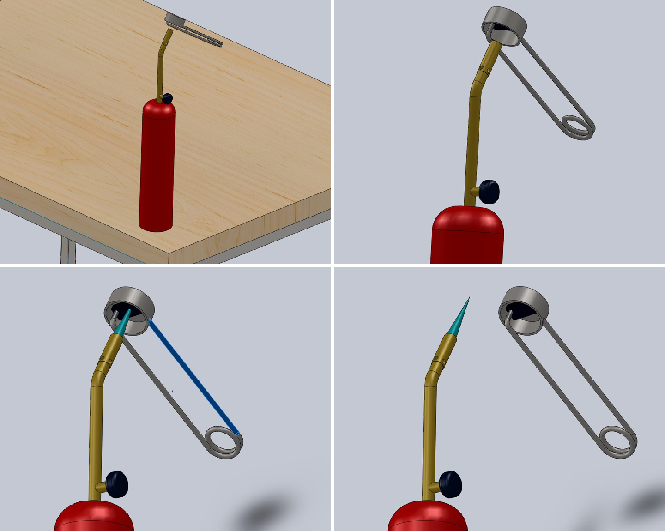

|  |  |
| --- | --- |
| 1 | 2 |
| 3 | 4 |

Figure 4: Properly lighting the propane torch- (1) Make sure the torch is pointed away from everything and everybody. (2) After turning on the gas, hold the striker just above the flame nozzle. (3) Light the flame by squeezing the handle of the striker to cause sparks. (4) As soon as the flame starts, remove the striker and be watchful of where the flame is directed.

**D.** To ensure the joint is soldered properly, first heat the metal joint with the propane torch. Do not heat the solder and drip it onto the joint. If the solder is melted with the propane torch, the solder will not bond with the copper. Once it has cooled it will pop apart.

**E.** Once is the metal is heated, move the flame around the joint, following it with the solder. Touch the solder to the metal, allowing the hot pipe to melt the solder and

letting it seep into the joint. Once the solder is all around the joint, it is done being soldered.

**SAFETY WARNING:** The pipe will be very hot! Wait until it is cooled before touching it!



**F.** Repeat steps A-C for all of the joints. Reclamp the pipes before soldering so that the joint to be soldered is in the same position as in Figure 5(1)

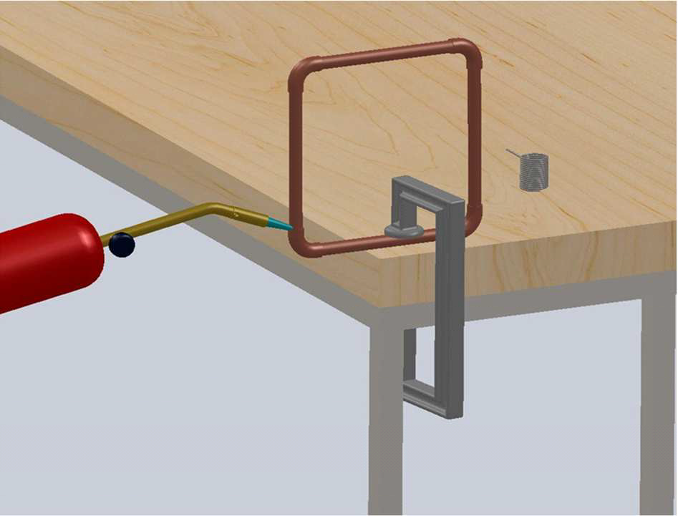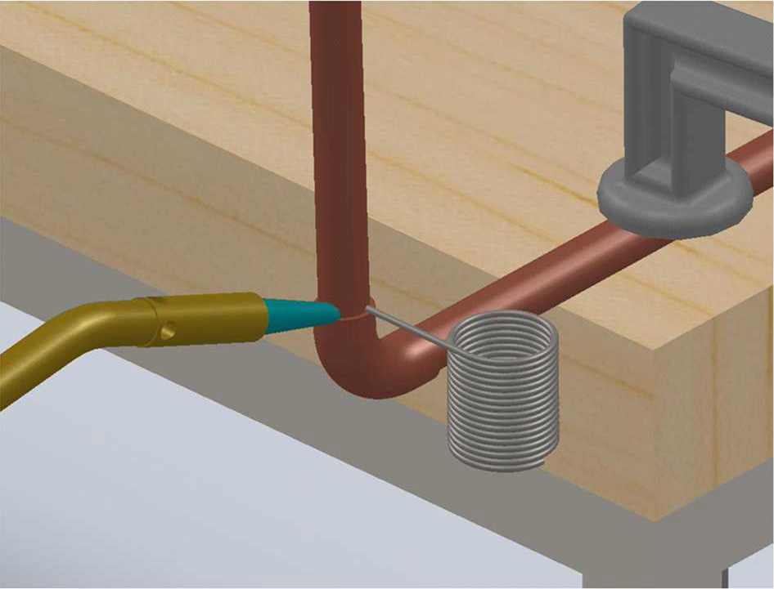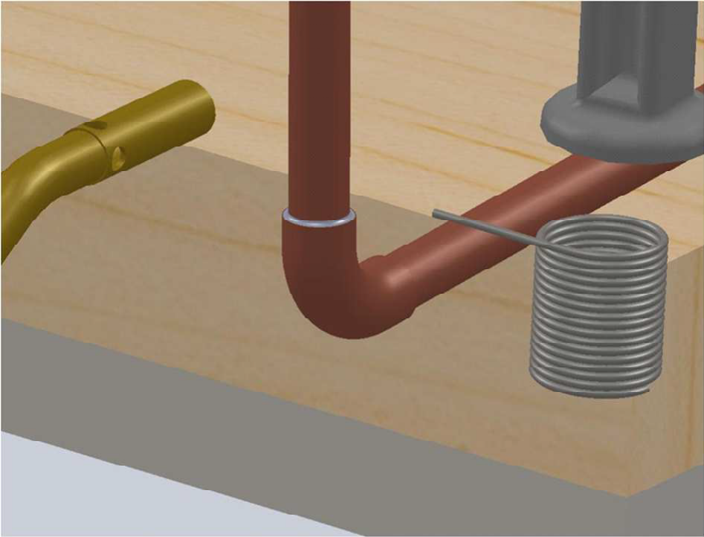

Figure 5: Properly lighting the propane torch- (1) Heat the joint with the propane tank before applying the flux. (2) After the pipe has been heated, continue to heat the pipe and apply solder to the joint. Make sure the metal, not the flame, is melting the solder. Apply the solder around the joint. (3) The joint

should be completely filled with solder with no holes.

STEM Academy: General Fabrication Methods Sweat Soldering

Figure 6: Final Square with all joints soldered.

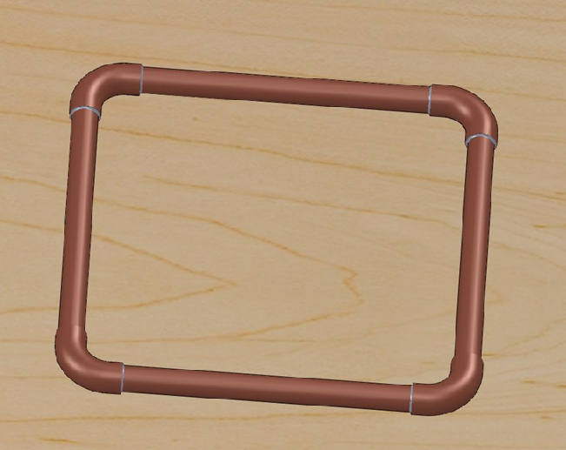

8

STEM Academy: General Fabrication Methods Sweat Soldering

**Step 8:** Test the seal of the soldered joints with water.

Note: A properly soldered joint should be completely sealed with no holes or leaks. To test the seal of your joints, you will place the square under water for an extended period of time to test whether water will seep into the tubes.



**A.** Fill a bucket or container that is big enough to fit your soldered square with enough water to submerge the square.

**B.** Place a weighted object on the square so it stays submerged and does not float to the

top. Leave the square submerged until the next class.

**C.** During the next class, remove the weight. If the square floats, your joints are sealed properly. If it does not float, water has seeped into the square through some imperfection in the soldering job.

**D.** Allow your instructor to take note if the square floats or sinks.

9