STEM Academy: General Fabrication Methods Sheet Metal Bending

**Sheet Steel Tray**

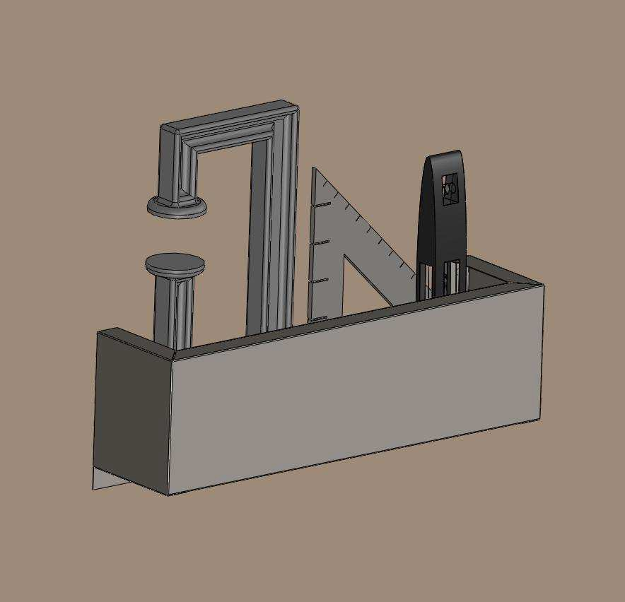

**Equipment**

A. Aviation Snips/Tin Snips

B. Power drill

C. Center punch

D. Rivet gun

E. 12" Bar Clamps (2)

F. 1/4"X1 1/4"x24" Steel Bending Bar

G. 3/16" Drill Bit H. Straight Edge I. Hammer

J. Scrap Block

**Materials**

A. 26 Gauge Sheet Steel

B. 3/16" Rivets

1

STEM Academy: GeneralFabrication Methods Sheet MetalBending

**Drawing 1: Complete Dimensions**

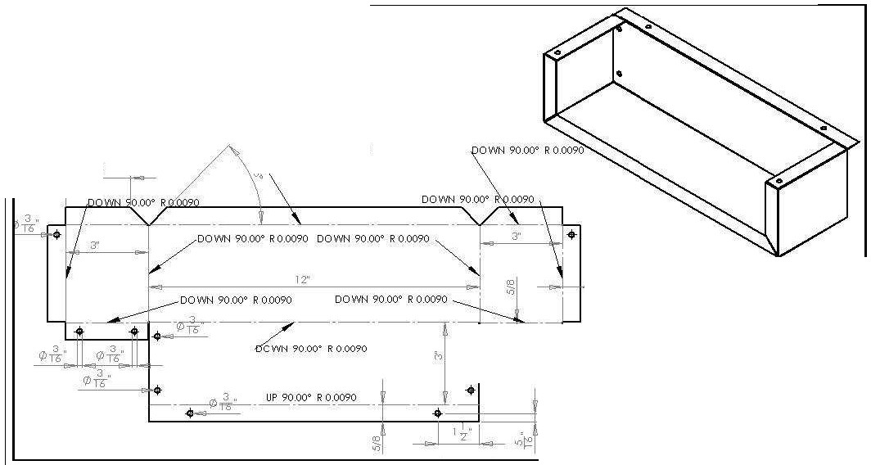

2.60

f>OWN 90.00° R 0.0090

\

.. . ..

5/8

2

STEM Academy: General Fabrication Methods Sheet Metal Bending

Drawing 2: Bend Dimensions

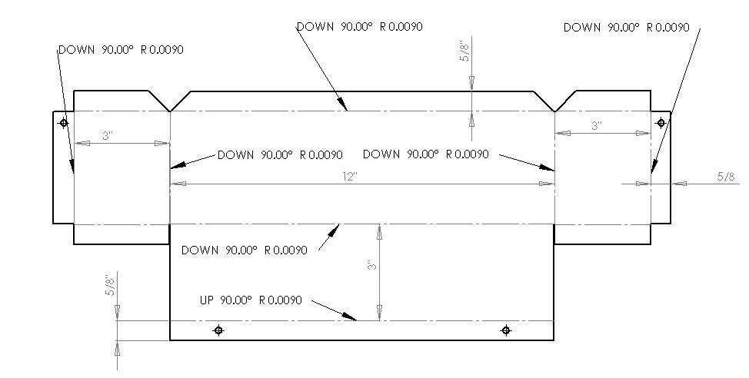

3

STEM Academy: General Fabrication Methods Sheet Metal Bending

**Drawing 3: Cut Dimensions**

19 1 /4"

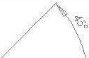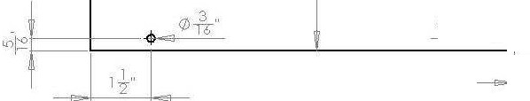

t --

12"

3"

4

STEM Academy: General Fabrication Methods Sheet Metal Bending

**Step 1:** Lay out work piece using the **Straight Edge**, **Marker**, and the dimensions found in

**Drawing 3: Cut Dimensions** (page 5).

**A.** Draw all of the edges of the piece and mark hole centers on 26 gauge sheet steel.

Note: The drawing is symetrical, therefore any missing dimensions can be found elsewhere on the drawing. Faint dashed lines are for dimension reference only.



**Step 2:** Create dents using **Center Punch** and **Hammer** where holes will be drilled in the work piece for attachment to wall. See Figure 1.

**A.** Position the tip of the **Center Punch** at the center of the hole location drawn on the work piece in Step 1A.

**B.** Tap the top of the **Center Punch** with the **Hammer** until a small dent appears in the work piece.

Note: When starting to drill a hold in metal and other hard materials, the drill bit tends to bend and wander away from the desired position. To prevent this



from happening, a small dent is made at the center of the desired hole location.

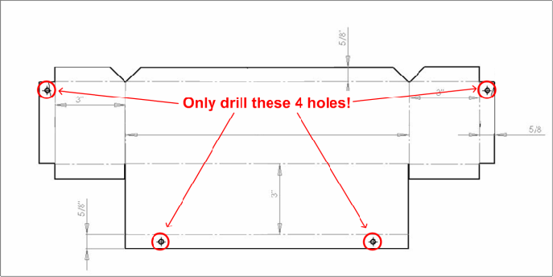

Figure 1: Step 2 holes- Only mark and drill holes in the four holes shown in

Drawing 3.

**Step 3:** Drill holes in work piece using the **Power Drill** and the **3/16” Drill Bit**.

Note: Remember to put scrap wood or other material below the sheet metal so you do not drill into the table. The scrap also acts as a backing to prevent the



sheet metal from bending from the pressure created while drilling.

5

STEM Academy: General Fabrication Methods Sheet Metal Bending

**Step 4:** Cut the piece out of the sheet steel using an **Aviation Snips**.

Note: Faint dashed lines are for dimension reference only and should not be cut. Examples of faint and dark lines can be found in Figure 2.

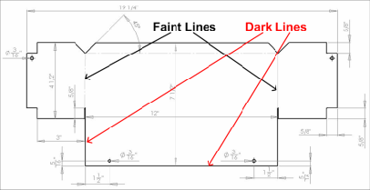

Figure 2: Examples of faint and dark lines Figure 3: Cut out piece with holes drilled and bend lines as shown

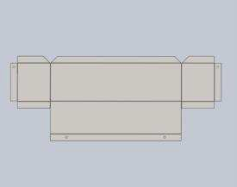

**Step 5:** Draw all of the bend lines onto the work piece using the dimensions from **Drawing 2: Bend Dimensions** (page 4).

Note: Make sure the lines are in the correct location, failure to do so will result in incorrect shelf shape. When you are done the piece should look like Figure 3.



**Step 6:** Position, clamp down, and bend work piece on bend line drawn for Bend #1 during Step 5.

**A.** Place work piece onto the work table and align the bend line drawn in the previous step with edge of the table as shown in Figure 4.

**B.** Place the **Bending Bar** as shown in Figure 4, aligning the edge of the bar with the

bend line.

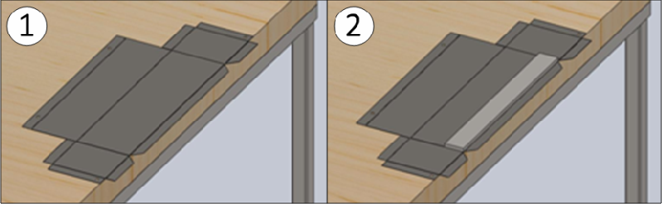

Figure 4: Setting up for Bend #1- (1) Align the bend line with the edge of the table. (2) Align the Bending Bar with the bend line and the edge of the table.

**C.** Clamp the **Bending Bar** in place using two **12” Bar Clamps** as shown in Figure 5.

6

STEM Academy: General Fabrication Methods Sheet Metal Bending

Note: When placing the clamps, make sure to leave a gap between the the clamp and the edge of the bending bar. The clamp should not be hanging over the edge of the bending bar where the bend is to be made as shown in Figure 5 (1).



**D.** Bend the flange up as shown in Figure 5(2). Use your hands to gently bend up the entire flange at one time. If it is too hard to bend by hand, use a second bending bar to

hold underneath and against the flange and use your hands to bend the flange upwards.

Figure 5: Bend #1- (1) Clamp Bending Bar down using Bar Clamps. (2) Bend flange up along 12” Bending Bar. (3) Finished work piece after Bend #1 is completed.

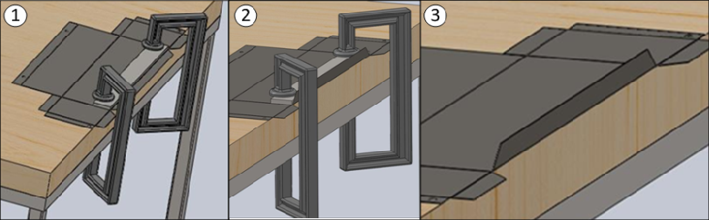

Note: Bends #1 - #11 should be done sequentially as shown in Figure 6.



Figure 6: Bend Order- All flanges should be bent in the numerical order shown in the diagram above.

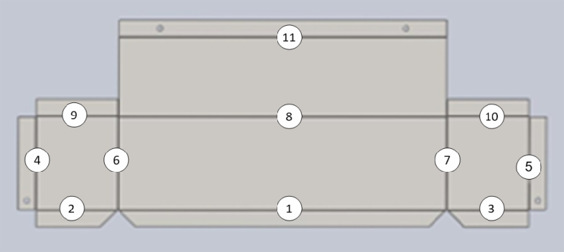

7

STEM Academy: General Fabrication Methods Sheet Metal Bending

**Step 7:** Repeat the procedure given in Step 6 to position, clamp, and bend the work piece on Bend

Lines #2 - #7 using the **Bending Bar** and **12” Bar Clamps**.

Note: Bends #1 - #7 are able to be made with the bend line and the **Bending Bar** lining up with the edge of the table. The same basic clamping and bending procedure provided in Step 6 can be used for all of these bends, but special care needs to be taken to ensure quality of each individual bend.



**A.** Bend #2

Figure 7: Bend #2- (1) Position and clamp Bending Bar down using 12” Bar Clamps. (2) Bend flange up along Bending Bar.

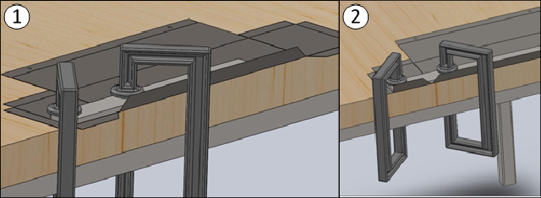

**B.** Bend #3 – Bend #5 should be completed as shown in Figure 8.

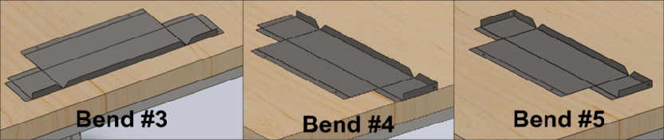

Figure 8: Bend #3 – Bend #5- Finished work piece after Bend #3, #4, and #5.

**C.** Bend #6- Clamp positioning is critical for this bend. Make sure that clamps will not get in the way of the edges being folded up. If positioned incorrectly, Clamp 2 will hit

the fold shown in Figure 9 and will prevent the side from bending to the full 90°.

8

STEM Academy: General Fabrication Methods Sheet Metal Bending

Figure 9: Bend #6- When clamping the Bending Bar down make sure to position the clamps to ensure that the work piece will not make contact with the clamp in the circled areas in the figure above.

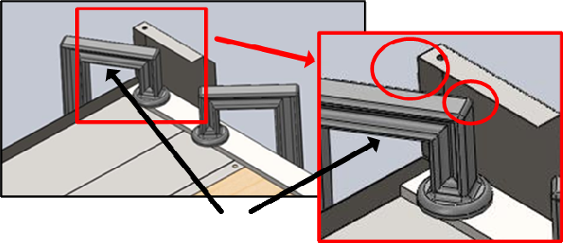

**D.** Bend #7- Repeat the procedure given in the previous step along with the provided cautions and safety considerations. The work piece should look like Figure 10 when

Bend #7 is completed.

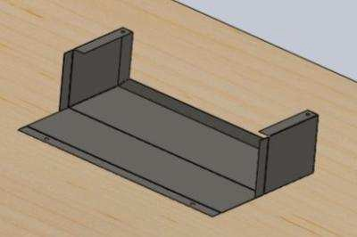

Figure 10: Bend #7- Finished work piece after completing Bends #1 through #7.

9

STEM Academy: General Fabrication Methods Sheet Metal Bending

**Step 8:** Bend #8- A modified procedure will be used for Bend #8 because the bend line cannot be aligned with the edge of the table. A different procedure will be used to complete Bends

#8 - #10 because the bend line cannot be aligned with the edge of the table.

Note: This method may not be necessary depending on the throat depth of the clamp you are using. Nonetheless, it is good practice for projects you may encounter in the future. A picture demonstrating a clamp’s throat depth can be found in Figure 11.

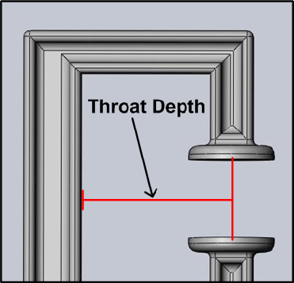

Figure 11: Throat Depth- Each different size and style of clamp has a different throat depth. The throat depth is the distance from the pads of the clamp to the back of the clamp.

**A.** Position two **12” Bending Bars** as shown in Figure 12(1) along Bend Line #8 as well as along Bend Line #1.

**B.** Position two **Scrap Blocks** evenly spaced along the **Bending Bars** as shown in Figure

12(2).

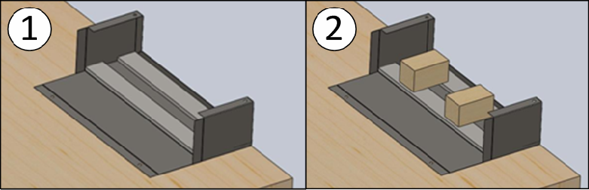

Figure 12: Bend #8- Bending Bar and Scrap Block Positioning- (1) Position one Bending Bar along Bend Line #8 and position the second Bending Bar along Bend Line #1. (2) Position the two Scrap Blocks evenly spaced along the Bending Bars.

10

STEM Academy: General Fabrication Methods Sheet Metal Bending

Note: Two blocks of wood are used in this example, but any rigid material will do.



**C.** Clamp the two **Bending Bars** and the two **Scrap Blocks** in place using using two **12” Bar Clamps** as shown in Figure 13.

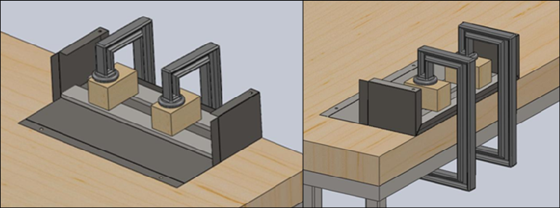

Figure 13: Bend #8- 12” Clamp Positioning- Clamp the Bending Bars and Scrap

Blocks in place.

Note: Make sure the **12” Clamps** are pushed into the table as far as they can go. This will apply pressure to the far edge of the Bending Bar where the bend is being made.



**D.** Bend the flange up as shown in Figure 14 until it is perpendicular with the work table.

Figure 14: Bend #8- Bend flange up- (1) Bend the flange up until it is perpendicular with the work table. (2) Finished work piece still clamped down after completing Bend #8. (3) Finished work piece after being unclamped from work table.

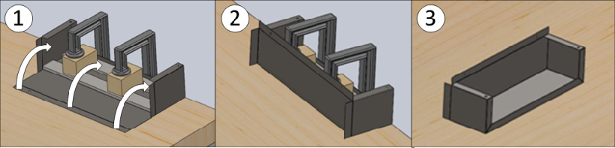

11

STEM Academy: General Fabrication Methods Sheet Metal Bending

**Step 9:** Bend down the flanges along Bend Line #9 and Bend Line #10 using the **Locking Sheet**

**Metal Tool** and your hands.

**A.** Position the edge of the **Locking Sheet Metal Tool** directly on the edge of the bend line.

**B.** Close and lock the **Locking Sheet Metal Tool**.

**C.** Gently bend the flange down as far as the **Locking Sheet Metal Tool** will allow.

Note: As the flange is bent downwards the **Locking Sheet Metal Tool** will come into contact with the work piece before the flange is bent into the proper position.



**D.** Unlock and remove the **Locking Sheet Metal Tool** from the work piece.

**E.** Bend the flange the rest of the way by hand.

**F.** Repeat Step 7A through Step 7E for Bend #10.

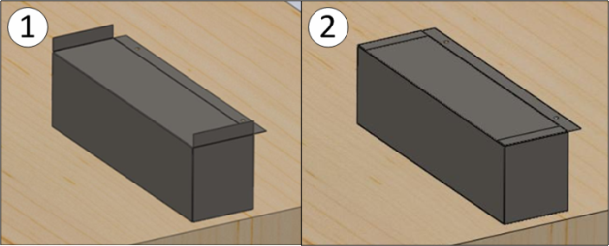

Figure 15: Bend #9 and #10- (1) Work piece before Bends #9 and #10. (2) Finished work piece after Bend #9 and Bend #10 have been completed.

12

STEM Academy: General Fabrication Methods Sheet Metal Bending

**Step 10:** Bend #11- The same procedure will be used for Bend #11 as was used for Bends #1 - #7.

**A.** Position the **Bending Bar** and Bend Line #11 to align with the edge of the work table.

**B.** Clamp down the **Bending Bar** using the **12” Clamps**. The work piece should look like Figure 16(1) after completing this step.

**C.** Bend the flange down 90° as shown in Figure 16(2).

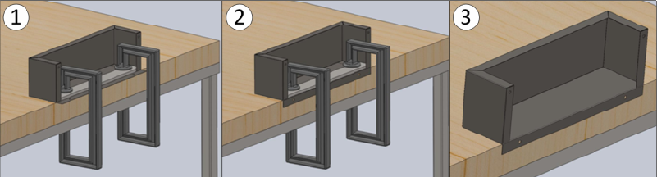

Figure 16: Bend #9 and #10- (1) Align and clamp down the Bending Bar along the edge of the work table. (2) Bend the flange down 90 degrees. (3) Work piece after completing Bend #11.

13

STEM Academy: General Fabrication Methods Sheet Metal Bending

**Step 11:** Rivet flanges created by Bends #9 and #10 in Step 7 to add strength to the tray.

**A.** Mark the correct location of center of the holes to drill using the **Straight Edge**,

**Marker**, and the dimensions found in **Drawing 1** (page 3).

Note: Make sure to draw the centers for the holes on both flanges.



**B.** Position the tip of the **Center Punch** at the center of the hole locations drawn on the work piece.

**C.** Tap the top of the **Center Punch** with the **Hammer** until a small dent appears in the work piece.

**D.** Drill holes on center marks using a **3/16” Drill Bit** and a **Power Drill**.

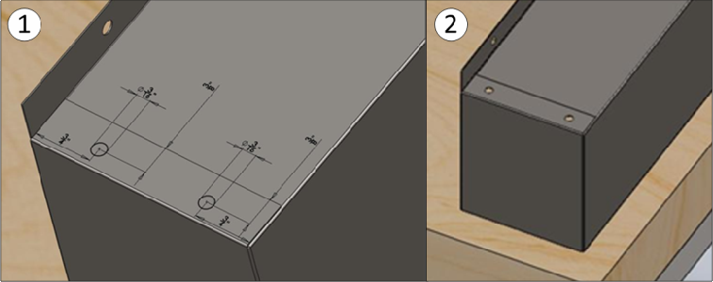

Figure 17: Drilling Holes for Rivets- (1) Mark centers for holes. (2) Drill holes through both pieces of the work piece.

**E.** Install 3/16” rivets using the **Rivet Gun** in all four holes drilled in the previous step.

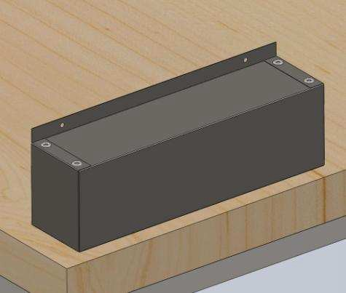

Figure 18: Installing Rivets- Place rivets in all four holes drilled in Step 8D.

14

STEM Academy: General Fabrication Methods Sheet Metal Bending

**Step 12: Optional**: if paint is available, paint tray the desired color.

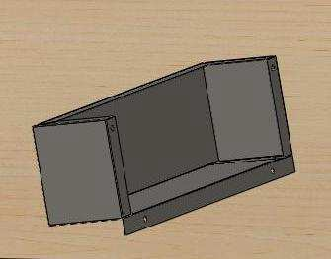

Figure 19: Finished Tray- This is what the tray should look like when fabricated correctly.

15