STEM Academy: General Fabrication Methods Floating Steel Cube

**Floating Steel Cube**

**Equipment**

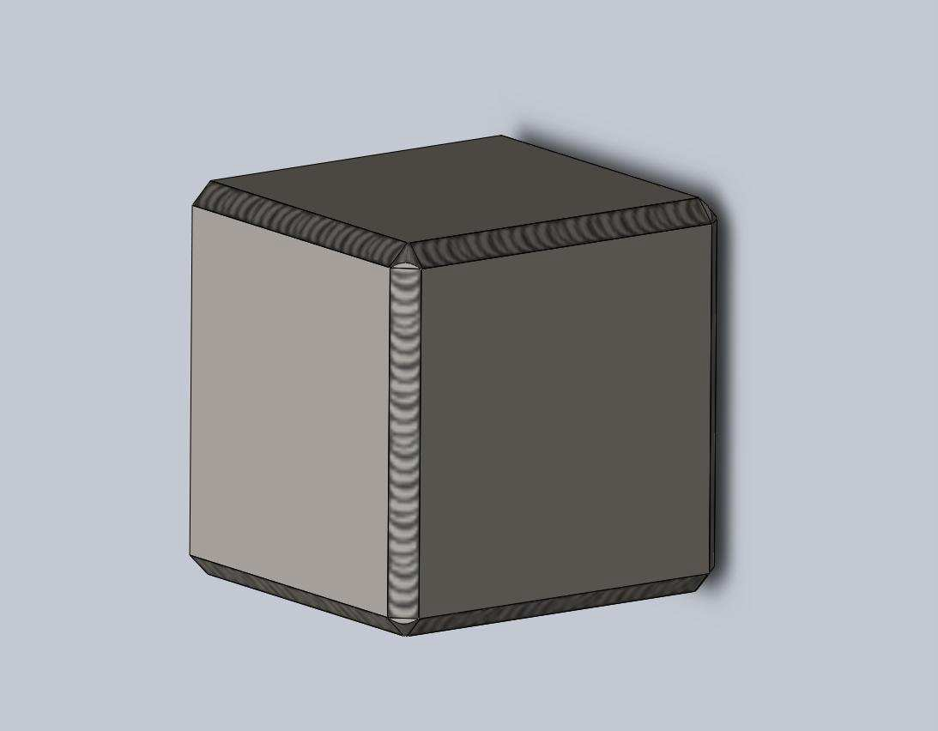

A. FCAW Lincoln 125 HD Welder

B. Welding Helmet C. Welding Gloves D. Chop Saw

E. Wire Brush

F. Slag Hammer

G. Welding Magnet

H. Combination Square

I. Safety Glasses

J. Hammer

K. Bench Vice L. Long Pants M. Long Sleeves

N. MSA Adjustable Face Shield

**Materials**

A. 1/8” x 2” x 3’ Steel Plate

1

STEM Academy: General Fabrication Methods Floating Steel Cube

Drawing 1: Steel Coupon Dimensions

2

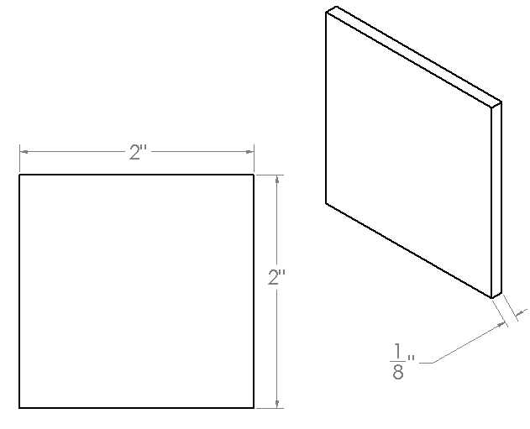

STEM Academy: General Fabrication Methods Floating Steel Cube

**Drawing 2: Welded Cube**

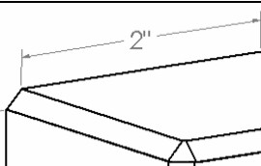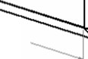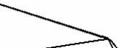

2"

l::2'

3

STEM Academy: General Fabrication Methods Floating Steel Cube

**Step 1:** Lay out work piece using the **Combination Square**, **Marker**, and the dimensions found in **Drawing 1: Steel Coupon Dimensions** (page 3).

**A.** Mark off a 2” steel coupon from the steel plate using a **Combination Square**, and a

**Marker**.

Note: This step will be repeated many times. Six 2” sections are needed for the cube, one for each side. The rest of the sections will be used for practice welding before welding on the final project. Due to the width of the saw blade, if all lines are marked at once, the first cut will throw off all of the remaining marks by the width of the blade. In the next step you will cut the 2” coupon



and then repeat the process for all coupons.

**Step 2:** Cut the 2” steel coupon using the **Chop Saw**.

**A.** Place the steel plate on the **Chop Saw** table so the 2” mark is close to the blade. Place a shim that is the same height as the chop saw table underneath the end of the board farthest away from the saw as shown in Figure 1.

Note: Putting a shim under this side of the board will allow the saw to make a



90º cut through the steel.

**B.** Next position the steel plate so the 2” section is to the right of the saw blade. Then position the line drawn in Step 1 directly to the right of the blade as shown in Figure

2(2). If the line is positioned directly under the blade, the 2” steel coupon will be half a blade’s width short of 2”. Clamp the steel plate snug against the back of the **Chop Saw**. This can be done with the clamp on the saw.

**C.** With all objects away from the blade and safety glasses on, turn on the saw and slowly lower the blade into the steel.

**D.** Repeat Step 1 and Step 2 until the 3” plate is all in 2” sections.

4

STEM Academy: General Fabrication Methods Floating Steel Cube

Figure 1: Shim up the steel plate- (1) Without a shim, the plate will not lay flat on the table. (2) The shim holds the plate flat on the table which makes it easier to line up the mark with the blade.

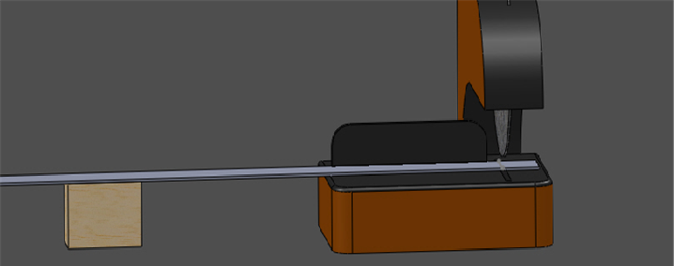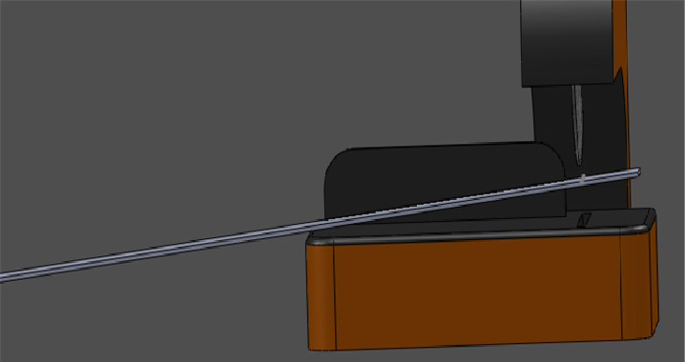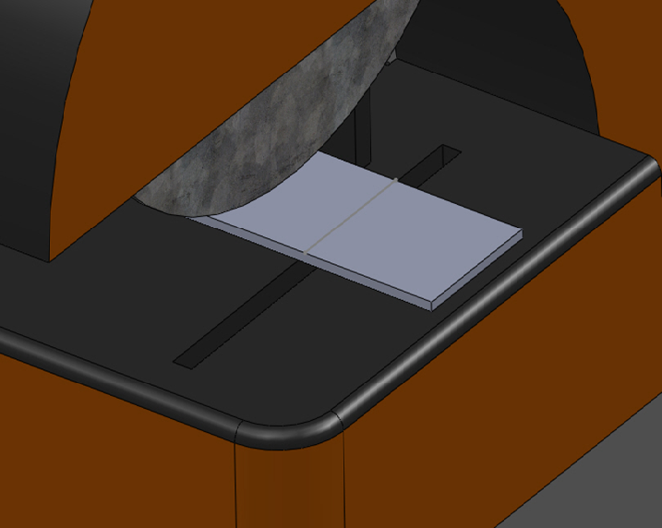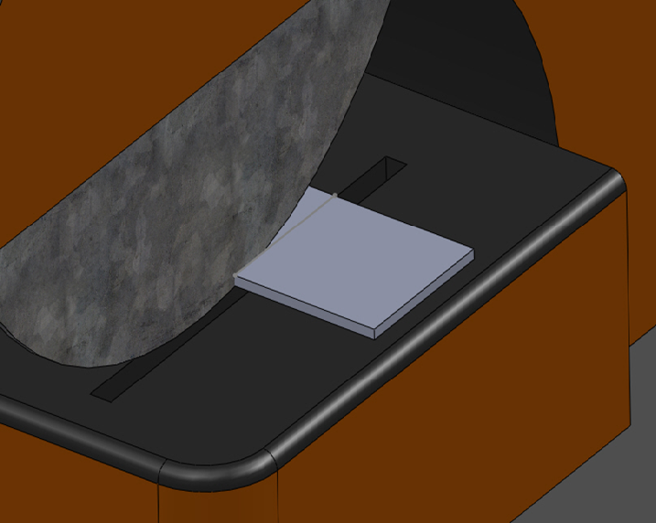

Figure 2: Shim up the steel plate- (1) Line up the line with the right side of the blade. Lower the blade to the piece to make sure it is lined up correctly (2) Slowly cut through the steel plate.

5

STEM Academy: General Fabrication Methods Floating Steel Cube

**Step 3:** Remove all burs from the steel coupons usng a **Bench Grinder** as shown in Figure 4.

Note: After the chop saw cuts through the steel coupons, it will leave a small bur at the end of each cut as shown in Figure 3. To ensure the six coupons fit together nicely, all burs must be removed.



**A.** Make sure all objects are away from both grinding wheels of the **Table Grinder**.

Wearing safety glasses, turn on the grinder.

**B.** When grinding any part, always look through the shield attached to the grinder, even if safety glasses are worn. Place steel coupon onto grinder table as shown in Figure 4.

**C.** Slowly touch the burred edge up to the abrasive grinding wheel and move the piece

left and right until all the bur is gone.

**D.** Remove any burrs on all pieces.

Figure 3: Bur from the chop saw

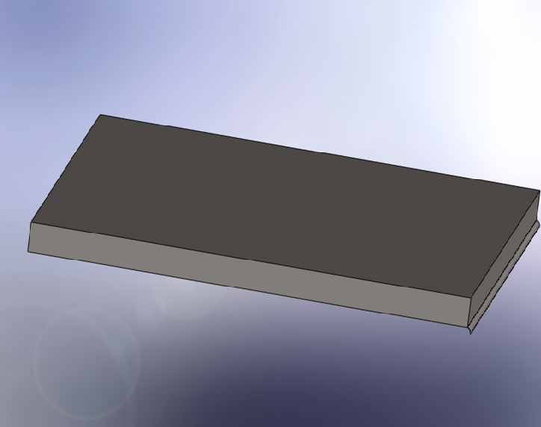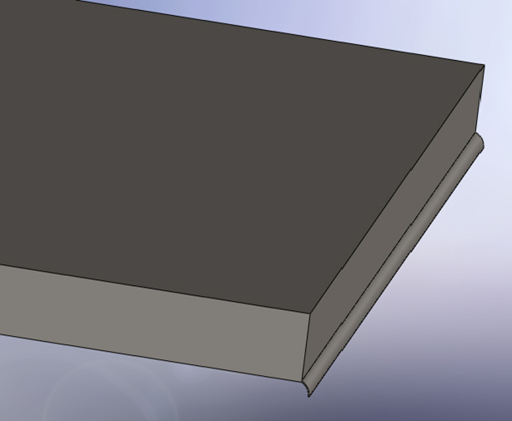

6

Figure 4: Grinding off burs- (1-2) Place the coupon on the grinder table. (3) Gently move the coupon across the abrasive wheel to remove the bur. (4) Always look through the grinder shield when using the grinder.

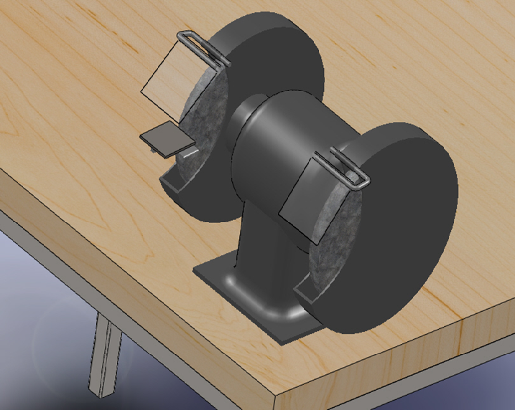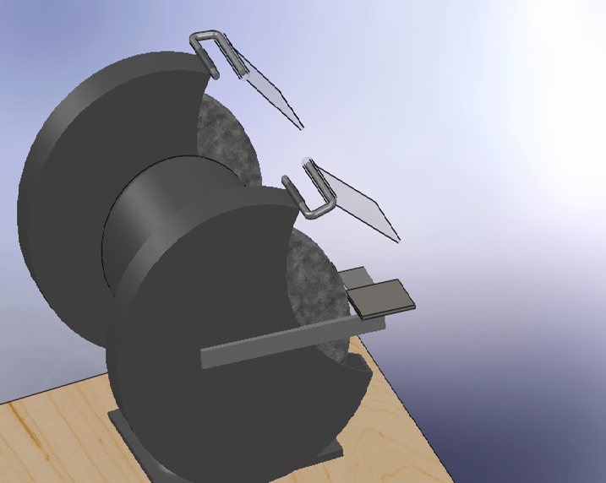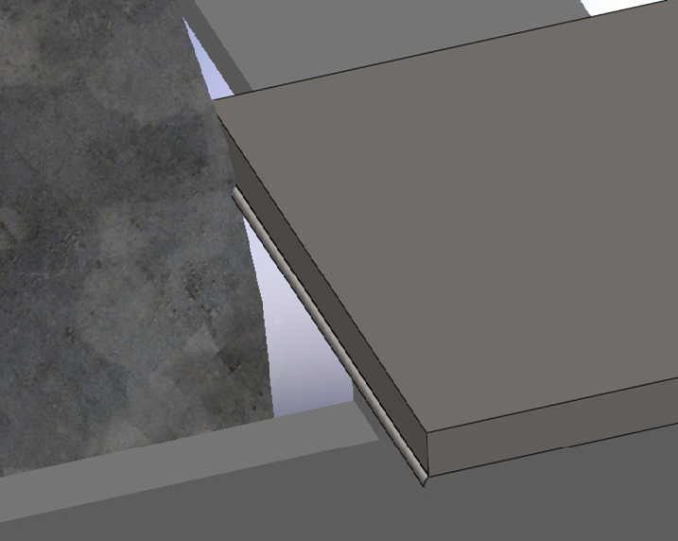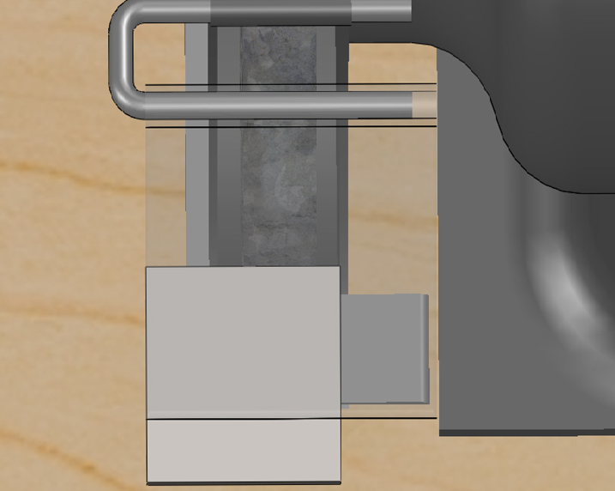

**Step 4:** Practice welding tacks and beads on all but seven of the coupons.

**SAFETY WARNING:** Never weld without a welding helmet on. Do not look at the light the welder produces without a welding helmet. This light can cause retina burns and cause blindness. Before welding, make sure all surrounding people are not looking towards the welding area. Never weld without all skin being covered. Welding light can cause severe skin burns. Never pick up



welded material with your bare hands or gloves. Newly welded material is very hot and should be handled with pliers.

**A.** Refer to your instructor or the operation manual of the welder for correct settings of the welder with the metal you are welding with.

**Step 5:** Position two of the six steel coupons for tacking at a right angle to each other as shown in

Figure 5 using a **Welding Magnet**.

Note: Tacking pieces together means to join them with a small amount of metal or weld at several points along the seam where a weld is to be put. Tacking holds the pieces in place as it is welded together. Due to the tremendous amount of heat the metal aquires while being welded, it will



expand and distort if it not tacked together.

Figure 5: Setting up for the first tacks

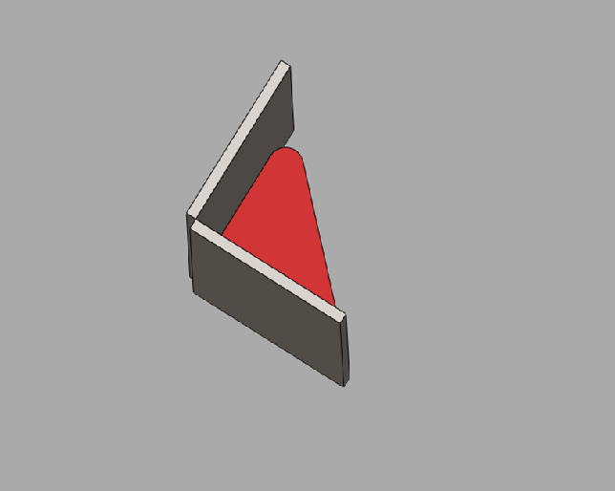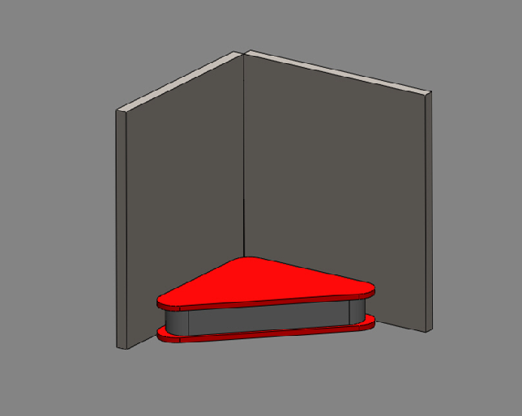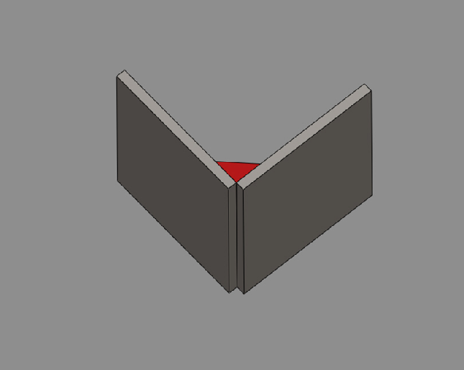

**Step 6:** This step should involve setting up the welder to the correct settings.

**Step 7:** Tack together the two pieces using a **Welder**, **Welding Helmet**, and **Welding Gloves**.

**B.** Connect the ground to the coupons as shown in Figure 6(1).

**C.** Wearing **Safety Glasses**, a **Welding Helmet**, **Welding Gloves**, **Long pants**, and

**Long Sleeves** tack the two pieces together as shown in Figure 6(1-5), placing one tack about 1/4"from the top of the two coupons and one tack the same distance from the bottom.

Note: To tack the two pieces together, place the welding as shown in Figure



6(1-3) with the tip of the gun about 1/4" to 1/2" away from the steel coupons. Then, gently pull the trigger and let it place a small bead on the two pieces of metal for about two to three seconds.

**SAFETY WARNING:** Never weld without a welding helmet on. Do not look at the light the welder produces without a welding helmet. This light can cause retina burns and cause blindness. Before welding make sure all surrounding people are not looking towards the welding area. Never weld without all skin being covered. Welding light can cause severe skin burns. Never pick up



welded material with your bare hands or gloves. Newly welded material is very

hot and should be handled with pliers.

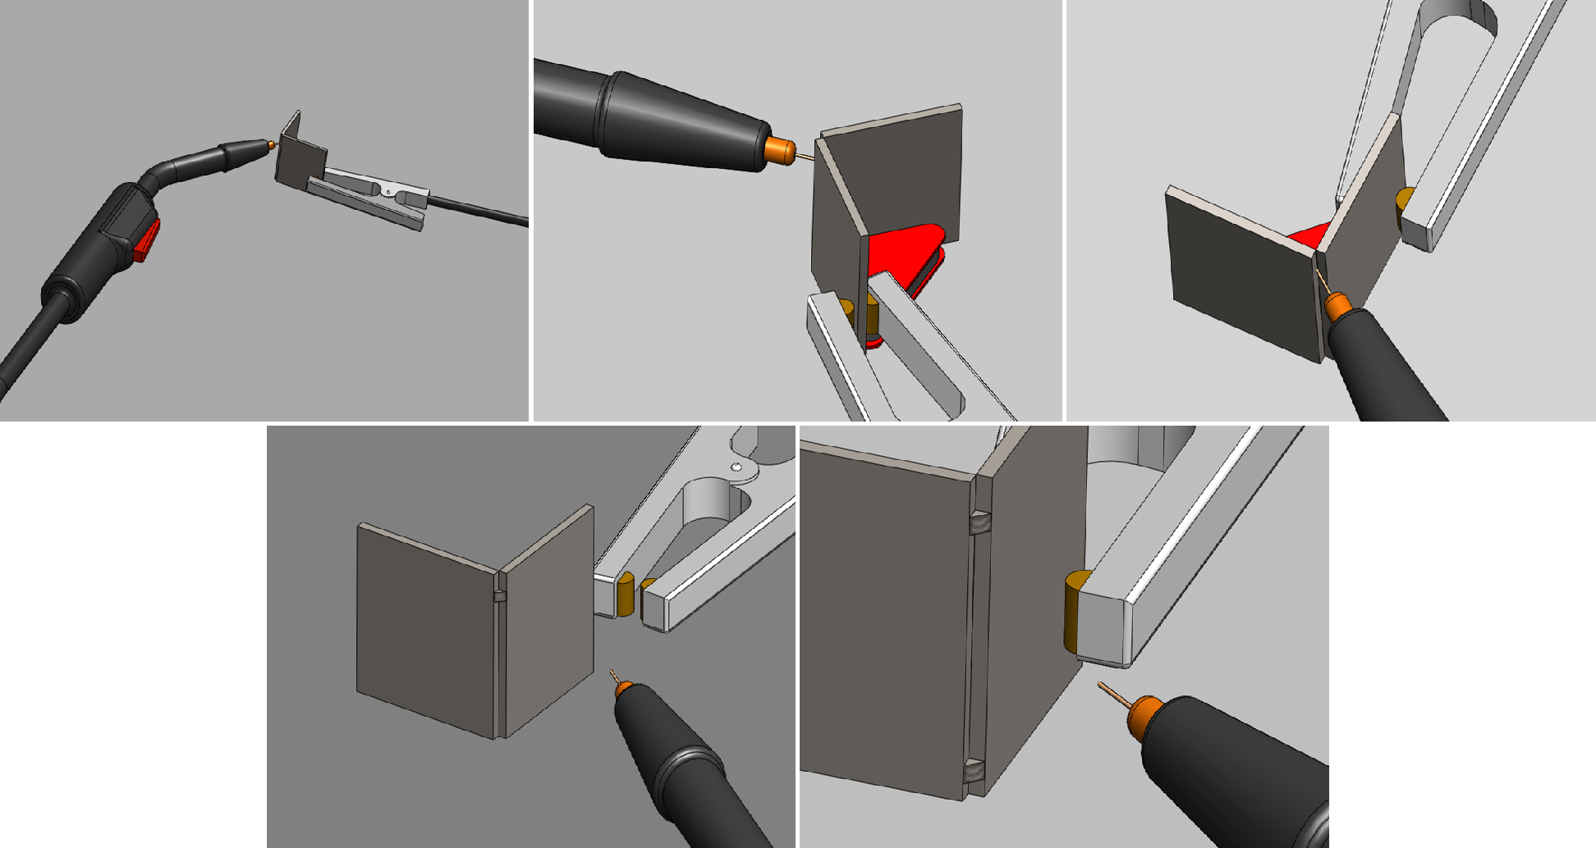

|  |  |  |  |  |  |
| --- | --- | --- | --- | --- | --- |
|  | |  | |  | |
|  |  | |  | |  |

Figure 6: Grinding off burs- (1) Clamp the ground onto the two coupons making sure it does not mess up their placement. (2-3) Start the tack about 1/4” from the top. (4) The top tack is finished. (5) Both tacks are now complete.

**Step 8:** Make sure the two coupons are tacked perpendicular to each other using a **Bench Vice**,

**Hammer**, and a **Combination Square**.

**A.** Place the tacked coupons into the **Bench Vice** as shown in Figure 7. Use the **Hammer** to gently tap the unclamped coupon in the direction needed to make the two coupons perpendicular together. Check position with a **Combination Square**.

Note: Do not pound the coupons too hard or the tacks will break.



**B.** If the coupons are not tacked together correctly and cannot be pound into the correct position. Use the set up shown in Figure 7 and break the tacks by pounding the coupons until they break.

**C.** Remove broken tacks by grinding them off using the bench grinder.

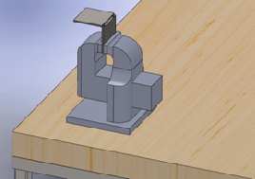

Figure 7: Clamp the piece into the vice

**Step 9:** Tack two more steel coupons together using the methods outlined in Step 5 and Step 8.

**Step 10:** Position the two L’s made in Step 5 and Step 8 together as shown in Figure 8 and tack them together.

Figure 8: Grinding off burs- (1) Position the two L’s together to make a box. (2) Have the magnet on the inside of the box.

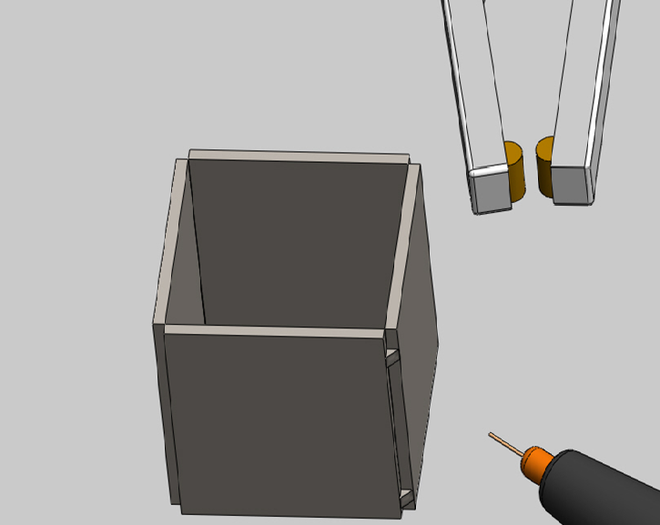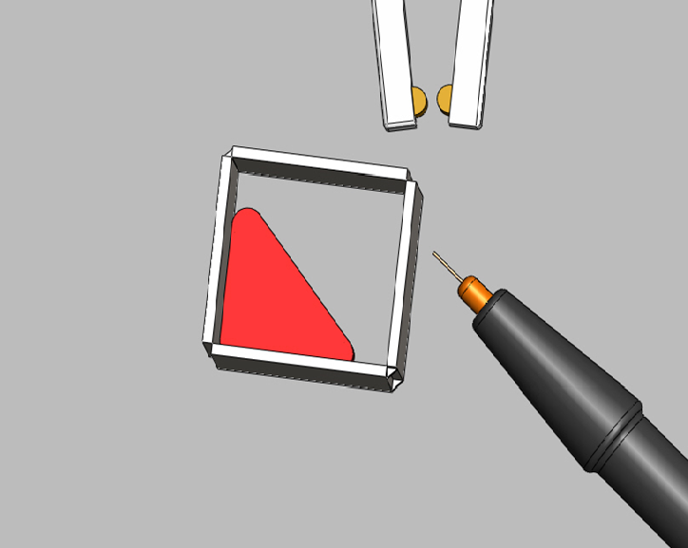

STEM Academy: General Fabrication Methods Floating Steel Cube

**Step 11:** Tack a coupon to the top and bottom of the piece as shown in Figure 9 completing the tacked cube.

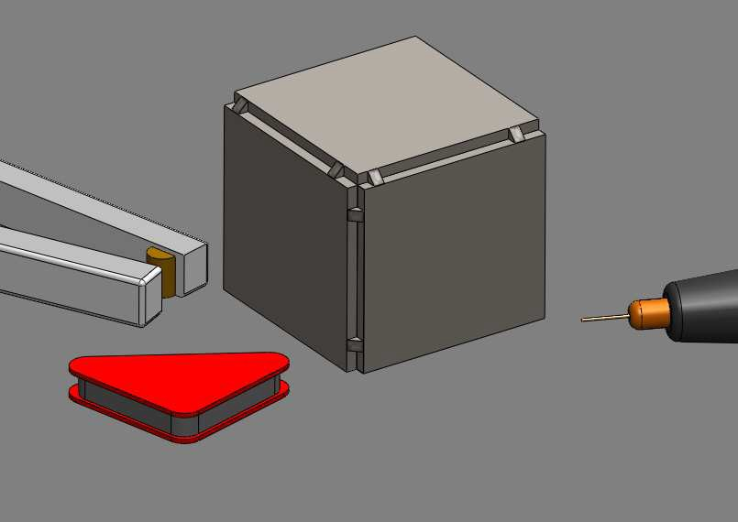

Figure 9: Complete the cube by tacking the top and bottom pieces on

**Step 12:** Prepare for welding by cleaning all the slag off the tacks using a **Slag Hammer** and a

**Wire Brush**.

Note: Slag is a protective coating covering the tacks. It comes from a thin coating on the electrode. The thin coating melts around the weld preventing oxygen from reaching the hot metal, which stops impurities from entering the weld.



A. Use the **Slag Hammer** to pound off all of the slag that is covering the welds as shown in Figure 10.

B. Brush the tacks clean using a **Wire Brush** to brush all remaining slag residue off the

tacks.

11

STEM Academy: General Fabrication Methods Floating Steel Cube

Figure 10: Remove all slag with a slag hammer

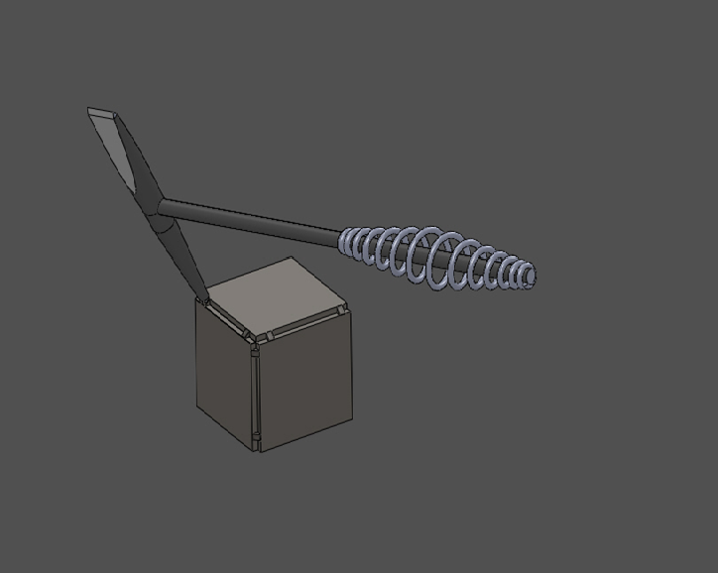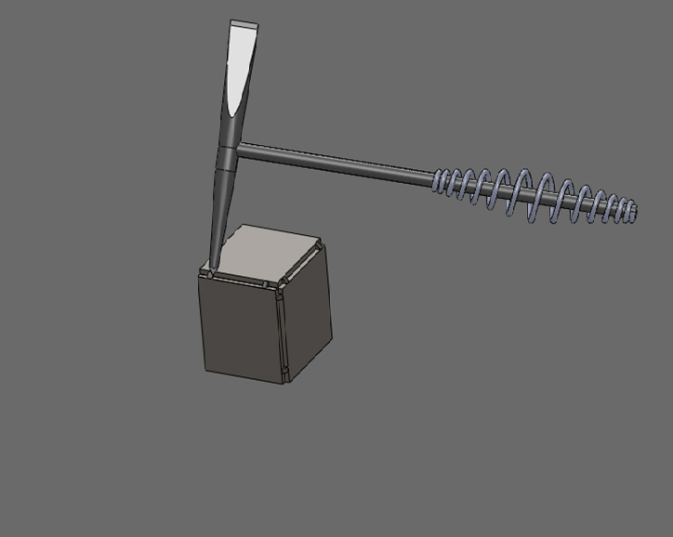

12

**Step 13:** Once all tacks are cleared of slag, weld all 12 joints together.

Note: To lay a bead of weld, hold the welding gun tip about 1/4" to 1/2" away from the corner of the steel cube. Position the gun so that it is at a 15° angle from the normal of the surface of the weld as shown in Figure 11. With safety glasses, welding helmet, welding gloves on, and ground clamp connected, you



are ready to weld.

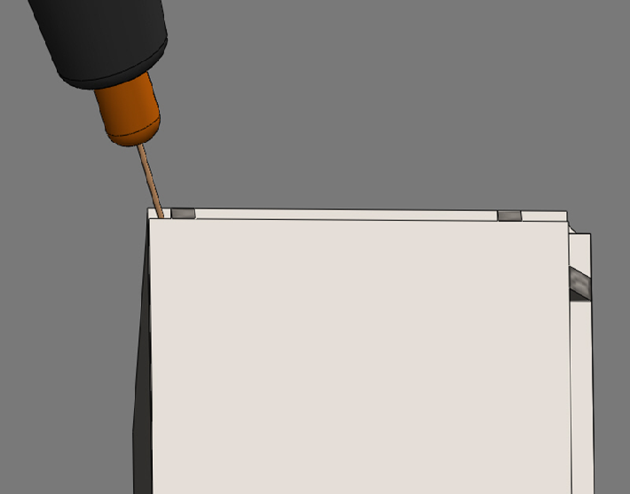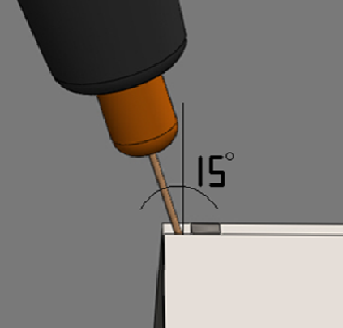

Figure 11: Proper gun angle for welding

A. Position the cube as shown in Figure 12(1) for the first weld.

Note: The cube is positioned this way to make welding easier. It is easiest to weld when the weld bead is level.



B. Weld the first weld. To do this, keep the gun at the correct distance from the weld and at the correct angle during the entire weld. Pull the trigger and slowly move

the gun forward across the joint as shown in Figure 12(2-3). Be sure to weld all the way through the tack to the end of the 2” coupon. Once you hit the edge, let go of the trigger and the weld is complete.

C. Always remove all slag before moving to the next weld

D. Weld all remaining joints.

|  |  |
| --- | --- |
| 1 | 2 |
| 3 | 4 |

Figure 12: Grinding off burs- (1) Position the two L’s together to make a box. (2) Have the magnet on the inside of the box.

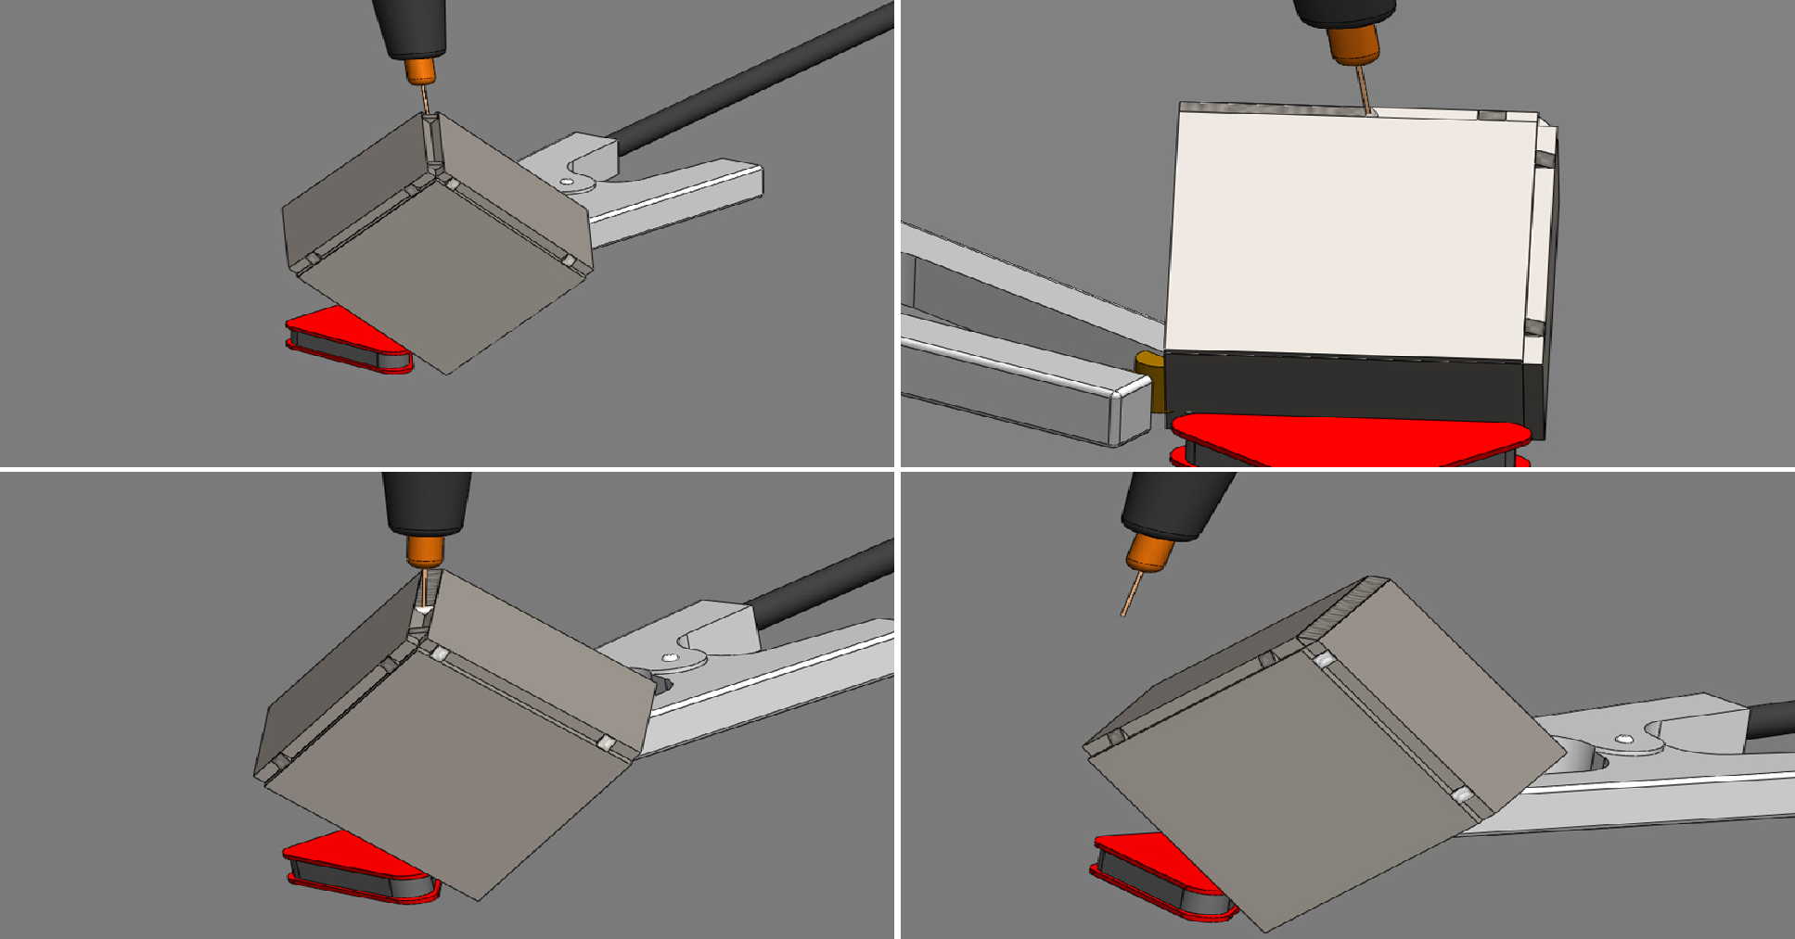

**Step 14:** After all joints are welded and slag is removed, clean up any weld spatter and weld globs using a **Bench Vice**, **MSA adjustable face shield**, and an **Angle Grinder** . Be sure to let the cube cool down before touching or setting on burnable surfaces.

**A.** Clamp the steel cube into the **Bench Vice** as shown in Figure 13.

**B.** Put on the **MSA Adjustable Face Shield**

**C.** Use the **Angle Grinder** to clean up any weld spatter and weld globs.

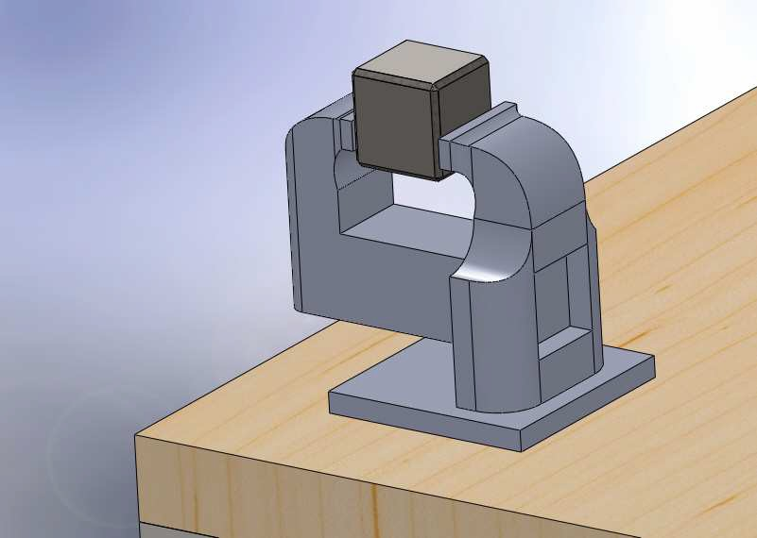

Figure 13: Clamp the piece into the



Figure 14: Final cube

**Step 15:** To test for any pin holes in welds, submerge cube in water and weigh it down below the surface. If it floats after an day, there are no pin holes. If it does not float, there are pin holes. Report results to your instructor.