Wall section

UNIT: architecture and CONSTRUCTION LEVEL 3

The Problem:

This project is intended to learn the basics of a residential wall section. STEM 101 recommends following the videos to complete the different activities within this kit.

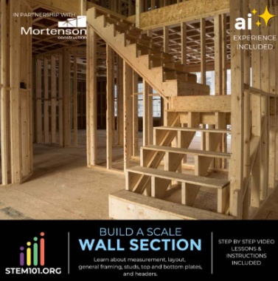

# CONSTRAINTS AND CRITERIA

1. Actively build a scale wood structures building
2. Follow video directions carefully

# MATERIALS:

* Wall Section kit from Stem 101

# TOOLS:

* Chromebook or computer

# DIRECTIONS:

* This link will take you to the video series that takes you through a typical wall section of a residential building