How Does it Stack Up

UNIT: design ProceSS – Engineering Challenge



The Problem:

Explore and practice the steps of the Design Process while you discover a variety

of techniques to build a plastic cup pyramid without directly touching any of the cups.

**CONSTRAINTS AND CRITERIA**

1. Collaborate to stack plastic cups into a pyramid structure.
2. Brainstorm and test a variety of solutions using the provided

materials.

1. Team members may not touch the cups during the challenge.
2. Each team member must participate in moving cups.
3. Be safe and appropriate with your materials. You may not alter them by breaking, cutting, poking holes, etc. You can tie the string if you wish.
4. You do not need to use all of the items you are given.
5. Additional constraints and criteria may be added in

new rounds of the challenge.

**MATERIALS**: (per 2 person team)

* 3 Plastic cups
* 1 Chopstick per team member
* 1 Rubber band
* 1 Piece of string per team member – approximately 18 inches
* OPTIONAL - Other items of teacher’s choosing

**TOOLS:**

* Pencil

# DIRECTIONS:

# Engineering Challenge Round 1:

# Your teacher will set a timer for 5 minutes. When the time begins, work with your partner and materials to move and stack the 3 cups into a pyramid structure (two on the bottom layer, one on the top layer). Remember, you may not touch the cups with your hands.

# If you are successful, start over and try again doing something different. If there are materials you haven’t used, see if you can find a way to use them in a new technique.

# Once time is up, talk with your partner about how you feel the challenge went. Then respond to the prompts below.

# Round 1 Reflection:

# Was your team successful in stacking the pyramid?

# What worked well for you or your team during this round?

# What challenged you and your team during this round?

# Engineering Challenge Round 2:

# Repeat the challenge. The goal remains the same. Move and stack the 3 cups into a pyramid structure without directly touching any of the cups.

# ADDED CONSTRAINT – Each team member may only use one hand. The only time you may use both hands is if you wish to tie a knot in the string.

# Instead of setting a timer this round, you will break the challenge down into steps and follow a Design Process.

# Look over the Design Process flow chart on page 4. Then follow each of the listed steps.

Be sure to check off each step ☑ as you progress.

* **Step#1** – Define the Problem

Listen to your teacher reread the problem from the first page. *Rewrite it in your own words in the Step 1 box on the Design Process chart on the next page.*

* **Step#2** – Define the Criteria

Listen to your teacher reread the challenge **constraints** and **criteria**, including the new one requiring you to only use one hand. These are your limitations and requirements for the challenge. *Summarize the key words for each and list in the Step 2 box on the Design Process chart.*

* **Step#3** – Develop Ideas

As a team **Brainstorm** different ways you might be able to use the materials to move and stack the cups with one hand. These ideas could be things you tried in round 1 or new ideas. *List at least 2 ideas in the Step 3 box on the Design Process chart.*

* **Step #4** – Develop Solutions

**Make a plan**. Decide what each team member’s role will be. Remember all team members must participate in moving cups. Begin Round 2 of the challenge - **Create** your cup pyramid. Be sure you follow the **constraints** and **criteria.**

* **Step #5** – Testing and Evaluating

**Test** as many techniques as possible for moving and stacking cups. **Evaluate** by asking yourself what is working well and what is still challenging you. If an idea doesn’t work as planned, try a new one. Don’t completely give up on an idea, sometimes small changes make a big difference. If an idea works well, see if you can build upon that idea to make it better or more efficient.

* **Step #6** – Present and Produce

You’ll be **sharing** what you learned and **put those skills to action** in Round 3.

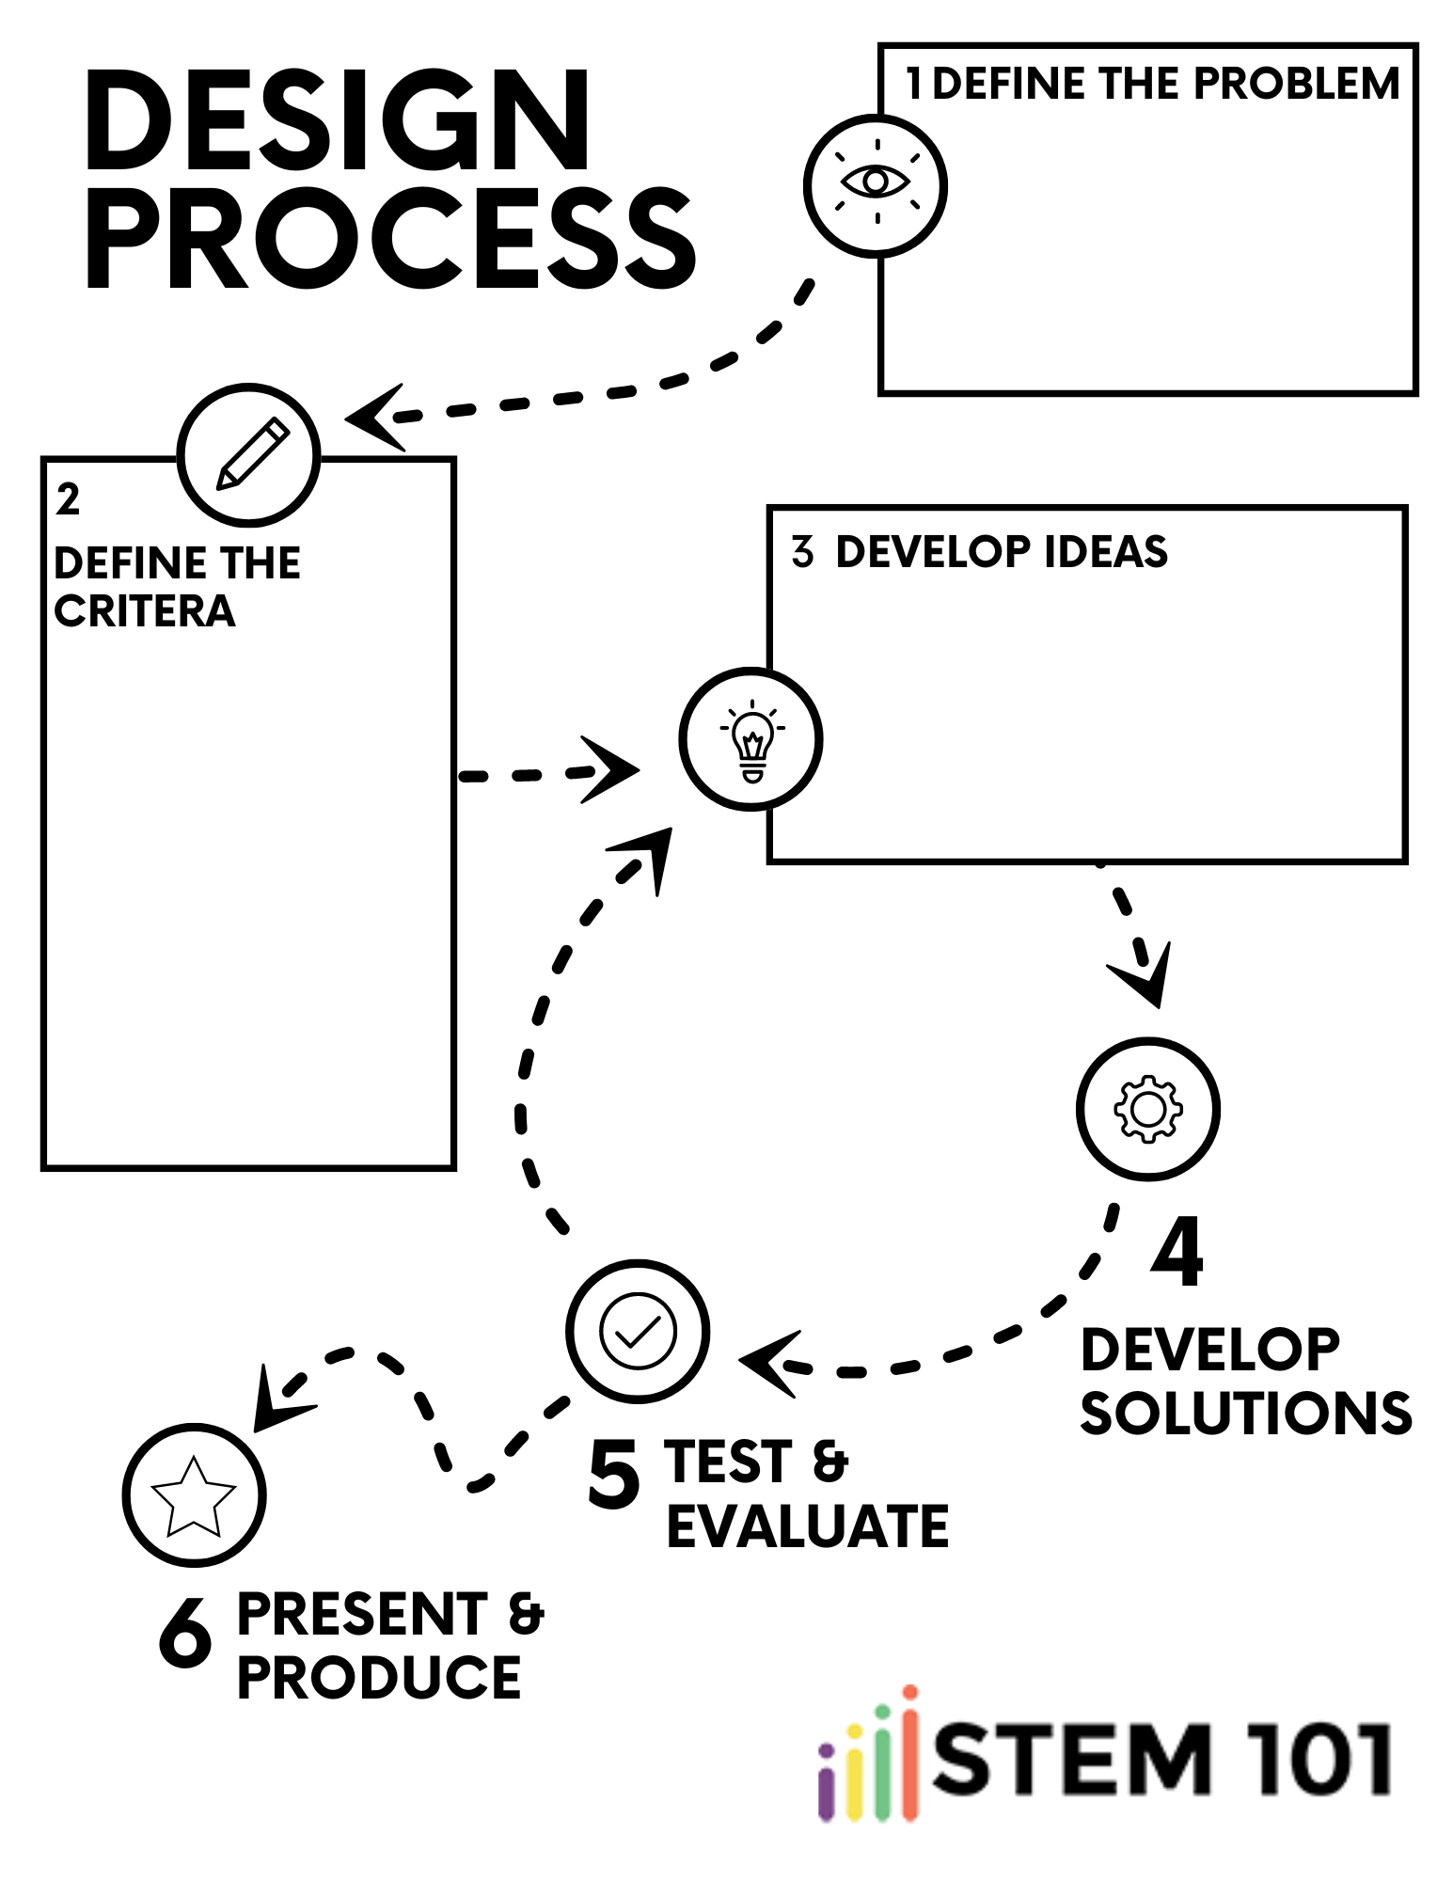

# Engineering Challenge Round 3:

# Repeat the challenge a third time. The goal remains the same. Move and stack the cups into a pyramid structure without directly touching any of the cups.

# Each team member still may only use one hand. The only time you may use both hands is if you wish to tie a knot in the string.

# For this final round you must join another team to create a team of 4. Instead of creating a pyramid of 3 cups, you must now create a 3 layer pyramid made of 6 cups (first layer 3 cups, middle layer 2 cups, top layer 1 cup)

# Use your Design Process chart to help your team break the challenge down into steps. During Step 3 – Develop Ideas, each team should share what worked well and what didn’t work well for them in Rounds 1 and 2.

# When your teacher says you may begin, Create your pyramid. Continue to follow the Design Process as you work. Test ideas and pause to evaluate by discussing what’s working well and what is still challenging the team.

# After you’ve completed Round 3, share your techniques with the class. Then answer the final reflection questions on the following page.

# FINAL REFLECTION QUESTIONS

# Which step of the Design Process do you feel is most important? Why?

# Which step of the Design Process challenges you most? Why?

# Describe a situation where you may have used the Design Process, a part of it, or a similar version outside of this class.

# Reflect on how your 2 person and 4 person teams worked together today.

# Describe a characteristic of your team today that was effective and led to your success.

# Describe a characteristic of your team today that challenged your success.

|  |  |  |  |  |
| --- | --- | --- | --- | --- |
|  | Indicator not demonstrated | Indicator  partially demonstrated | Indicator adequately demonstrated | Indicator effectively demonstrated |
| **Participation**  **& Effort**  **Round 1**  Points ___ /4 | **Incomplete**  Was unable or refused to participate  1 | **Inadequate**  Frequent reminders needed to stay on task; prevented team from completing task  2 | **Adequate**  Limited prompting needed; on task, appropriate effort  & behavior  3 | **Exceptional**  Independent & effective participation  4 |
| **Participation**  **& Effort**  **Round 2**  Points ___ /4 | **Incomplete**  Was unable or refused to participate  1 | **Inadequate**  Frequent reminders needed to stay on task; prevented team from completing task  2 | **Adequate**  Limited prompting needed; on task, appropriate effort  & behavior  3 | **Exceptional**  Independent & effective participation  4 |
| **Participation**  **& Effort**  **Round 3**  Points ___ /4 | **Incomplete**  Was unable or refused to participate  1 | **Inadequate**  Frequent reminders needed to stay on task; prevented team from completing task  2 | **Adequate**  Limited prompting needed; on task, appropriate effort  & behavior  3 | **Exceptional**  Independent & effective participation  4 |
| **Design Process**    Points ___ /4 | **Incomplete**  Did not complete or skipped steps in the process  1 | **Inadequate** Frequent  assistanceneeded in process  2 | **Adequate**  Limited or  no prompting needed  3 | **Exceptional**  Independent completion  4 |
| **Design Brief**  **Reflection Questions**  Points ___ /4 | **Incomplete**  Less  than 50%  complete  1 | **Inadequate**  Mostly complete; Criterion not met  2 | **Adequate**  Criterion met;  more attention  to neatness or  detail needed  3 | **Exceptional**  Meets or exceeds expectations; high effort & attention to detail  4 |