Electrical Circuits

UNIT: Electricity level 1

The Problem:

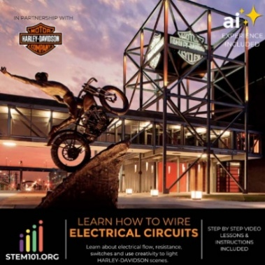This project is intended to learn the basics of electricity. STEM 101 recommends following the videos to complete the different circuits within this kit.

# CONSTRAINTS AND CRITERIA

1. Actively work through different circuits in the kits
2. Follow video directions carefully

# MATERIALS:

* Electrical Circuits kit from Stem 101

# TOOLS:

* Chromebook or computer

# DIRECTIONS:

* This link will take you to the video series that takes you through many different electrical circuits