Build a led flashlight

UNIT: electricity_level 2

The Problem:

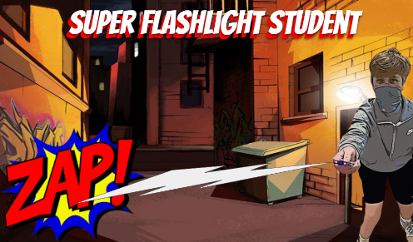Create a working flashlight using only cardboard, a LED, Aluminum foil tape, a 3-volt coin battery and clear tape.

# CONSTRAINTS AND CRITERIA

1. Design and develop a working LED flashlight using cardboard
2. Understand basic electricity to complete the project
3. Follow directions carefully in the design brief as well as the Electricity Level 2_Flashlight presentation
4. Submit working flashlight to instructor

# MATERIALS:

* 1/8” corrugated Cardboard (5” x 7”)
* Aluminum Foil tape
* White LED
* CR2032 Coin battery
* Clear Tape

# TOOLS:

* Ruler
* Pencil
* Cutting mat
* Hobby utility knife; box cutter; scissors

# DIRECTIONS:

The steps are below. It is suggested to follow the detailed step by step presentation to build your flashlight. Be sure to check off each step ☑ as you progress.

* **Step#1** – Cut out your cardboard pieces. Use the template for the pattern
* **Step#2** – Create the switch
* **Step#3** – Cut two 4.5” of foil tape
* **Step #4** – Connect the negative side of the circuit
* **Step #5** – Prepare battery compartment
* **Step #6** – Place foil tape on center piece. Label positive and negative
* **Step #7** – Make the switch
* **Step #8** – Add the LED. Pay attention to the long leg and short leg to make sure you place the LED correctly. Tape down with clear tape once you are certain the LED is correctly placed
* **Step #9** – Assemble the flashlight. Use the presentation and images to assist in assembly
* **Step #10** – Test it out! Press on the switch to see if the LED lights up
* **Step #11** – Make it permanent. Wrap the flashlight with clear tape.

**Reflection Questions**

What type of circuit did you create? Series or Parallel?

What went well during construction of the flashlight?

What part of your flashlight construction was challenging?

What did you do to overcome the challenge?