Building Electromagnets

UNIT: Acoustic and Electromagnetism_Level 1

The Problem:

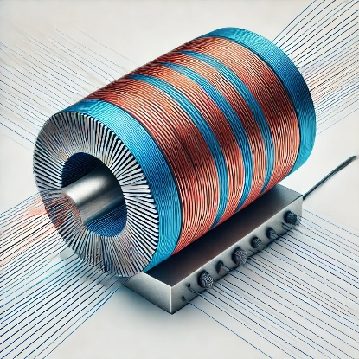Magnetism and electricity are forces generated by the movement of electrons. They are electromagnetic forces – moving electrically charged particles produce magnetic forces, and moving magnets produce electric forces. Using the materials provided, you will experiment with making different electromagnets and comparing the effectiveness of them.

# CONSTRAINTS AND CRITERIA

1. Create electromagnets using different materials supplied
2. Follow directions carefully
3. Determine the best electromagnet built

# MATERIALS:

* Enameled magnet wire
* “C” size battery
* “D” size battery
* Battery holder
* Alligator clips
* Variety of nails
* Small paper Clips
* Sandpaper

# TOOLS:

* (Optional) Basic DC power supply (12 volts) or better. This could replace the batteries

# DIRECTIONS:

Be sure to check off each step ☑ as you progress.

* **Step#1** – Define the Problem

Read the problem listed on the first page and write it in your own words

* **Step#2** – Define the Criteria

Listen and take notes as your teacher reads the activity and constraints.

* **Step#3** – Develop Ideas

After being introduced to the materials provided, use your knowledge of electromagnets and sketch/write down 5 different ways you could make an electromagnet that would affect its performance of picking up paperclips.

* **Step #4** – Develop Solutions

Determine which 3 ideas you will use to create your electromagnets. Be sure to document all 3 ideas and what is different about each one. Additionally, do predictive analysis of each solution you will build. How many paperclips do you think each electromagnet will pick up?

* **Step #5** – Testing and Evaluating

Build and test each of your 3 electromagnets. Write down the results of each electromagnet you created.

* **Step #6** – Present and Produce

Answer the questions in the reflection section. Turn in the design brief, full sized drawing, and Excel document with the final results.

**STEP 1:** Describe the problem in your own words. You can use drawings too.

**STEP 2:** Think about the problem and constraints your teacher gave you. What is the hardest criteria you will have to deal with?

**STEP 3:** Develop 5 electromagnet Ideas (Draw Pictures if needed). Make sure to add details

**STEP 4: Develop/** Draw your final 3 ideas here. (Pictures and details should be included)

**STEP 5:** Testing and Evaluating

Write down the results of your testing here.

|  |  |  |
| --- | --- | --- |
| Electromagnet #1 | Electromagnet #2 | Electromagnet #3 |
| Materials used: | Materials used: | Materials used: |
| # of paperclips held at one time.  ____________ | # of paperclips held at one time.  ____________ | # of paperclips held at one time.  ____________ |
| How fast did you move 10 paperclips?  Time (seconds) ____________ | How fast did you move 10 paperclips?  Time (seconds) ____________ | How fast did you move 10 paperclips?  Time (seconds) ____________ |

**STEP 6:** Reflections:

After you have finished testing your electromagnets, answer the following questions.

1. Which electromagnet design proved to be the best? Why?
2. What was the most challenging part of this project?

1. What are some key points of interest you found in this activity

1. What are some improvements would you make if you had to do this again?