Coffee Cup Speaker Learning Activity

UNIT: Acoustics and Electromagnetism_level 2

Engage: ***What do you need to know about electromagnets?***

Can you imagine life without radios? Do you know that the object that makes the speaker in the radio work is an electromagnet? An electromagnet is created with a battery (or some other source of electricity) and a wire. A battery has two ends, positive and negative. Although electrons collect at the negative end of the battery, they can flow to the positive end through a wire. The flowing electrons generate a magnetic field. The magnetic field from one wire is quite small. By putting many wires next to each other, a much larger field is created. The easiest way to do this is by making the wire into a coil with many loops. The idea behind an electromagnet in a speaker is simple: by running electric current through a wire coil, you can create a magnetic field. The field from the electromagnet is attracted or repelled from the field of a permanent magnet in the center of the speaker. When the current in the coil changes, so does the strength of the magnetic field. When the strength of the magnetic field changes, the attractive force between the coil and the permanent magnet changes. The changing force makes the speaker vibrate and produce sound. The bigger the vibrations, the louder the sound. Electromagnets are also used inside televisions to generate pictures, in electric motors, and in some medical devices.

EXPLORE: ***How can electromagnetism be used to do work?***

Now that you know some applications of electromagnets, can you say what the difference between a regular magnet and an electromagnet is? A magnet is any material that has a magnetic field. With a regular magnet, the magnetic field is permanent or "always on." However, with an electromagnet, only when electrical current is flowing through the wire coil is there a magnetic field. This property makes electromagnets more useful than permanent magnets in many applications. For example, a big electromagnet on the end of a crane can lift and drop large masses of iron such as junk cars in a scrap yard. Three factors that increase the strength of an electromagnet are: 1) increasing the current flowing through the coil, 2) increasing the number of coils, and 3) putting an iron core inside the coil.

Extend: ***Can you make a speaker out of a coffee cup?***

PROBLEM:

The challenge is to make a speaker out of a coffee cup, a few magnets and magnet wire. You will need roughly one or two class periods and all the pages of this STEM Learning activity to complete this STEM challenge.

CONSTRAINTS:

1. You will be given a length of wire by your teacher
2. Only one type of cup will be used by the entire class
3. You must test with one magnet to start

# MATERIALS:

* Neodymium magnets
* Enameled magnet wire
* Paper coffee cup
* Electrical tape
* Glue dots
* D-Cell batteries
* Sandpaper

# TOOLS:

* Lepai Amp
* RCA to 3mm adapter

**NOTE:** The homemade speaker wires may get hot when they are attached to the radio. This is more likely to occur with very thin wires and very high-power radios that are set at a high volume. CAREFUL! Neodymium magnets are powerful and they snap together quickly. These magnets have a tendency to chip if they snap together. MAGNETS SHOULD NEVER BE SWALLOWED!

# DIRECTIONS:

Be sure to check off each step ☑ as you progress.

* **Step#1** – Read the problem and the criteria.
* **Step#2** – Listen as your teacher reads the constraints and write down any additional constraints or special instructions.
* **Step#3** – Read the procedure directions carefully and construct the speaker.
* **Step #4** – Test your speaker.
* **Step #5** – Write down observations and record your data in the chart provided.
* **Step #6** – Talk to your group about possible modifications.
* **Step #7** – Make modifications and retest/modify for a total of 3 tests. Write down observations for each trial in the chart provided.
* **Step #8** – Turn in your speaker and all of your tools.
* **Step #9** – Share your results through a brief presentation by speaking in front of the class or recording short video.

# PROCEDURE:

1. Explore, the effects magnets have on each other when similar poles are near each other (such as either north to north or south to south). Notice the effects the magnets have on each other when dissimilar poles are near each other (such as either north to south or south to north).
2. Create electromagnets by winding roughly 6 to 15 feet of wire around a cylindrical object such as a C- or D-cell battery. Leave ten inches of wire hanging off at each end.

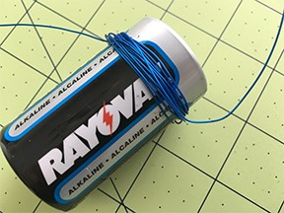

1. While keeping the wire in the shape of a coil, carefully remove the wire from the cylindrical object and tape the coil so it does not unravel.  Here’s a trick: use a small piece of electrical tape to secure the coil just as it comes off the battery.

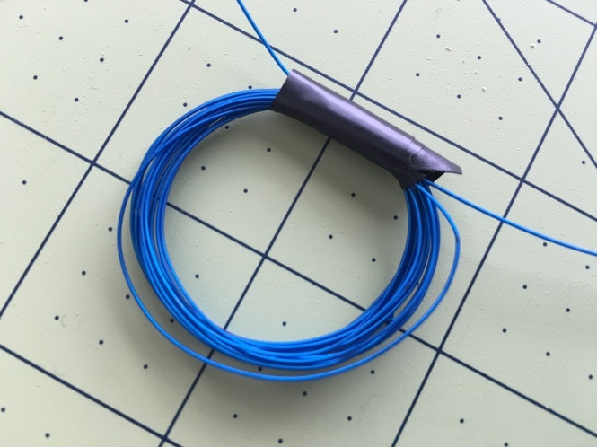

1. 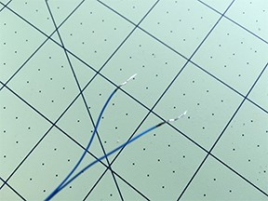Rub a piece of sandpaper on each free wire end to remove the enamel insulation. Remove about 1 inch of insulation from each end.  Tip: Make sure you can see bare wire; the color should be removed from the wire.
2. Hold the ends of the wire to opposite ends of the battery to make a series circuit with the battery and the coil. Move the coil close to the magnet and observe its motion. Hook the battery up differently and see what happens to the magnets. (When the coil is connected to the battery in one way, one side of the coil is the north pole and the other side is the south pole of the electromagnet. The north pole of the electromagnet will be attracted to the south pole of the permanent magnet. When the battery is turned around, the poles of the electromagnet are reversed.)

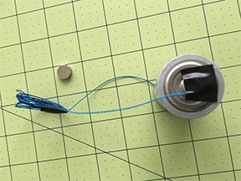

1. Attach the coil to the bottom of the container in the center with either tape or glue.

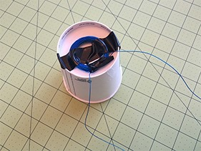

1. Attach permanent magnet to the bottom of the container with a glue dot. Attach magnet in such a way so that it is centered in the coil that is on the other side of the cup.

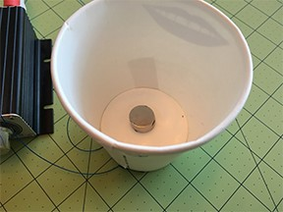

1. Plug the end of the wires into the amplifier (make sure the insulation has been removed with sandpaper). Start the music on your device and make sure the RCA to 3mm adapter is plugged in to your device and the amp. Turn on the amp with the volume down and gradually bring up the volume.

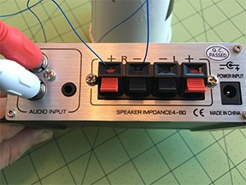

Elaborate: ***How can you validate your solution?***

**Testing**

1. You may attempt one test and to start. A retest may only occur when no teams are waiting.
2. For each attempt made, record the changes you made and your observations of what the difference was.

|  |  |  |  |
| --- | --- | --- | --- |
| Test | Modifications | Predictions | Observations |
| 1 |  |  |  |
| 2 |  |  |  |
| 3 |  |  |  |

**Communicating Results**

Create a brief presentation to share your results with other groups. You can choose to speak in front of the class or prepare a short video.

EVALUATE:

***How creative were students in solving a critical problem?***

1. The solutions were successful and the speaker produced sound from the amplifier
2. Changes after unsuccessful attempts saw significant modifications that made logical sense.
3. Classmates let go of controlling strategies and were open to more ideas than their own.
4. The facilitator did not have to remind students that they only have three attempts.
5. Broken or nonreturnable items were listed as used.
6. Real teachable STEM moments were observed in this assignment.
7. The facilitator did not interfere with the discussions as much as possible.
8. The facilitator encouraged ideas to extend technological capability.
9. Teacher exercised better higher order thinking required to solve this problem.

***Did students have an understanding of the concepts?***

1. Was a rubric used that contained a number of processes and showed evidence of understanding?
2. Were students given a chance to provide peer reviews?

|  |  |  |  |  |  |
| --- | --- | --- | --- | --- | --- |
| Elements | Criteria | | | | Total Points |
| Point Value | 4 | 3 | 2 | 1 or 0 | 0-4 |
| Participation | Attraction and repelling forces of magnets were discovered.    Coils were made and the windings were counted. | Attraction and repelling forces of magnets were discovered.    Coils were made, but windings were not counted. | Attraction and repelling forces of magnets were not discovered.    Or the coils were not made. | Coils were not made and limited or no observations were made regarding magnets |  |
| Variables | All variables are clearly described with all relevant details. | All variables are clearly described with most relevant details. | Most variables are clearly described with most relevant details. | Variables are not described OR the majority lack sufficient details. |  |
| Analysis | The relationship between the variables is discussed and trends/patterns logically analyzed.    Predictions are made about what might happen when the design is modified. | The relationship between the variables is discussed and trends/patterns logically analyzed. | The relationship between the variables is discussed with few trends/patterns or predictions made. | The relationship between the variables is discussed with no trends/patterns or predictions made. |  |
|  | | | | Total Points/12 |  |