 | Preparation: Summary of “to do’s” that the teacher should understand and prepare before bringing this lesson to the classroom.
Information:

Before starting this exercise, students and teachers should have an understanding of material covered in:

- Video: Speakers - Magnetism & Sound

Teachers will need to ensure that the proper supplies are available for students to build their solutions.

Materials:
- Neodymium magnets
- Enameled magnet wire
- Paper coffee cup
- Electrical tape
- Glue dots
- D-Cell batteries
- Sandpaper

Tools:
- Lepai LP-2020A+ Tripath TA2020 Class-T Hi-Fi Audio Amplifier with Power Supply
- RCA to 3mm adapter cord

Additional Materials:
- Bring in your iPhone, iPod, Samsun Cell phone or any MP# player with music on it and a 3MM headphone jack

Adapted from: GK-12 Program, Center for Engineering and Computing Education, College of Engineering and Information Technology, University of South Carolina

 | Safety: Summary of safety strategies in the lesson.
The homemade speaker wires may get hot when they are attached to the radio. This is more likely to occur with very thin wires and very high-power radios that are set at a high volume. CAREFUL! Neodymium magnets are powerful and they snap together quickly. These magnets have a tendency to chip if they snap together. MAGNETS SHOULD NEVER BE SWALLOWED!

 | Desired Results:
Established Goals: |  |  | Transfer:
Problem Solving Techniques and Applications Standards: |  |  | Students will be able to independently use their learning to…  - Understand and appreciate the various parts of speakers and their functions.
 |  |  | Meaning:
 |  |  | Understandings  Students will understand that...  - When current travels through a conductor, a magnetic field is created  - When a magnetic field passes by a conductor, voltage is induced in the conductor  - electric currents produce magnetic fields. The stronger the current, the more intense the magnetic field.  - Magnets can be permanent or temporary  - Magnets and electromagnets attract or repel each other; similar poles repel, while dissimilar poles attract. | Essential Questions  Students will keep considering...  - How speaker technology differs from speaker to speaker  - Different types of speakers and how their parts are different
 |  |  | Acquisition OF KNOWLEDGE AND SKILL:
 |  |  | Students will know...  - The various parts to a speaker  - How a speaker works  - The principles on how the speaker operates | Students will be skilled at...  - Constructing speakers and other speaker technology  - Identifying different parts of a speaker
 | Evidence:
Evaluative Criteria: |  |  | Assessment Evidence:
- Functions as expected  - Constructed well |  |  | Performance Task(s):  Building a Coffee Cup Speaker  Students will construct a simple audio speaker using simple electrical device and tools in this exercise.
- Completed |  |  | Other Evidence:  - Coffee Cup speaker grading rubric
 | Learning Plan: Summary of Key Learning Events and Instruction
Adapted from: GK-12 Program, Center for Engineering and Computing Education, College of Engineering and Information Technology, University of South Carolina

Pre-Assessment

Understand a series circuit.
Identify the north and south poles of a magnet

Discussion Questions: Solicit, integrate and summarize student responses:
- Can we make a non-magnetic object magnetic? (Answer: Yes, this is known as magnetic induction. This phenomenon can be demonstrated with two nails. We can magnetize one nail by touching it to a magnet. Then, both nails will hang together. The magnetized nail is a temporary magnet. Temporary magnets retain their magnetism for a short time. They are similar to electromagnets that magnetize where the electric current is on and demagnetize when it is off.)

- What is a magnetic field and where do magnetic fields come from? (Answer: Magnetic fields are caused by the movement of electrons. The magnetic field lines give the direction in which the magnetic force acts. They converge where the magnetic force is strong and spread out where it is weak. For instance, in a compact bar magnet, they spread out from one pole and converge towards the other. The magnetic force is strongest near the poles where these field lines come together. A space modified by the presence of magnetic field lines is a magnetic field.

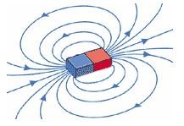
The field lines around a bar magnet.
Copyright © Schoolscience

Does magnetism ever wear off? (Answer: Most permanent magnets retain their magnetism for a very long period. This is because they are composed of electrons divided naturally into "magnetic domains"—tiny regions where all the magnetic fields of the atoms are all pointing in the same direction. These electrons are charged and spin, acting like little electromagnets, and their magnetism never wears off. It is the lining up of many, many electron spins that creates permanent magnets. Therefore, the underlying magnetism never wears off; only the ordering of all the spins together may become more disordered.)

Outline:

- Introduction
- Have students watch and listen to the video “Speakers - Magnetism & Sound.”
- Pass out student activity sheets “Building a Coffee Cup Speaker” to each student.
- Have students listen and read along as you review electromagnetics with the Engage section of the Learning Activity, the problem, and the constraints.
- Have students write down any extra constraints or special instructions you wish to add.

- Construct
- Have students read the procedures and construct the speaker.

- Test
- Students test the speaker
- Students discuss and write down observations into the chart provided.

- Brainstorm
- Students discuss and write down possible modifications they can make to their speakers.
- Students make modifications to their speakers.

- Test
- Students test their speakers again and write down observations.
- Students discuss, record, and make modifications and then retest for a total of 3 tests.

- Communicate Results
- Students discuss their results with their group and write a short presentation communicating their results.
- Students share their results by speaking in front of the class or recording a short video.

Suggested Strategies

- Before the activity
- Set out pairs of magnets at each table.
- Briefly review magnets and their polarities.
- (Optional) Bring out a speaker radio and have it playing some music.

- Demonstrate
- Follow along in the activity with the students going over each step and demonstrating how that step is done.

- Tips and tricks
- The more magnets in the cup the better the sound. Start students off with only one magnet. CAREFUL! Neodymium magnets are powerful and they snap together quickly. These magnets have a tendency to chip if they snap together. MAGNETS SHOULD NEVER BE SWALLOWED!
- Shorter coils produce less sound. Vary the lengths given to students and see the differences. If groups with shorter coils want to make a larger coil, let them!
- These small amplifiers sometimes have protection devices inside them that shut the amp off. Turn down the volume and try again.
- Glue dots can be tricky and sticky! Stick the magnet to the glue dot and peel the dot off the paper. Then position at the bottom of the cup and press!

- Student Table
- Set up work stations for students with all parts laid out and labeled.

- Student Time
- Give students time to construct their speakers. Once they are done, connect the wound wire to the tone generator and test the student-made speaker.

Student Procedure:

- Explore, the effects magnets have on each other when similar poles are near each other (such as either north to north or south to south). Notice the effects the magnets have on each other when dissimilar poles are near each other (such as either north to south or south to north).

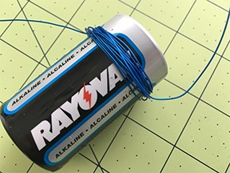
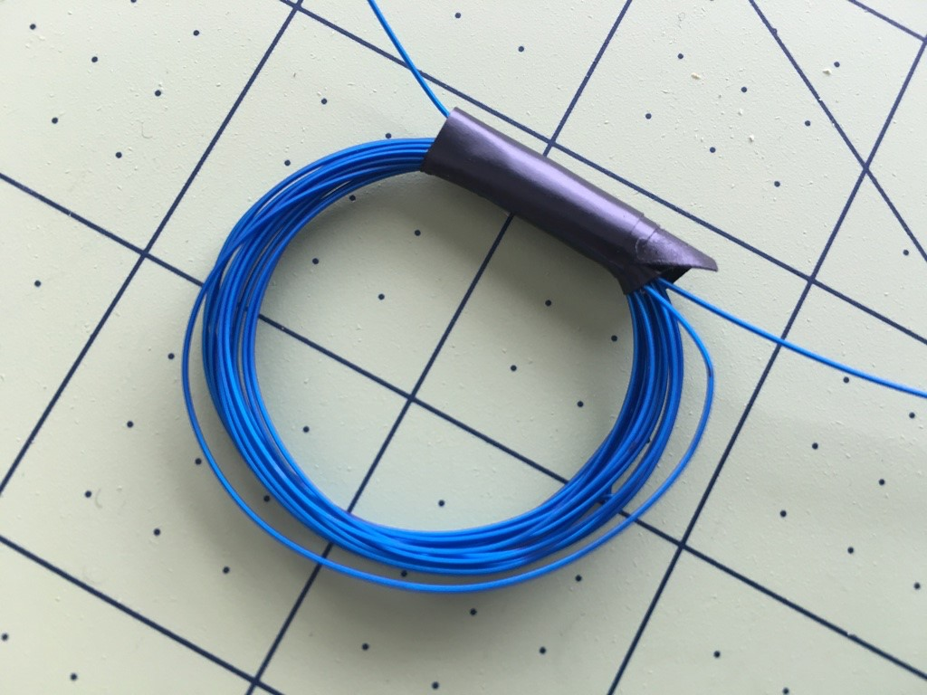
- Create electromagnets by winding roughly 6 to 15 feet of wire around a cylindrical object such as a C- or D-cell battery. Leave ten inches of wire hanging off at each end.

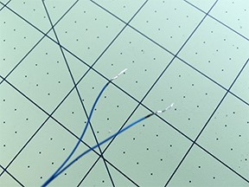
- While keeping the wire in the shape of a coil, carefully remove the wire from the cylindrical object and tape the coil so it does not unravel. Here’s a trick: use a small piece of electrical tape to secure the coil just as it comes off the battery.

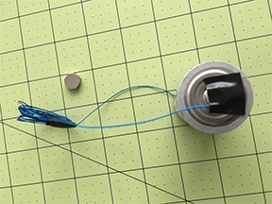
- Rub a piece of sandpaper on each free wire end to remove the enamel insulation. Remove about 1 inch of insulation from each end. Tip: Make sure you can see bare wire, the color should be removed from the wire.

- Hold the ends of the wire to opposite ends of the battery to make a series circuit with the battery and the coil. Move the coil close to the magnet and observe its motion. Hook the battery up differently and see what happens to the magnets. (When the coil is connected to the battery in one way, one side of the coil is the north pole and the other side is the south pole of the electromagnet. The north pole of the electromagnet will be attracted to the south pole of the permanent magnet. When the battery is turned around, the poles of the electromagnet are reversed.)

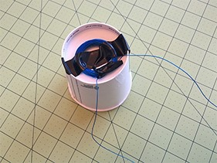
- Attach the coil to the bottom of the container in the center with either tape or glue.

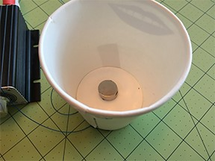
- Attach permanent magnet to the bottom of the container with a glue dot. Attach magnet in such a way so that it is centered in the coil that is on the other side of the cup.

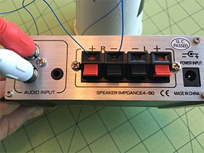
- Plug the end of the wires into the amplifier (make sure the insulation has been removed with sandpaper). Start the music on your device and make sure the RCA to 3mm adapter is plugged in to your device and the amp. Turn on the amp with the volume down and gradually bring up the volume.

- Discussion

A follow-up discussion of this activity should include having a student explain in detail how the speaker works. Have them trace the path of electrons from the wires coming out of the tuner though the speaker. Try putting a little pinch of salt on the speaker cone. You will see the salt oscillate up and down. Put all the students’ speakers in series with alligator clips and see if you can get them to all work. If they do not all work, it is a good lesson to have students trouble shoot and check continuity down the line.

Progress Monitoring:
- The instructor will need to monitor the classroom, check students’ work, and ensure students are on task and following directions.
- Ensure students store their projects at the end of class and leave all materials in the room.
- At the end of the activity, post student projects in the room and provide appropriate feedback.

Sample Grading Rubric:

Elements | Criteria |  |  |  | Total Points
Point Value | 4 | 3 | 2 | 1 or 0 | 0-4
Participation | Attraction and repelling forces of magnets were discovered.  Coils were made and the windings were counted. | Attraction and repelling forces of magnets were discovered.  Coils were made, but windings were not counted. | Attraction and repelling forces of magnets were not discovered.  Or the coils were not made. | Coils were not made and limited or no observations were made regarding magnets
Variables | All variables are clearly described with all relevant details. | All variables are clearly described with most relevant details. | Most variables are clearly described with most relevant details. | Variables are not described OR the majority lack sufficient details.
Analysis | The relationship between the variables is discussed and trends/patterns logically analyzed.  Predictions are made about what might happen when the design is modified. | The relationship between the variables is discussed and trends/patterns logically analyzed. | The relationship between the variables is discussed with few trends/patterns or predictions made. | The relationship between the variables is discussed with no trends/patterns or predictions made.
 |  |  |  | Total Points/12

Copyright © 2005 Center for Engineering and Computing Education at the University of South Carolina
 | Differentiation: Summary of Key Differentiation Techniques
Please use this space to insert your differentiation techniques. Depending on the needs of students, various techniques might be needed in a classroom, therefore use the information below and experts in the area needed to design your plan for differentiation.

The ASCD Study Guide for Integrating Differentiated Instruction and Understating by Design: Connecting Content and Kids.
by Carol Ann Tomlinson, Jay McTighe

Integrating Differentiated Instruction and Understating by Design: Connecting Content and Kids.
by Carol Ann Tomlinson, Jay McTighe
ISBN-13: 978-1416602842
ISBN-10: 1416602844

Differentiating Reading Instruction
by Laura Robb.
ISBN13: 9780545022989

A Teacher's Guide to Differentiating Instruction
The Center for Comprehensive School Reform and Improvement

 | career Connections: Summary of Career Opportunities Associated with this Lesson
Please use this space to insert careers that might be connected to this lesson. This section will need continuous updating as new careers and emerging technologies change the opportunities available in the workforce.

Electrical Engineer
Electrical engineers can design systems that oscillate electricity for products such as speakers.

Sound Engineer
Sound engineers manipulate speakers and electricity to produce desired sounds and effects.

System Engineer
System engineers utilize speakers for systems such as sound systems.

 | Keywords: Please Insert Keywords from this Lesson with their Definitions
Please use this space to insert keywords and their definitions

Current: A flow of electrical charge carriers. The common symbol for current is the uppercase letter I. The standard unit is the ampere symbolized by A.
Electromagnet: A magnet consisting of a coil of insulated wire wrapped around a soft iron core that is magnetized only when current flows through the wire.
Magnet: An object that is surrounded by a magnetic field and has the property of attracting iron, steel, or other magnets.
Magnetic field: A region in which magnetic forces can be observed.
Magnetic force: The force exerted between magnetic poles or between two electrically charged moving particles (protons and electrons).

