Ukulele Learning Activity
UNIT: Acoustics and Electromagnetism_level 3
Engage: When was the ukulele invented?
The most familiar Hawaiian instrument is the 'ukulele, a small type of guitar. The instrument was probably introduced to Hawai'i in 1879 by Portuguese settlers from Madeira who brought with them a small guitar called the braguinha.
EXPLORE: How much do you know about ukuleles?
The ukulele, also called a uke, is a member of the lute family of instruments of Portuguese origin and popularized in Hawaii. It generally employs four nylon strings. The tone and volume of the instrument vary with size and construction. Ukuleles commonly come in four sizes: soprano, concert, tenor, and baritone. Is a ukulele a guitar yes, or no? It's a fact that the ukulele is more like a guitar than it is like any other instrument. There are some important differences between the two string instruments. Guitars generally have six strings while ukuleles tend to have four. Guitars use nylon strings or steel strings, while ukuleles mostly just use nylon strings.

Extend: Can you construct your own ukulele?

Directions:

Follow the construction instructions in this learning activity. Also, watch the videos in the Presenting the Solution unit online at: https://learn2.stem101.org/login/index.php. The videos are located in the Learning Activity inside Student Activity.

Problem:

The challenge is to make a basic working ukulele. You will need roughly three or four class periods and all the pages of this STEM Learning activity to complete this STEM challenge.

Constraints:

The ukulele must be made from kit components only.

Any design work on your ukulele is encouraged. Be creative and make your ukulele stand out!

Materials:

- Ukulele kit
- Markers/Colored pencils (optional)

Tools:
- Mini Glue gun (optional)
- Hand drill/Power drill (optional)
- Phillips screw driver (inside kit)
- 1/8” drill bit (inside kit)

Construction Instruction

Step 1: Body and Neck assembly

- For this step, you will need the body, neck, wood dowel pin and adhesive.
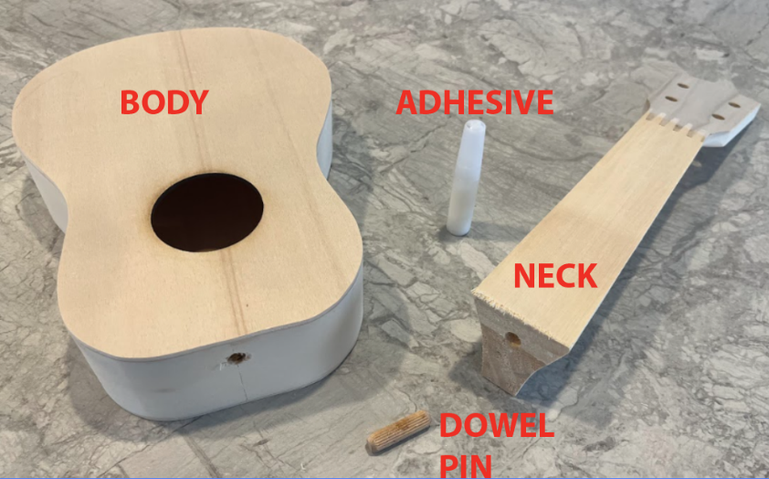
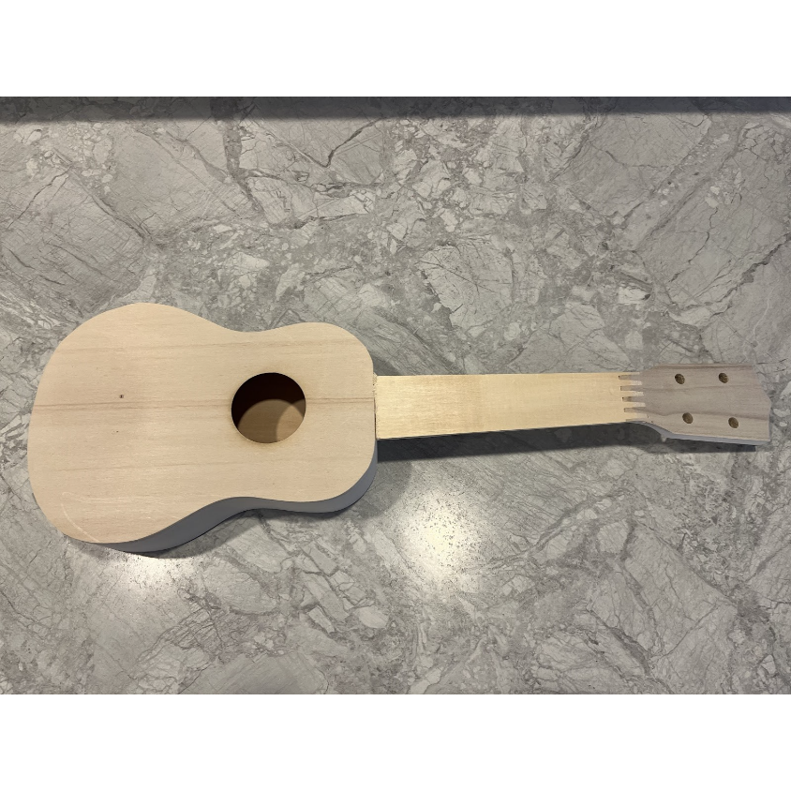
- Apply adhesive in the hole at the end of the neck. Also, apply adhesive to the hole in the body. The dowel pin will be inserted into both holes. Before inserting the dowel pin, apply adhesive to the “V” shaped end of the neck. This will allow it to bond to the body after assembly. Push the wood dowel into the hole in the neck first. You may need to push the dowel on a table to make sure it is inserted to the proper depth. Now push the dowel into the body and make sure the neck and body components make a tight connection. Apply painter's tape on the joint to hold the pieces together.
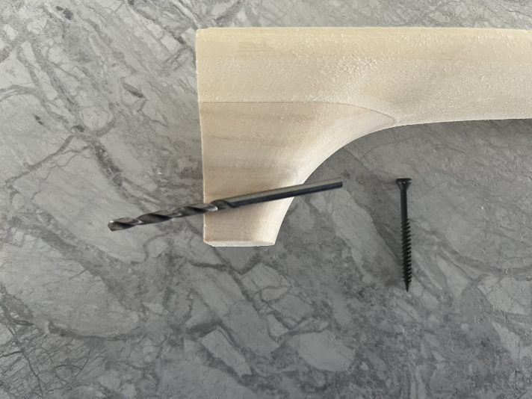
NOTE: A 1 5/8” trim screw could be used to hold the neck to the body as well. There is a 1/8” drill bit in your bag that can be used to pre-drill through the neck (not the body) to make it easier for the trim screw to be applied.

Step 2: Attach Fretboard and Nut

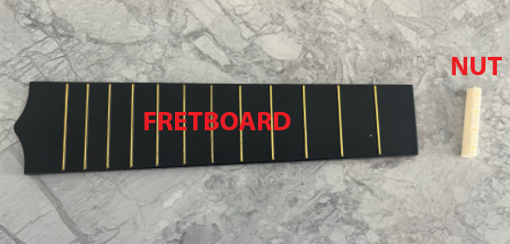
- You will be gluing the Fretboard to the neck and body as well as the Nut.

- Apply a consistent bead of adhesive to the backside of the Fretboard.

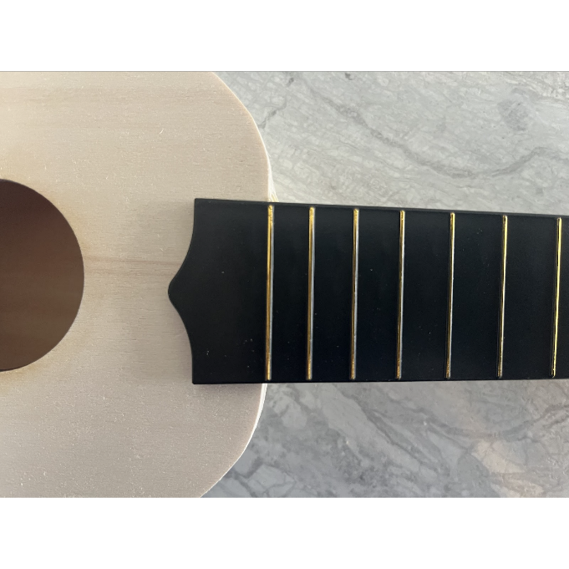
- Align the Fretboard properly. Proper alignment is important. The last gold Fret line on the wider end should line up with the Body and Neck joint.

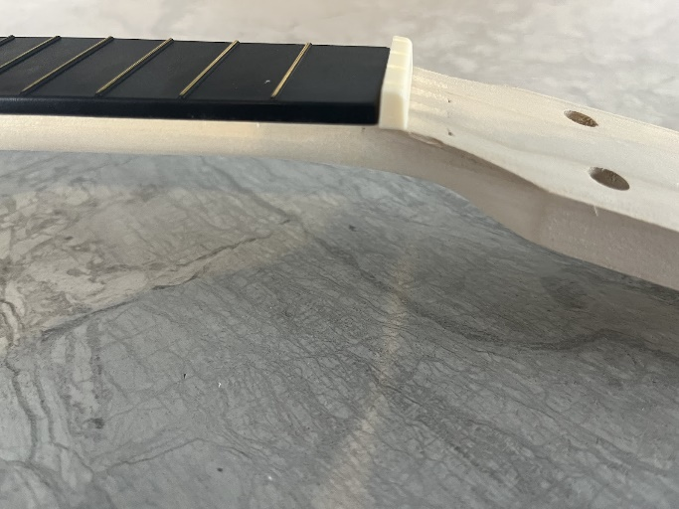
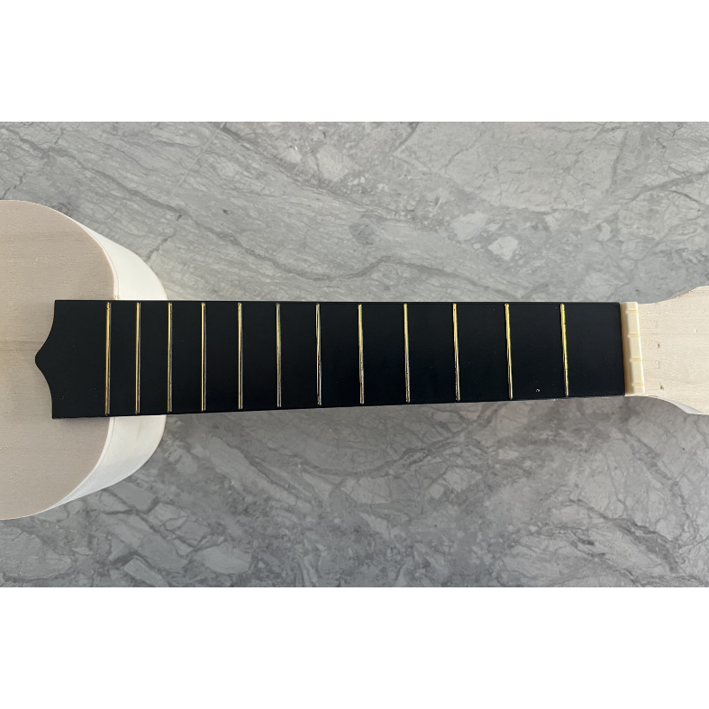
- Apply the zip ties to hold tightly in position. The nut is positioned at the narrow end of the Fretboard. Notice the curved end on the Nut. This curved end needs to face the Tuning Peg holes.

Step 3: Attach the Tuning Pegs

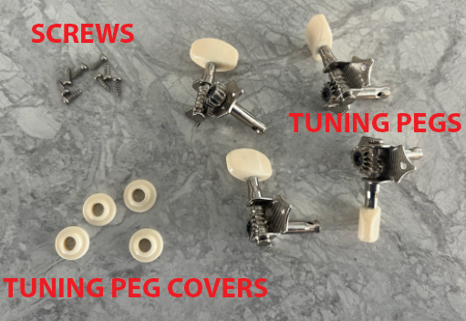
- Find the Tuning Pegs; eight small screws and the Tuning Peg plastic decorative covers.
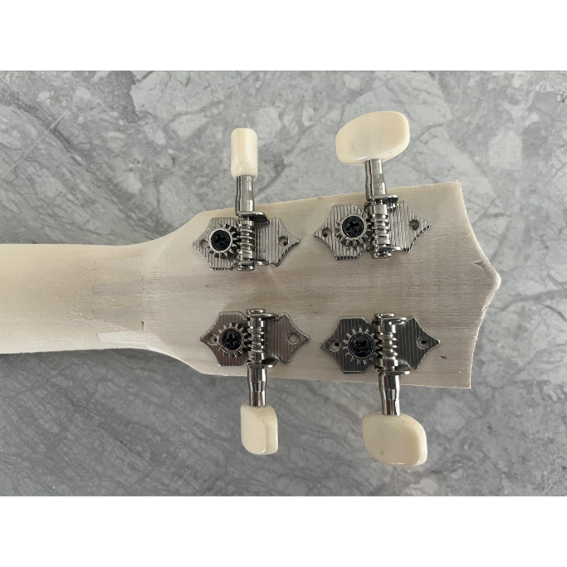
- The Tuning Pegs will be fastened on the bottom side of the Neck. There are pre-drilled holes for proper alignment of the Tuning Pegs. It is important that the gear faces toward the Body.

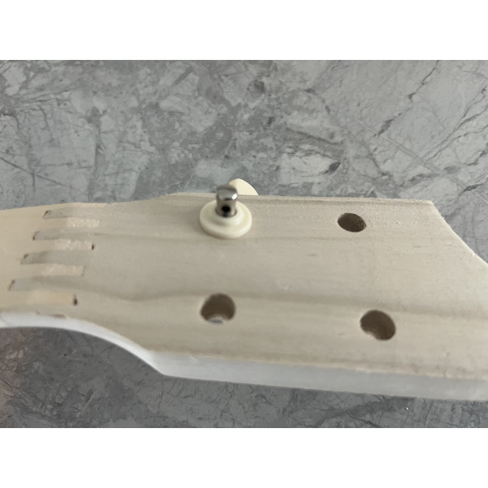
- Place a small amount of adhesive on the plastic decorative cover and attach over the Tuning Peg shaft.

Step 4: Attach the Bridge

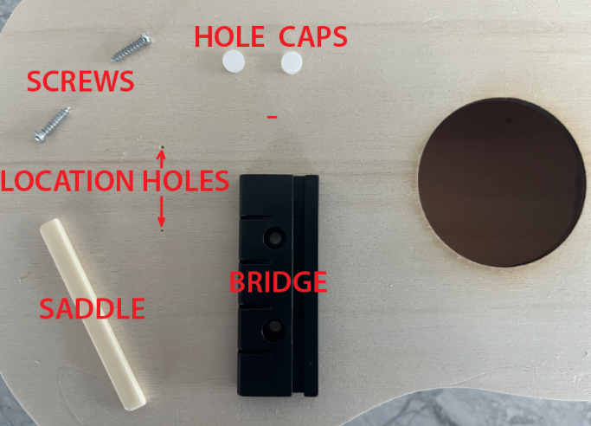
- You will need the Bridge, Saddle, two plastic hole caps and two screws.

- Fasten the Bridge to the Body using the two screws. There are locating holes in the Body to properly align the Bridge. Place the Caps in the holes when the screws are secure. Snap the Saddle in the groove on the top of the Bridge. It’s time to string your Ukulele!

Step 5: Attach the strings
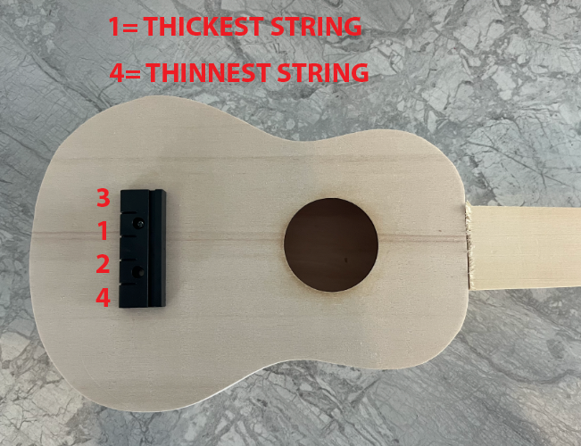
- There are four strings for the Ukulele. All are different diameters and it is important to install the strings in the proper order.

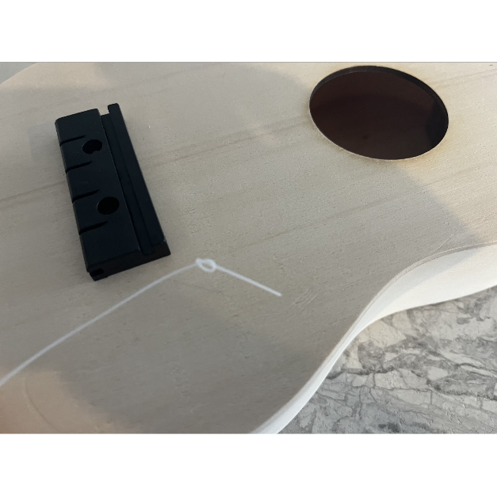
- Tie a knot in your string. You may need to double knot the thinner string(s).

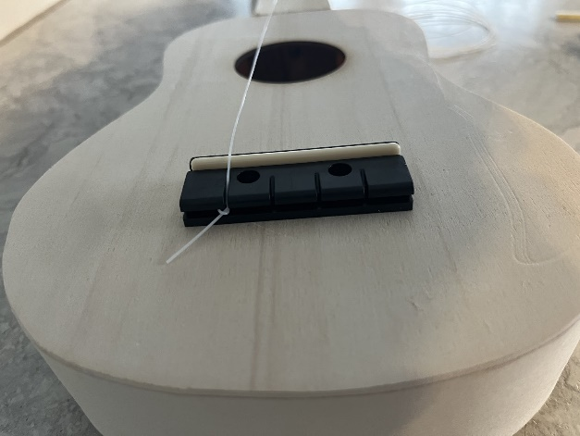
- The knot will go in the side groove of the Bridge.
- Now, place the string through the Tuning Peg. Be sure that the string is in the proper slot in the nut.
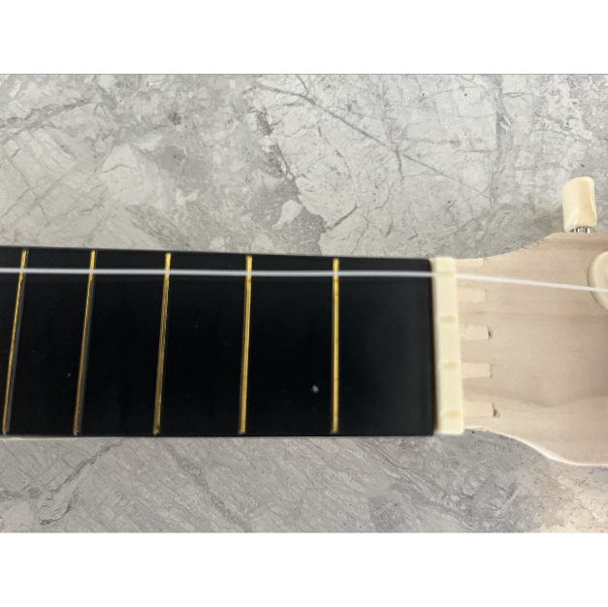
- The string needs to go through the hole in the Tuning Peg. There is an order for where the strings go. Push the string through the hole and then back through the hole a second time.
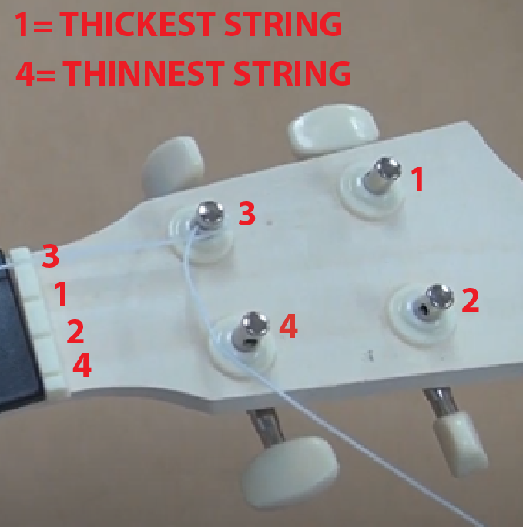
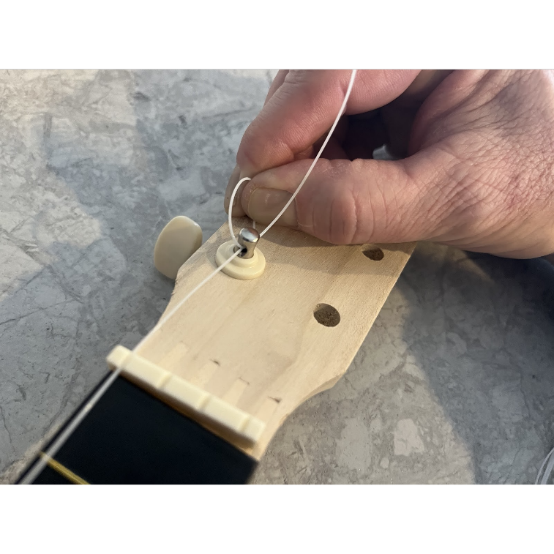
- With the string pulled tight, turn the Tuning Peg knob counterclockwise to tighten the string until you can strum it and hear it play a note. Do not over tighten the strings. You will tune your Ukulele once all strings are attached.

Step 6: Tune your Ukulele

- There are many sites that you can go to for tuning your Ukulele. Here is one site you can use. https://ukebuddy.com/ukulele-tuner. ENJOY YOUR UKULELE!!!

Elaborate: How can you validate your solution?

Testing
- You may test your ukulele when it is complete and approved by your teacher.
Evaluate:

How creative were students in solving a critical problem?
- The solutions were successful, and the ukuleles were used as musical instruments only.
- Real teachable STEM moments were observed in this assignment. =
- The facilitator did not interfere with the discussions as much as possible.
- Teacher exercised better higher order thinking required to solve this problem.

Did students have an understanding of the concepts?
- Was the ukulele identification exercise completed, and correct?

