Code Your Own Video Game

UNIT: ELECTRONICs/CODING LEVEL 1- Activity 3

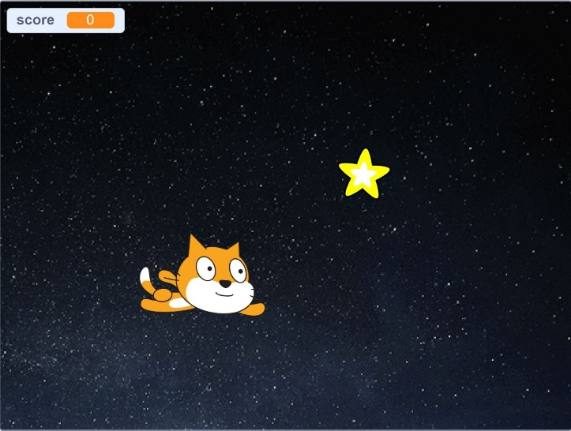The Problem:

# In this activity you will code your own unique video game. The game you create will use a variety of code commands that will allow the players of your game to score points and win!

# CONSTRAINTS AND CRITERIA

1. Safely create or log in to a classroom online Scratch account with your teacher’s assistance.
2. Practice appropriate online responsibility and safety.
3. Select a theme or storyline for your game and choose a **backdrop** and **sprites** that coordinate.
4. Code the “chasing” sprite to move up, down, left, and right when the keyboard **arrow keys** are pressed.
5. Code the other sprite to keep moving around the screen to **random positions**.
6. Create a **variable** block to score and display a point each time the second sprite is “tagged”.
7. Use a **conditional** to end the game once the player reaches a set score.
8. Make your game even more unique by choosing one or more of the following options:

* Add additional sprites as obstacles or code the game to subtract points if they are “tagged”.
* Change the **looks** or **costume** of the sprite each time it is tagged, or have it **hide** to disappear.
* Code your game to advance to a new level when a set score is reached by changing the backdrop and sprites, the speed they move, or the score needed to win/move on.
* Create a “You Win” or “Game Over” type end game message.
* Other creative ideas with teacher approval

# MATERIALS:

* Online classroom Scratch account

# TOOLS:

* Pencil
* Computer or Chromebook with online internet access

# DIRECTIONS:

Be sure to check off each step ☑ as you progress.

* **Step#1** – Define the Problem

Read the problem listed on the first page and write it in your own words (p. 3).

* **Step#2** – Define the Criteria

Listen and read along as your teacher reads the activity and constraints. Then actively participate in the Scratch Video Game training session with your teacher to safely set up your Scratch account and practice coding with the colored code blocks. Write down and describe what you find most challenging and what you’re most looking forward to learning or improving during this activity (p.3).

* **Step#3 – Develop Ideas constraints**

Brainstorm ideas for your game (p. 4). In this game, one sprite (character or object) will be chasing the other and earning a point each time it tags or touches it. Choose a theme or story you’d like your game to follow. Choose sprites and a backdrop to fit your ideal. Be creative and make it unique! Include a rough sketch of your plan and list what you might include to make your game more unique (p. 5). See the list of suggestions (p. 1, #8) Be flexible and know your plan may change during this process.

* **Step #4 –** Develop Solutions

Create your game in Scratch. Be patient, it takes a lot of coding to make little things happen.

* **Step #5** – Testing and Evaluating

Each time you click a block you are running a test of your coding program. Continue to test and modify as much as needed to finish your animation.

* **Step #6 –** Present and Produce

Answer the questions in the reflection section (p. 6). Reflect on your design process by describing at least one test that went well and one that needed modification. Share and/or present your game as directed by your teacher. Turn in the design brief.

# STEP 1: Describe the problem in your own words.

# STEP 2: After you’ve completed the training segment, revisit the problem and constraints. What do you think will challenge you most and why?

# What are you most looking forward to learning or improving and why?

# STEP 3: Develop Ideas – Plan the details of your animation here. Feel free to list multiple ideas.

# Which sprites are you considering using? Which will be chasing? Which will be chased?

# Which backdrop(s) are you considering using?

# What might the theme or story be?

# Sketch a rough drawing of your idea below:

# What other ideas do you have to make your game unique from all the others?

# STEP 5 & 6: Reflection Questions

# Each time you clicked a block to see how it was working in your animation was a “test”. Describe a test that didn’t go as you planned and needed modification. What did you do to make it work the way you wanted it to?

# Describe one of your coding successes. What can you code now that you couldn’t before this activity?

# What is still challenging you? What coding skills would you like to improve, learn more about, or have more time to practice?

# Describe what you added to your game to make it unique. Which blocks did you use to make that happen?

**GRADING RUBRIC:**

|  |  |  |  |  |
| --- | --- | --- | --- | --- |
|  | Indicator not met | Indicator partially demonstrated | Indicator adequately demonstrated | Indicator effectively demonstrated |
| **Design Brief**  Points___ /4 | **Incomplete**  Less  than 50%  complete  1 | **Inadequate**  Mostly complete; Criterion not met  2 | **Adequate**  Criterion met;  more attention  to neatness or  detail needed  3 | **Exceptional**  Meets or exceeds expectations; high effort, attention to detail  4 |
| **Scratch Game**  **Theme**  Points___ /4 | **Incomplete**  Sprite or backdrop is missing from games  1 | **Inadequate**  Sprite & backdrops do not coordinate, or theme unclear  2 | **Adequate**  Sprites and backdrop coordinate in a chase game format  3 | **Exceptional**  Creative details or additional coding blocks add to the game flow & experience  4 |
| **Design Plan**  **& Process**  Points___ /4 | **Incomplete**  Did not complete or skipped steps  in the process  1 | **Inadequate** Frequent  assistance; final project very different from plan  2 | **Adequate**  Limited assistance needed; plan was used to lead to final project  3 | **Exceptional**  Independent completion; revisions were made to improve  4 |
| **Effort & Online Responsibility**  Points___ /4 | **Incomplete**  Was unable or refused to complete work or inappropriate online use  1 | **Inadequate**  Frequent reminders needed to stay on task or be responsible online  2 | **Adequate**  Occasional reminders or prompting  needed  3 | **Exceptional**  Independent completion;  safe and responsible online use  4 |
| **Required Coding Skills/Blocks** | **Incomplete**  Two or more constraints from  #3-7 missing or not working | **Inadequate**  One of the constraints from  #3-7 missing or not working | **Adequate**  Constrains #3-7 met, additional feature from #8 missing or not working | **Exceptional**  Game effectively met required constraints #3-7 and an additional extra #8 |
| Points___ /4 | 1 | 2 | 3 | 4 |