Electronics/Coding Level 3 Quiz – Answer Key

1. 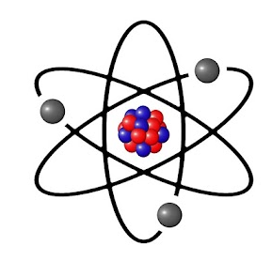What part of the atom moves in an electrical circuit?

Select one:

1. Protons
2. Neutrons
3. Electrons
4. Conductors allow electrons to flow freely between atoms, while insulators do not allow electrons to move between atoms.

Select one:

1. True
2. False

1. An open circuit will allow electrons to flow?

Select one:

1. True
2. False
3. 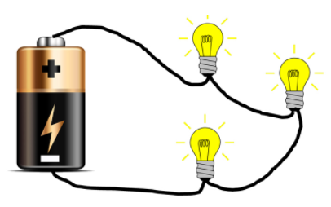All of the electrons in this circuit travel the same path. Is it a series or parallel circuit?

Select one:

1. Series
2. Parallel
3. 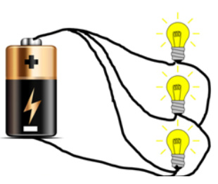Each component's electrons in this circuit have their own path back to the battery. Is it series or parallel?

Select one:

1. Series
2. Parallel
3. 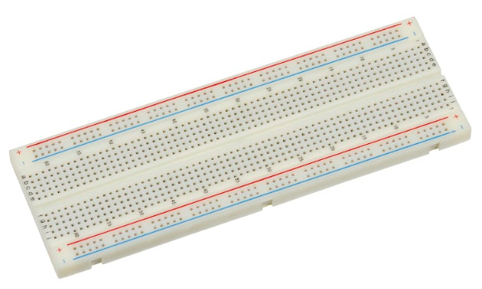The long rows on the sides of a breadboard are all connected to each other. What are they called?

Select one:

1. Power Rails
2. Terminal Strips

1. The short rows of 5 pins running down the center of the breadboard are called.



Select one:

1. Power Rails
2. Terminal Strips
3. Which of the following Arduino components are INPUTS?

Select one:

1. GND
2. 5V
3. Analog Pins
4. Digital Pins

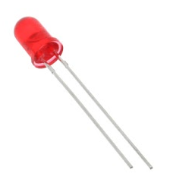

1. LEDs are polarized, so they will only work if…

Select one:

1. The anode (long side) is positive and the cathode (short side) is negative.
2. The cathode (short side) is positive and the anode (long side) is negative.
3. It doesn't matter which side goes where as long as the circuit is connected.
4. Resistors are used to limit the flow of electrons through a circuit.

Select one:

1. True
2. False