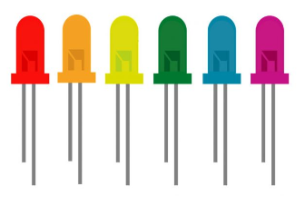

Blink Programming Challenges

UNIT: ELECTRONICS/CODING LEVEL 3

1. Design a program that could be used to control a stop light.
2. When the program starts, the green light should be on for 3 seconds.
3. Next, the yellow light should be on for 1 second.
4. After the yellow light, the red light should be on for 2 seconds.
5. 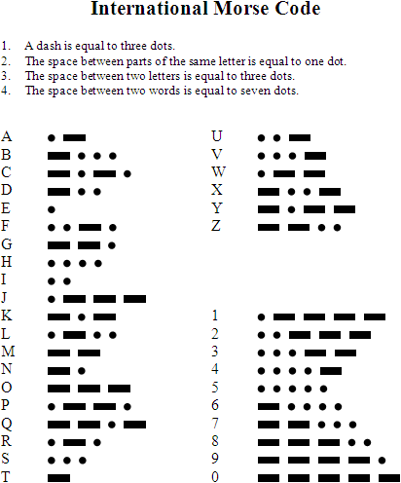Morse code is an alphabet where letters are represented by long and short flashes of light. It is named after Samuel Morse, the inventor of the telegraph.
6. Write a program that transmits your initials in Morse Code.
7. Extra! Write a program to send a secret message in Morse code (one short word works best). Use the attached key to see the codes for each letter. When you are done, see if one of your classmates can decode it!
8. 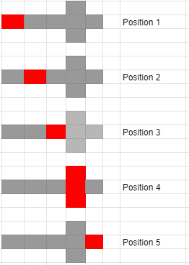Write a program that will light up a directional arrow from back to front. There is an example LED sequence attached. Yours does not have to look like this, but it can.