Photoresistor Challenges

UNIT: ELECTRONICS/CODING LEVEL 3

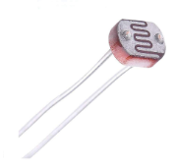

1. Program 3 LEDs so that they light as it gets darker. For instance, when it is bright, 0 are lit. When it is a little darker - one lights, a little bit darker - 2 LEDS light, and at maximum dark - all 3 LEDs light. Lower a book toward the photoresistor. The closer the book gets, the more LEDs light up.