Servo Programming Challenges

UNIT: ELECTRONICS/CODING LEVEL 3

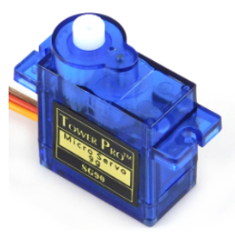

1. Use an analog sensor (photoresistor OR ultrasonic sensor) to control the angle of the servo.

*If photoresistor*: The darker it gets, the higher the angle of the servos should be.

*If ultrasonic sensor*: The closer the object gets to the sensor, the higher the angle should be.

**Credit**: Have the servo move into three different positions based on the input from the analog sensor. Low, medium, and high.

**Extra Credit**: Have the servo move infinitely based on the input of the analog sensor. (AS the analog value changes, the servo moves proportionally.)