Switch Programming Challenges

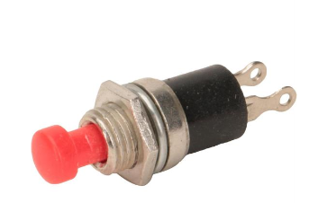UNIT: ELECTRONICS/CODING LEVEL 3

1. Program an LED to light up when two switches are pressed at the same time, and NOT when one or the other is pressed.
2. Program a LED to light up when one switch OR the other is pressed but NOT both.
3. Program ONE LED to do the following:
4. If one switch is pressed, blink the LED at 2 second intervals,
5. If the other switch is pressed, blink the LED at 1 second intervals,
6. If both switches are pressed the LED should blink at .25 second intervals.
7. If neither switch is pressed, the LED should stay on.
8. **Part 1:** Arrange 5 LEDs in a row on your breadboard.

When a switch is pressed the LEDS light from left to right. (Think traffic sign in the blink assignments) They should light at .5 second intervals. When the switch is NOT pressed, the LEDS light from right to left, also at .5 second intervals.

**Part 2:** Add a second switch. This switch is Turbo mode. When this switch is pressed the lights move at .1 second intervals instead of .5 second intervals. The lights should still move in the same directions as Step 1.