Ultrasonic Distance Sensor Challenges

UNIT: ELECTRONICS/CODING LEVEL 3

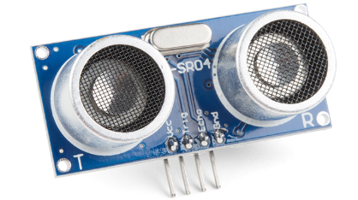

1. Program a LED to turn on when an object is closer than 25 cm to the sensor and turn off when it is further than 25 cm.
2. Program a LED to blink faster as an object gets closer to the ultrasonic distance sensor.
3. When the object is further than 50cm, the LED should be off.
4. As the object moves from 49cm to 21cm the LED should blink at an increasing rate.
5. When the object is closer than 20cm the LED should stay on.