Engineering Level 1 Quiz – Answer Key

1. Which of the following is an example of a standardized unit of measurement?

Select one:

1. Cubit
2. Pace
3. Foot
4. Girth
5. Which of the following units are examples of the metric system?

Select one:

1. Foot
2. Inch
3. Meter
4. Liter
5. Which of the following units are examples of the standard system?

Select one:

1. Mile
2. Kilometer
3. Centimeter
4. Yard
5. This type of engineering drawing is used for brainstorming. It is not used as finished plans.

Select one:

1. Thumbnail
2. Isometric
3. Orthographic
4. This type of engineering drawing is 3D. It has accurate dimensions and scale. It can be used as plans.

Select one:

1. Thumbnail
2. Isometric
3. Orthographic
4. This type of engineering drawing has a front, top, and right-side view. It is commonly used in manufacturing.

Select one:

1. Thumbnail
2. Isometric
3. Orthographic
4. 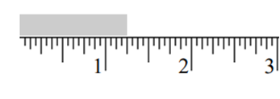What measurement is shown on this ruler?

Select one:

1. 1 ½”
2. ½”
3. 1 ¼”
4. 1 ⅛”
5. 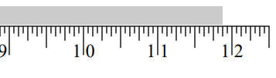What measurement is shown on this ruler?

Select one:

1. 12”
2. 11 ¾”
3. 11 ⅞”
4. 11”
5.  What command do you press first after you start a new file on Onshape?

Select one:

1. Corner Rectangle
2. Line
3. Sketch
4. Extrude
5.  What command do you use to turn a 2D sketch into a 3D object on Onshape?

Select one:

1. Corner Rectangle
2. Line
3. Sketch
4. Extrude