Technical Drawing
UNIT: ENGINEERINg drawing and measuring_LEVEL 1

Thumbnail Sketch

Isometric Drawing


Orthographic Projection
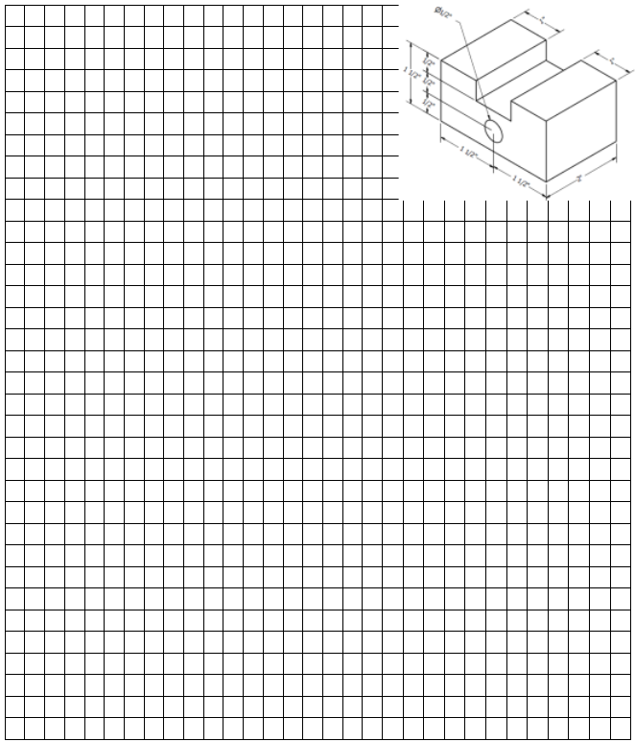

Types of Lines

Object Line:

(Draw your example in this box)

Hidden Line:

(Draw your example in this box)

Center Line:

(Draw your example in this box)

Dimension Line:

Extension Line:

(Draw your example in this box)

