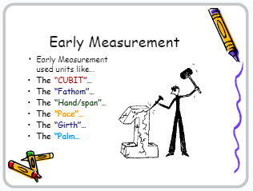 | -The purpose of this slide is to compare the accuracy of modern measurement to the inaccuracy of early measurement.  - Cubit = Distance from elbow to fingertip  - Fathom = Wingspan  - Hand /Span = Width of hand the hand  - Pace = One step length  - Girth = Around the body at the beltline  - Palm = Width of palm  - Have students measure their desk in hands, the height of the door in cubits, etc.  Discuss the pros and cons of this type of measurement.  - Discuss reasons that this type of measurement has been abandoned for modern standardized units
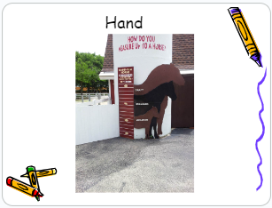
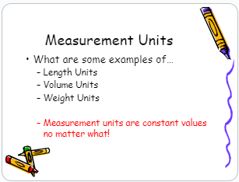 | - Have students give examples of length, volume, and weight units.  Key Understanding: Students should know that measurement units are standardized no matter who is measuring them or where they are measured
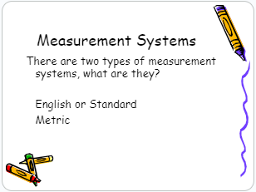
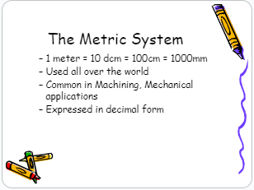 | Ask students to find the pattern in units (base 10)
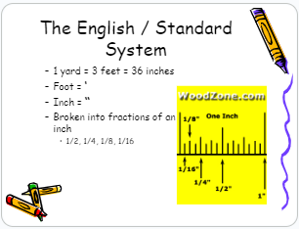 | Ask students to find the pattern in units here (trick question, there is none)  Foot is abbreviated with one mark (‘)  Inch is abbreviated with two marks (“)  Take time to explain the length of the lines as they relate to the inch in the picture.
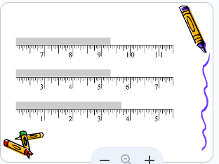 | Work through these inch measurements together as a whole group.

