Engineering Level 3 Quiz

1. 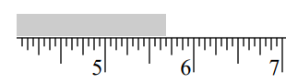 What is the measurement on this ruler?

Select one:

1. 5 ⅜”
2. 5 ⅝”
3. 5 11/16”
4. 5 ¾”
5. 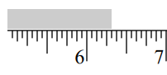What is the measurement on this ruler?

Select one:

1. 6 ¼”
2. 6 ⅜”
3. 6 5/16”
4. 6 7/16”
5. What measurement is shown on this dial caliper?

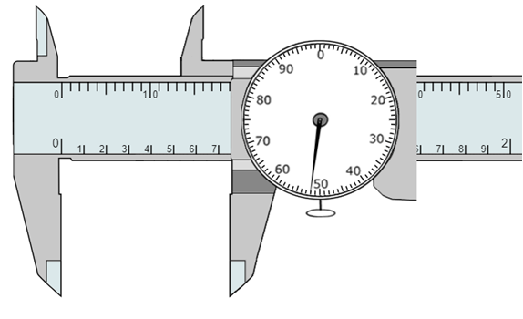

Answer: _________________

1. 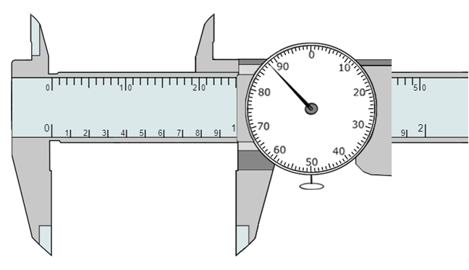What measurement is shown on this dial caliper?

Answer: _________________

1. 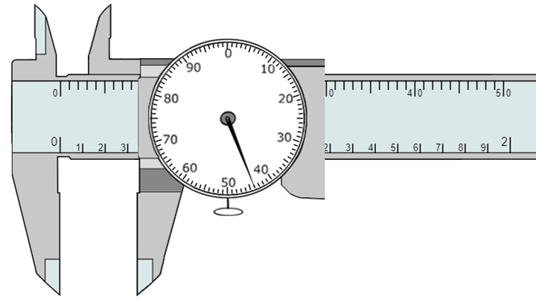What measurement is shown on this dial caliper?

Answer: _________________

1. What workplane is this sketch drawn on?

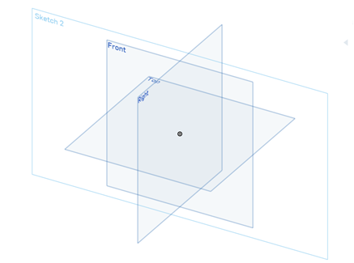

Select one:

1. Front
2. Top
3. Right
4. In the orthographic drawing below, which view shows the hole as visible?

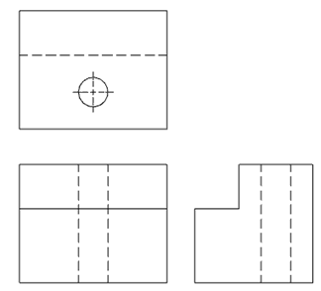

Select one:

1. Front
2. Top
3. Right

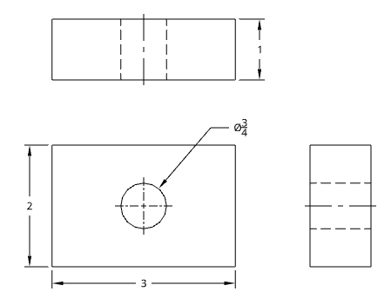Use the following orthographic drawing to answer questions 8-10.

1. How wide is the front view?

Select one:

1. 3”
2. 2”
3. ¾”
4. 1”
5. How tall is the right side view?

Select one:

1. 3”
2. 2”
3. ¾”
4. 1”
5. What is the diameter of the hole?

Select one:

1. 3”
2. 2”
3. ¾”
4. 1”