Hydroponics

UNIT: Environmental Engineering Concepts

STEP 1: Preparing the FlexiPlug

Before you begin building the system, find the FlexiPlug in your kit. Place in a bowl half filled with water and let it saturate for 1-2 minutes. Remove from water and place in a clean sink for 15 minutes to allow it to drain.

STEP 2: Kit components

Check to make sure you have all component in your kit:

1. 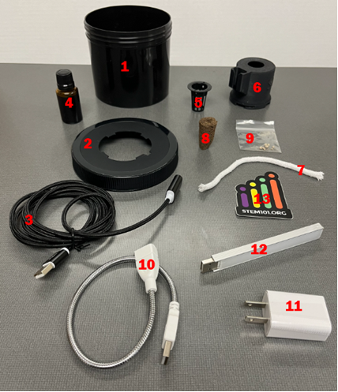Black jar
2. Lid for jar with a cut out
3. Black USB extension cord
4. Brown bottle with nutrients
5. Net
6. 3D printed part for lid
7. Wick
8. FlexiPlug
9. Seeds (Pelleted Salanova Lettuce)
10. White rigid USB extension
11. Charging Block
12. UV light
13. Stem 101 sticker

STEP 3: Prepare the FlexiPlug

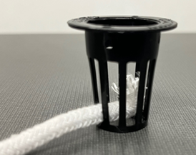Find and set aside the net, FlexiPlug and wick. Insert the wick at the bottom of the net. To do this, push one end of the wick through one of the slots on the side of the net. Be sure that the end of the wick is at the base of the net. See image below. This allows for proper water going to the FlexiPlug. Set the rock wool into the net. It will rest on the wick. Remember this FlexiPlug will be moist from step 1.

STEP 4: Prep the jar

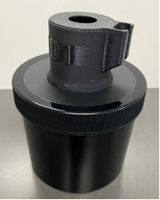Find the black jar, lid and 3D printed tower. Attach the lid to the jar. This makes it a little easier to connect the 3D printed tower to the lid. Place the tower onto the lid. You will see 4 tabs in the opening on the lid. When looking at the tower from the bottom, you will see 4 slots on the tower. Align the slots on the tower over the tabs on the lid. Once aligned you need to turn the tower clockwise to lock the tower in place. The tower will only turn a small amount. It is important the tower locks into the lid. Without doing so, you risk the tower falling off when assembling the light system to the tower. See image below.

STEP 5: Attach the sticker

Apply the Stem 101 sticker to the side of your jar.

STEP 6: Assemble the light system

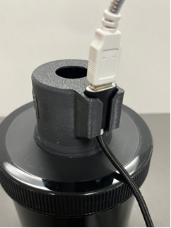Insert the UV light into the proper end of the rigid USB extension. Connect the rigid extension to the long black USb extension cord. Insert the light system into the side of the tower. The black female end of the USB extension cord that is connected to the rigid extension will slide into the side of the tower. See image below.

STEP 7: Filling your jar

With the lid removed, fill your jar with 18 ounces of water. The more pure the water is, the better the growth will be. Distilled water is the best to use. Bottled water could be another option. Tap water will work if that is all you have. Screw the lid back onto the jar. NOTE: You should replace water once a week. Dump out the old water and add 18 ounces of new water weekly.

STEP 8: Insert net and wick

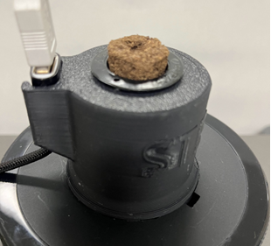With the wick and FlexiPlug assembled to your net, place it in the tower. The wick will go through the hole in the tower first with the net to follow. You will need to use a little force to push the net into position on the tower. The top of the net will rest on the top of the tower. See image below.

STEP 9: Plant your seed

Take one seed from your bag and place it in the hole of the FlexiPlug. With a pen or pencil tip, push the seed down into the FlexiPlug. You should still be able to see the seed. This is important as the seed needs to be visible for the light to shine on it so it can grow.

STEP 10: Light up the system

Your hydroponic system needs the UV light for 18 hours a day. If you are at home, it is a good idea to turn the light on in the morning and shut it off at night. If at school, the light can be off during the school day. Turn it on at the end of the school day and off when you arrive at school. Seeds need rest too. Keeping the light on 24 hours a day is not good for growing.

STEP 11: Add nutrients in weeks 3-4

Add 15 drops of nutrients from the brown bottle on weeks 3 and 4. A drop is a small amount. Example: If you were to put a drop on a flat surface, it will be about the size of a dime.

**NOTE: Don’t forget to replace you water before adding the nutrients.**

STEP 12: Week 5 and beyond

On week 5, you will add 26 drops of nutrients to the water.

**NOTE: Don’t forget to replace your water before adding the nutrients.**

STEP 13: Harvest

When you feel your lettuce has matured enough to harvest, you can remove it and enjoy your hard work. Try it in a salad. Make a sandwich or BLT. Enjoy!