Design a Cool School

UNIT: Environmental and Agricultural Concepts

Overview

Students will critique the design of energy efficient, high-performance schools.

**Objectives**

1. List the different components used to design a high-performance school building.
2. Evaluate the qualities of a high-performance school building.

**ACTIVITY**

**Part 1**

* You will be working in groups of two to four to design a school. First, cut out the School Components pieces and tape them to the School Layout #1 sheet any way you wish. Give your school a name and write it on the top of the sheet.
* After you have completed your initial design, read the [Cool School Design Information Sheets](https://learn2.stem101.org/mod/url/view.php?id=23612).

**Part 2**

* Once your design of a high-performance school is complete (including the Questions About Your School Design), swap designs with another group. Use the High-Performance School Evaluation to provide feedback for the design you are evaluating. Use constructive criticism in a manner that is positive and friendly.
* When you have finished completing the evaluation, return the designs and evaluations to the proper owners. Review the comments made by your classmates and make changes to your design if needed.

**Part 3**

* Present your design to your classmates. Be sure to ask questions to help you understand the thinking behind your peers’ designs.

**Credit**

* This activity is used with permission from the Wisconsin K-12 Energy Education Program (KEEP) *Energy and Your School: A School Building Energy Efficiency and Education Supplement to the KEEP Activity Guide.*

NOTE: There is much more involved in designing a high-performance school building than what is found in the following pages. These are excerpts from the Energy Design Guidelines for High Performance Schools: Cold and Humid Climates produced, in part, by the U.S. Department of Energy. For a comprehensive collection of publications related to high performance school buildings, including the topics of Energy Efficient Building Shell, Lighting and Electrical Systems, and Mechanical and Ventilation Systems, visit [www.eere.energy.gov/buildings/info/publications.html](http://www.eere.energy.gov/buildings/info/publications.html)

**Site Design**

**Introduction**

By orienting your school building linearly on an east-west axis, you can maximize solar access and boost the effectiveness of daylighting strategies, reducing the need for electrical lighting. If deciduous trees are incorporated in the design on the south side, you get the advantage of extra light and heat in the winter when the leaves are gone and shade in the summer when school is out and cooling load can be avoided.

Retaining ecosystems and wildlife habitat surrounding schools and incorporating them into outdoor learning activities enhances student interest in the environment.

**Building Orientation**

To minimize energy use, maximize your potential by siting the school correctly.

* Establish the building on an east-west axis.
* Develop a floor plan that minimizes east- and west-facing glass.
* Large, one-story designs require more energy to offset heat loss through the foundation and roof. Large building footprints also consume more scarce buildable land, especially in urban areas.

**Protecting Local Ecosystems**

The protection of local ecosystems is critical to an environmentally sensitive site design.

* Protect or restore ecosystems and wildlife habitats on the site.
* Protect areas for viewing natural habitat.

**Renewable Energy**

When evaluating site design issues, it is essential to investigate renewable energy systems early in the process. Solar systems need to have solar access, and wind systems require proper placement to be maximized.

* Consider installing building-integrated solar thermal systems for domestic hot water, space heating, and absorption cooling.
* Consider building-integrated photovoltaic systems for electricity production.
* Ensure that solar systems are not shaded and that they are positioned to be visible to the students, teachers, and parents.
* Consider wind energy systems for electricity or well water.
* Consider geothermal heat pumps.

**Daylighting and Windows**

**Introduction**

Of all the high-performance design features typically considered, none will have a greater impact on your school than daylighting. Not only can optimum daylighting design drastically reduce electric lighting energy consumption, it also creates healthier learning environments that may result in increased attendance and improved grades. When properly designed, windows can provide a large portion of lighting needs without undesirable heat gain or glare.

**Building Orientation and Solar Access**

By elongating the school design on an east-west axis, the potential for cost-effective daylighting is maximized.

* Consider daylighting strategies that primarily use south-facing glass and north-facing glass. An elongated building that has its major axis running east-west will increase the potential for capturing winter solar gain through south glass as well as reducing unwanted summer sun that more often strikes on the east and west surfaces. Exposed, eastern- and western-facing glass should be avoided wherever possible because it will allow excessive summer cooling loads, unless it is controlled by glass with low solar heat gain.
* Verify that other exterior design elements or existing site features do not unintentionally shade windows that are designed as daylighting elements

**Renewable Energy Systems**

**Introduction**

There is no shortage of renewable energy. Renewable energy can contribute to reduced energy costs and reduced air pollution. More importantly, the renewable energy systems that you design into your school will demonstrate to the students the technologies that will fuel the 21st century.

Over the past two decades, the cost of renewable energy systems has dropped dramatically. Wind turbines can now produce electricity at less than four cents per kilowatt-hour – a seven-fold reduction in energy cost. Concentrating solar technologies and photovoltaics have dropped more than three-fold during the past 20 years. With improvements in analytical tools, passive solar and daylighting technologies can be implemented into schools with less than a two-year return on investment.

Incorporating renewable energy options into your school design helps students learn firsthand about these cost-effective and energy efficient options. Buildings that teach offer students an intriguing, interactive way to learn about relevant topics like energy and the environment.

**Building Orientation and Solar Access**

Employing renewable energy strategies cost effectively requires the school to be sited to maximize the local natural resources.

* Establish the building on an east-west axis that maximizes southern exposure for daylighting and other solar systems.
* Ensure that adjacent buildings or undesirable trees do not block the intended solar access.

**Building-Integrated Approaches**

To maximize cost effectiveness and improve aesthetics, consider integrating solar thermal and photovoltaic systems into the building shell.

* Integrate solar systems into the overall design to allow the system to serve multiple purposes (e.g., a photovoltaic array that can also serve as a covered walkway).
* Eliminate the additional costs associated with a typical solar system’s structure by designing the building’s roof assembly to also support the solar components.

**Solar Hot Water**

Because of the high hot water demands associated with cafeterias, solar heating systems are often viewed as important strategies in reducing energy bills. In middle schools and high schools, with showers for gym classes and sports programs, it is even more beneficial to address this significant load.

**Wind**

Wind turbines convert kinetic energy in the wind into mechanical power. This mechanical power can be used directly (e.g., water pumping), or it can be converted into electricity.

**Geothermal Heat Pumps**

Geothermal heat pumps work differently than conventional air source heat pumps in that geothermal systems use the more moderately tempered ground as a heat source and heat sink. The result is that geothermal systems are more efficient and more comfortable.

**Photovoltaics**

Photovoltaic modules, which convert sunlight into electricity, have numerous school applications and can be designed as standalone applications or for utility grid-connected applications. Stand-alone systems address small, remotely-located loads. They tend to be more cost-effective than the conventional approach requiring extensive underground wiring. Some of the more appropriate applications include parking and walkway lighting, caution lights at street crossings, security lights, emergency telephone call boxes, and remote signage. Grid-connected systems are often used in large applications where peak load pricing is high or where initial cost is an issue. Because these systems typically rely on the utility to provide power when the sun isn’t shining, battery cost is eliminated and long-term maintenance is reduced greatly. This strategy is typically advantageous to both the utility and the

school because peak demand will be occurring when the sun is shining.

**Water Conservation**

**Introduction**

Water rationing is becoming commonplace in thousands of communities across the country, and the price of water is escalating at unprecedented rates. You can make a considerable difference at your school in reducing community water use. By using water conserving fixtures, implementing graywater or rainwater catchment systems, and using xeriscape practices, schools can easily reduce their municipal water consumption by 25% - 75%. By saving half of the 1 million to 3 million gallons that each of the 90,000 public schools consume every year, more than 200 million gallons of treated water could be saved each day.

**Water-Conserving Landscaping Strategies**

The demand for water will be greatly impacted by the amount of site irrigation required. By limiting new landscaped areas and considering the type of plants and vegetation installed, water needs will be reduced.

* Minimize disruption to the existing site conditions, and retain as much existing vegetation as is practical.
* Incorporate native and drought-resistant plants and exercise xeriscape principles to minimize irrigation requirements.

**Rainwater Management**

Rainwater captured off the roof of your school can be harvested and stored in cisterns for non-potable use. In most rainwater catchment systems, the water runs off the roof into gutters and downspouts, which carry the water to a storage device for future use.

* Use harvested water to irrigate vegetation on school property.
* Use a durable storage container, and locate it away from direct sunlight.

**Recycling Systems and Waste Management**

**Introduction**

Public schools across the country are producing billions of pounds of municipal solid waste each year. You can help reduce much of this waste by recycling or composting at your schools.

By creating schools in which comprehensive waste recycling can be carried out, your design team has an opportunity to instill the practice of recycling in your school’s children. The most successful recycling and waste management programs are integrated into classes, with students making use of mathematical, investigative, and communication skills in implementing these programs.

**Paper, Plastics, Glass, and Aluminum Recycling**

Students are able and eager to participate in recycling programs. Successful recycling programs teach students recycling skills and save money through reuse of materials and disposal fees.

* Allocate space within each classroom, the main administrative areas, and the cafeteria for white and mixed paper waste.
* Provide central collection points for paper and cardboard that are convenient to custodial staff as well as collection agencies or companies.
* Place the receptacles for all recyclables where the waste is generated.
* Locate convenient bins for other materials being recycled.

**Safe Disposal of Hazardous Waste**

Provide a secure space within the school to temporarily store hazardous materials (e.g., batteries, fluorescent lights, medical waste) until they can be taken to a recycling center or safe disposal site.

**Composting**

About a third of the average school’s waste stream is food and other organic materials. Composting is one environmentally friendly way of handling this waste.

* Design a conveniently located composting bin.
* Use vermicompost bins in classrooms as educational tools. The bins use worms to dramatically speed up the decomposition of food.

**Transportation**

**Introduction**

In many school districts across the country, more energy dollars are spent by the school system in transporting students to and from school than in meeting the energy needs of their school buildings.

Incorporating a network of safe walkways and bike paths that connect into the community’s sidewalks and greenways can reduce local traffic congestion, minimize busing costs, and reduce air pollution. By incorporating natural gas, biodiesel, methanol, or solar electric buses into a district’s existing vehicle fleet, you can help to reduce fuel costs and harmful emissions.

**Connecting the School to the Community**

One of the measures of success of a school is the degree to which the school is a vital part of the community. If addressed early in the site selection and design phase, a school can be planned to serve not just the students but also the entire community.

* Design the school so that the athletic fields, gymnasium, media center, and classrooms are accessible and can be shared at appropriate times with the community.
* Provide good access to public transit.
* Through good site design, link the school to the surrounding communities through safe bicycle routes, pedestrian pathways, and greenways.
* Incorporate convenient bicycle parking at the school to discourage single car traffic.

**High-Efficiency and Low-Emission Vehicles**

In addition to incorporating safe and traffic-reducing elements into your site design, consider the use of high-efficiency and low emission vehicles in your fleet. Electric vehicles, hybrid electric vehicles, and vehicles using alternative fuels like ethanol and compressed natural gas are cost-effective and proven options.

**Resource-Efficient Building Products**

A school, like any building, is only as good as the sum of the materials and products from which it is made. To create a high-performance school, your design team must choose the most appropriate materials and components, and combine these components effectively through good design and construction practices.

**The Life Cycle Approach**

To select environmentally preferable products, it is necessary to consider environmental impacts from all the phases in the product’s life cycle. This approach is called life cycle analysis. A product’s life cycle can be divided into the following phases: raw material extraction, manufacturing, construction, maintenance/use, and reuse or disposal.

**Phase 1: Raw Material Extraction**

Building materials are all made from resources that are either mined from the earth or harvested from its surface. The most common materials are sand and stone to make concrete, clay for bricks, trees for wood products, and petroleum for plastics and other petrochemical-based products.

* Eliminate component materials from rare or endangered resources.
* Determine if there are significant ecological impacts from the process of mining or harvesting the raw materials.
* Specify that wood products must be harvested from well-managed forests.
* Determine the origin of the primary raw materials, and select options closer to the site, requiring less shipping.

**Phase 2: Manufacturing**

Manufacturing operations can vary considerably in their impact on the environment. The manufacturer of one product may rely on numerous out-sourcing operations at separate locations or obtain raw materials from another country. Another, less energy-intensive product may be produced in a single, well-integrated operation at one site with raw materials and components coming from nearby locations. Likewise, a particular manufacturer may use a process that relies on toxic chemicals while a competing manufacturer may incorporate environmentally friendly technologies to accomplish the same end.

* Determine if the manufacturing process results in significant toxic hazardous byproducts. Most petrochemical-based products involve some hazardous ingredients, so plastics should be used only when they offer significant performance advantages.
* Specify products that are made from recycled materials.
* Select products that are made from low-intensity energy processes.
* Select products manufactured at facilities that use renewable energy.

**Phase 3: Construction**

To a great degree, the energy and environmental impacts of products and materials are determined by the way they are implemented.

* Avoid products containing pollutants.
* Require the contractor to recycle construction materials.
* Require proper handling and storage of toxic materials at the job site.
* Require that the packaging of products, materials, and equipment delivered to the site be made of recyclable or reusable materials, and discourage unnecessary packaging.

**Phase 4: Maintenance/Use**

How easily building components can be maintained – as well as their impact on long-term energy, environmental, and health issues – is directly linked to the quality of materials, products, and installation.

Select materials, products, and equipment for their durability and maintenance characteristics. Particular attention should be paid to selecting roofing systems, wall surfaces, flooring, and sealants – components that will be subject to high wear-and-tear or exposure to the elements.

**Phase 5: Disposal or Reuse**

Some surfaces in the school, such as carpets, may need to be replaced on a regular basis. The building as a whole will eventually be replaced or require a total renovation. To minimize the environmental impacts of these future activities, designers have to choose the right materials and use them wisely.

* Select materials that can be easily separated out for reuse or recycling after their useful life in the structure.
* Avoid materials that become a toxic or hazardous waste problem at the end of their useful life.

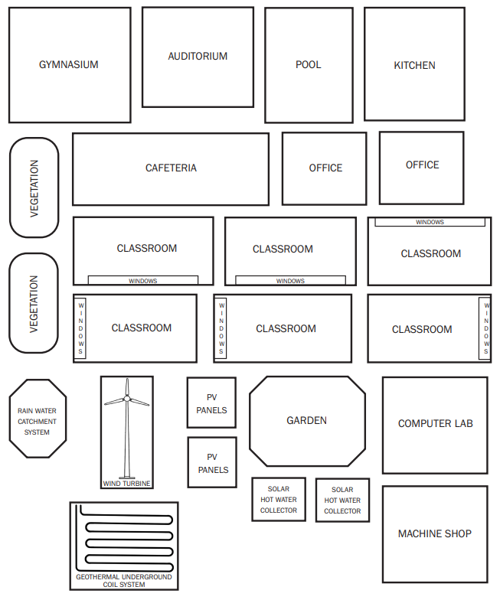**SCHOOl Components**

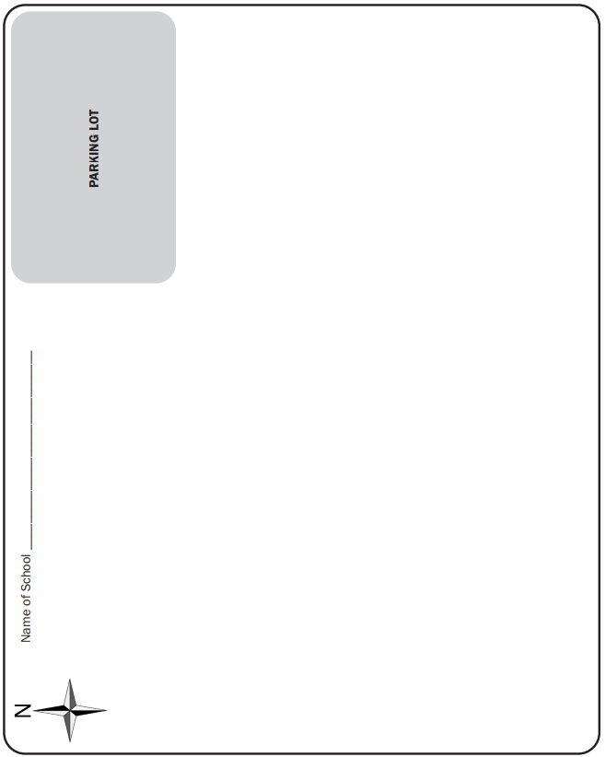**School Layout #1**

**School Layout #2**

**Questions About Your School Design**

* Should accompany your **School Layout #2** design

In an ideal situation, how would the high-performance school you just designed incorporate the following issues?

* **Recycling Systems and Waste Management Plan**

Briefly describe your recycling system and waste management plan

* **Transportation**

Briefly describe your transportation options and how they attribute to your high-performance building plan.

* **Resource-Efficient Building Products**

Briefly describe how the building products used to construct your school are resource-efficient.

**High Performance School Evaluation**

General

1. Name of school: ________________________________________________________________________
2. Name of designer(s): ____________________________________________________________________
3. Were all of the school components used? ____________________________________________________

Site Design

1. How is the building oriented (east-west, north-south, or other)? _________________________________
2. Is there any vegetation or wildlife habitat incorporated into the site design? ________________________
3. Describe two site design features that you find desirable. _______________________________________

______________________________________________________________________________________

1. What about the site design is unclear or needs further explanation? ______________________________

______________________________________________________________________________________

Daylighting and Windows

1. How many rooms have windows facing south? North? East? West? _______________________________
2. Are there any structures or vegetation that may unintentionally shade the windows? ________________
3. Describe two ways daylighting was successfully incorporated in this school design. __________________

______________________________________________________________________________________

1. Are there any areas daylighting could be used to save energy in this building design? _________________

______________________________________________________________________________________

Renewable Energy Systems

1. What are three benefits of having the systems placed where they are? ____________________________
2. What are two things that may be a challenge with having the renewable energy systems placed where they are? ______________________________________________________________________________
3. Do you have any suggestions to improve the design of the renewable energy systems? _______________

______________________________________________________________________________________

Water Conservation

1. Was a rainwater catchment system incorporated into the design? ________________________________
2. If so, what are two good reasons to have it placed where it is? ___________________________________
3. Could a rainwater catchment system be placed elsewhere to be used more efficiently? If so, describe where to place it and why. ________________________________________________________________