Design and monitor a building system

UNIT: environmental and agricultural concepts_Level 2

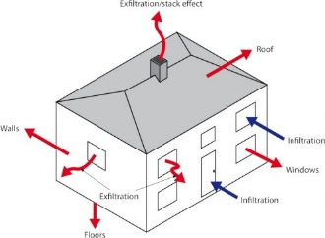The Problem:

Designing and monitoring a building system involves creating and managing the infrastructure to ensure optimal performance, safety, and sustainability. The design phase includes identifying the system's purpose, selecting appropriate technologies, and ensuring compliance with industry standards and regulations. This process often involves detailed planning, simulation, and collaboration between architects, engineers, and stakeholders. Monitoring begins after installation, using sensors, software, and control systems to track functionality, energy consumption, and environmental impact. Regular assessments and real-time data help detect inefficiencies or malfunctions, enabling timely adjustments to enhance system reliability and efficiency. Together, design and monitoring ensure a building system meets user needs while minimizing costs and environmental impact.

# CONSTRAINTS AND CRITERIA

1. Build a scaled building made of foamboard
2. Using Bluetooth technology, connect a temperature sensor to an electronic device. It is not compatible with a Chromebook
3. Collect and analyze data while conducting many different experiments.
4. Follow directions carefully

# MATERIALS:

* Design and Monitor a Building System kit- Order from Stem 101

|  |
| --- |
|  |
|  |

# TOOLS:

* Electronic device for temperature sensor connection. Not compatible with a Chromebook

# DIRECTIONS: