automated greenhouse

UNIT: environmental and agricultural concepts_Level 3

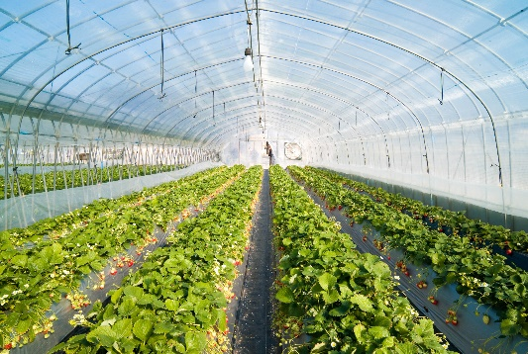The Problem:

A **greenhouse** is a structure designed to provide an optimal environment for growing plants by controlling temperature, humidity, and light. It serves as a protective space that fosters plant growth, particularly in regions with challenging or variable climates. You will construct a greenhouse and program it to control the indoor temperature automatically

# CONSTRAINTS AND CRITERIA

1. Build an automated greenhouse
2. Write a basic code for the automated greenhouse
3. Connect sensors and fans and program

# MATERIALS:

* Automated Greenhouse kit- Order from Stem 101

|  |
| --- |
|  |
|  |

# TOOLS:

* Electronic device for programming

# DIRECTIONS: