Will it Sell?

# UNIT: Manufacturing Level 1

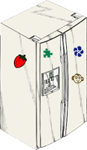

The Problem:

This is an activity that teaches the different aspects of manufacturing through the eyes of the designer. You will develop teams that will design a product utilizing custom, job lot, and mass production as the process to produce a product for sale.

The question is will it sell?

You will develop and design the final product as well as figure out how to set up the management, labor, and design aspects that affect the resulting outcome of the product. There will be unknown circumstances imposed on your team that will challenge your ability to produce the product, but the ultimate challenge will be your team's ability to problem solve and see the outcome of selling the product throughout the process.

# Constraints:

1. Design and develop one refrigerator magnet per team or individually
2. Follow directions carefully
3. Submit Final Refrigerator magnet and Design Brief

# Materials:

* Metallic Sequins
* Craft Sticks
* White glue
* Craft magnets
* Beads
* Sequins and spangles
* Wonder-foam cutouts

# Tools:

* Ruler
* Pencil
* Scissors
* Hot Glue gun

# Directions:

Be sure to check off each step as you progress

* **Step#1** - Develop and design a product (refrigerator magnet) that will be produced utilizing a specific method of manufacturing.

The goal is to effectively produce and sell the largest percentage of products as it relates to the materials supplied. The method of determining this percentage will be decided by a Quality Assessment Manager (principal, local business dignitary, parent, etc.). That person will evaluate the quality of the end result product and determine if it is fit for sale. If it meets the specifications (negotiated by the class prior to the manufacturing run), then each team will try to sell their products throughout the school within a designated period of time.

* **Step#2** - Determine the rules and regulations for the entire company to follow. The product might have cost constraints, total resources, safety considerations, size limits, should be aesthetically pleasing (pretty), manufactured with quality, able to be sold, have skills and tools to perform operations, time available. These rules and laws can be predetermined, but there is a great deal of learning accomplished when they are negotiated.
* **Step#3** - Develop the ideas with a variety of creative methods. Each team or group will need to discuss, sketch, think tank, and exercise creativity. The goal of developing ideas is to get to the final solution.
* **Step #4** - Decide on a solution and draw the final plan. It might be necessary to make a prototype or model (this will utilize some of the materials) for information. This information will help the team set up the manufacturing system. There may be jigs and fixtures that need to be constructed. A final drawing needs to be constructed before final production can begin.
* **Step#5** - Set up the process run. Make a plan, draw the pictures, and simulate making the product. Be careful not to waste your materials since you only get so much to work with. Work out the kinks, shorten distances, and be effective regardless of the system. Run several trials and document data. Make decisions on how to make modifications prior to starting production.
* **Step#6** - Run the production lines. Take notes and make observations about how well the solution works. What might you do better the next time? What worked well? Prepare the products to be presented to the Quality Assurance Manager. Pay attention to detail and make the best product you can! Develop good marketing strategies either before or afterward so that the teams do a nice job selling the product.
* **Step#7** Fill in reflection section of this assignment.

STEP 1: List possible products you could create

STEP 2: Determine the Rules (Write out rules and ideas here)

STEP 3: Generate Ideas (Draw Pictures of Ideas Here)

STEP 4: Select a Solution (Draw your Final Idea Here)

# STEP 5: ReFlections:

After you have finished creating your refrigerator magnet, type a formal report address and answer the following questions.

1. What was the main problem you found in doing this project?
2. What are some key points of interest you found in this lesson?
3. What are some improvements would you make if you had to do this again?
4. Explain how this project incorporated all disciplines such as, math, science, and social studies.
5. Explain the impacts of consumables and the responsibility of product design?

# Grading Rubric

|  |  |  |  |  |
| --- | --- | --- | --- | --- |
|  | Indicator not demonstrated | Indicator partially demonstrated | Indicator adequately demonstrated | Indicator effectively demonstrated |
| **Effort/Task**  **Commitment** | Resistant | Inadequate effort observed for task and /or did not meet most criterion | Appropriate effort and time on- task, also followed criterion. | Extensive effort; uses time well; self motivated, surpassed criterion |
| Points ___/4 | 1 | 2 | 3 | 4 |
| **Appearance** | Inadequate; not neat, little care evident | Adequate; needs more attention to detail | Attractive & visually appealing; neatly completed | Eye catching; aesthetically pleasing, beyond  expectations |
| Points ___/4 | 1 | 2 | 3 | 4 |
| **Creativity** | Uses others ideas | Typical responses; little creativity | Creative: added to more typical idea | Unique ideas or responses |
| Points ___/4 | 1 | 2 | 3 | 4 |
| **Time**  **Management** | Did not complete task | `Needed frequent assistance | Used time appropriately | Autonomous; mature time management |
| Points ___/4 | 1 | 2 | 3 | 4 |
| **Carried Out**  **Plan** | Did not complete plan or lacked plan | Completed with frequent assistance and prompting | Completed plan; limited prompting needed | Followed through well; autonomous; exceeded expectations |
| Points ___/4 | 1 | 2 | 3 | 4 |

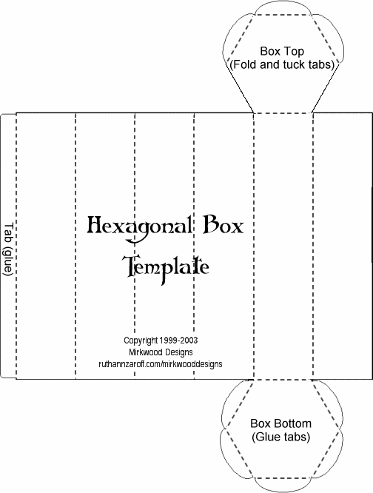

# WRITE YOUR Helpful RESOURCES HERE: