Surface Area Activity

UNIT: ManufacturinG Level 2

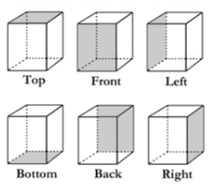

**SURFACE AREA:**

The area of all the outermost layers(faces) of a shape. To the right is a picture of all the faces on a prism. If we were to find the area of all the shaded rectangles and add them together that would be the surface area of this shape.

Your job is to take your fruit container and find the total surface area of your fruit container. SHOW ALL WORK.

|  |  |  |  |  |
| --- | --- | --- | --- | --- |
| **Face #** | **Draw a picture of the face.**  **Measure and label all important lengths of that shape.** | **Formula (refer to formula sheet)** | **Calculate Area. Show all steps.** | **Area of Face**  **(include unit)** |
| 1 |  |  |  |  |
| 2 |  |  |  |  |
| 3 |  |  |  |  |
| 4 |  |  |  |  |
| 5 |  |  |  |  |
| 6 |  |  |  |  |
| 7 |  |  |  |  |
| 8 |  |  |  |  |
| 9 |  |  |  |  |
| TSA | Total Surface Area | Add together all areas of each face. | Show all numbers you are adding together below. | Total Surface Area: |

**FORMULA SHEET**

|  |  |  |
| --- | --- | --- |
| **Shape** | **Picture** | **Area Formula** |
| Square |  | A= L * W |
| Rectangle |  | A= L * W |
| Triangle |  | A= ½ * B * H |
| Parallelogram |  | A= B * H |
| Trapezoid |  | A=(B1 + B2) * ½ * H |