Future City Competition

UNIT: MANUFACTURING_Level 2

CASE STUDY:

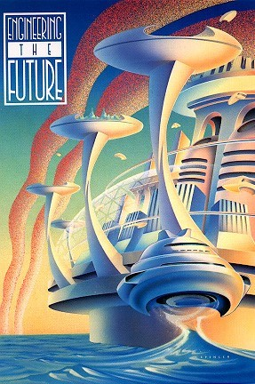Cities of the future must maintain the quality of life for their citizens and the efficient use of land within their borders. To accomplish this, city governments will increasingly rely on redevelopment projects to improve vacant land or to rehabilitate existing structures. Prime locations for redevelopment include downtowns, transit corridors, and locations near employment, shopping, and recreational centers, and cultural amenities. City governments will actively promote redevelopment of areas for the following reasons:

1. Redevelopment reuses properties that may have been underutilized or blighted, helping to encourage revitalization.
2. Redevelopment has the potential to boost jobs, purchasing power, and public amenities in neighborhoods, and to generate tax dollars for local government.
3. Redevelopment projects can reduce pollution.

THE CHALLENGE: DESIGN AND BUILD A FUTURE CITY

Design a future city using SimCity 3000™ competition software. Teams will design and build a city of the future. The city must display residential, commercial, and industrial areas, power plants, roads, and power distribution networks. The city must be energy -efficient, supplying enough energy for its residents. Other considerations are pollution levels, traffic density, and cost efficiency. The solution includes developing a project plan, a logical model of the city using SimCity3000™ software, a team-made physical scale model, an essay, an abstract, and a verbal presentation.

FUTURE CITY COMPETITION OVERVIEW

PHASE I

Computer City Design (disk)

With the help of the engineer mentor and teacher-sponsor, design a logical model of the city using SimCity3000™ software.

PHASE II

Build Model

Your team will construct a physical model of the city using recycled materials. The model can be no larger than 30" (W) x 60" (L) x 24" (H).

PHASE III

Essay

Write a 500-word to 700-word essay on “Creating an Engineering Feasibility Plan” for a specific redevelopment are in a Future City. They also will write a 300-word to 500-word abstract describing their city and some of its services.

PHASE IV

Verbal Presentation

Explain the unique design features of your city during the team verbal presentation to a panel of judges.

RESOURCES

Find all information needed for the case study at: http://www.futurecity.org/