Chocolate Casting

UNIT: MANUFACTURING_Level 3

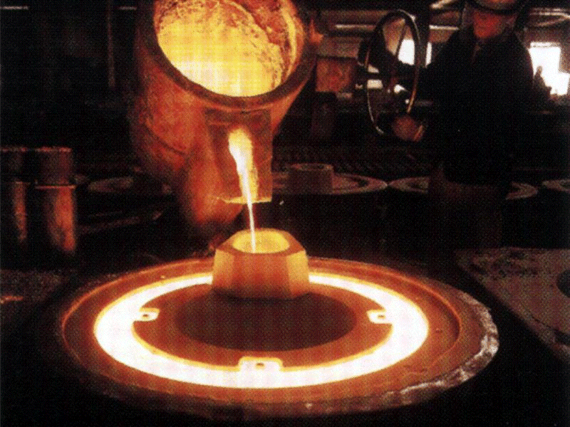THE PROBLEM:

Casting has been around for years and is used to make parts for cars, video games, sporting equipment, and yes, for making candy. Jewelers have used casting to make their designs, automobile manufacturing companies cast their parts for their cars, and sports companies use casting to make protective equipment for players.

You will be given time by your instructor to cast your chocolate mold and then weigh it, recording this information to compare to the class later. The objective is to create the most “perfect” casting by not using too much or little chocolate to fill the mold. Your weight will be compared to the weight of a perfect mold and to your classmates’ molds.

# MATERIALS:

* Bake ware to melt chocolate
* Heat source (microwave, hot plate, oven, other)
* Chocolate
* Water
* Molds (at least 10 molds that are the same)
* Plastic spoons
* Pan for cooling water
* Paper towels
* Scale (centigram preferably)

# DIRECTIONS:

Be sure to check off each step as you progress.

* **Step#1** – Read the problem.
* **Step #2 –** Listen as your teacher reviews the procedures for casting your chocolate mold and write down any special instructions.
* **Step #3 –** With your small group, discuss and write down possible ideas.
* **Step #4 –** Cast your chocolate mold.
* **Step #5 –** After your chocolate cools, weigh it and write down the weight.
* **Step #3 –** Share your weight with the class by telling your teacher or writing it into a class chart.
* **Step #4 –** Discuss how your weight compares to the ideal weight and the weights of your classmates’ casts.
* **Step #5 –** Read the reflection questions and write your answers into the space provided.

# REFLECTION:

Answer the following questions in complete sentences.

1. If you were a candy maker, would you want to have more chocolate in the mold than it can hold?

1. How much variation was there between your mold and the rest of the class?

1. How could you control the amount of chocolate that goes into the mold?

# ASSESSMENT:

**Chocolate Casting Rubric**

|  |  |  |  |  |  |
| --- | --- | --- | --- | --- | --- |
| **Category** | **Exemplary**  **30-24** | **Accomplished**  **18** | **Developing**  **12** | **Beginning**  **6** | **Score** |
| Casting process | The casting process was completed with precision accuracy quantity of chocolate and the final product was weighed appropriately | The casting process was completed with an acceptable quantity of chocolate and the final product was weighed appropriately | The casting process was completed and the final product was weighed appropriately | The casting process was completed however the final product was weighed inappropriately |  |
| Data collection | Student has accurately graphed the class data collected and displayed by the teacher noting where there data point is. | Student has graphed the class data collected and displayed by the teacher noting where there data point is. | Student has graphed the class data collected and displayed by the teacher | The data is incomplete, but an attempt was made |  |
| Written answers | All questions were answered completely, in paragraph form and spelling was checked | All questions were answered completely, in paragraph form however spelling was not checked | All questions were answered as fragments and not in paragraph form and spelling was not checked | Most of the information is missing,  disordered or is confusing |  |

# RESOURCES:

http://www.candylandcrafts.com/

A complete Candy Making, Cake Decorating & Soap Making supply store for the do-it-yourselfer. Over 10,000 stocked items, including → molds, decorating supplies, chocolate, Bakeware, cake and candy ingredients, books, equipment, and packaging supplies.

http://www.hitchiner.com/home.html

Hitchiner Manufacturing Co., Inc. is a privately-held company founded in 1946 and now headquartered in Milford, New Hampshire. It is the world's premier supplier of complete-to-print, high-volume, full-service commercial investment castings.