Design and Test a Balsa Bridge

UNIT: STRUCTURES_LEVEL 3

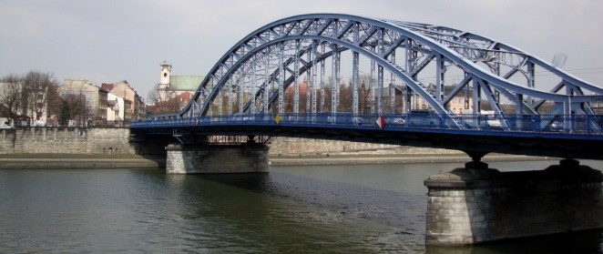The Problem:

Design a Balsa bridge to the specifications on this sheet using only the material provided by the instructor.  The bridge will be tested based upon the ratio of what the bridge weighs to the amount of weight the bridge holds.  The following are the parameters for your design.

# CONSTRAINTS AND CRITERIA

1. Height of the bridge can be no higher than 4” above the testing surface
2. Your structure cannot be more than 1” below the testing surface
3. The span is 10”. This is the opening that your bridge will be spanning.
4. Length of bridge cannot be longer than 12”
5. The roadbed (Area where the test plate will be placed) needs to be at least 3”.
6. The test plate assembly used to apply the force must be placed on the roadbed. The size of the test plate is: .25” x 2.750” x 2.750”.
7. A 3–5-gallon bucket will hook onto the test plate assembly. Sand will be added to the bucket until the structure fails.

# MATERIALS: (per 2-person team. Or per person if not in teams)

* 120” of 1/8”x1/8” balsa
* ½” x 18” chip board strip. This is for your joints.
* Glue. Wood glue is recommended. Hot glue is ok but is heavy. However, it does work to “tack” components together. Any other type of adhesive needs to be approved by your instructor.
* 11”x17” graph paper. This is for the full-size sketch.
* Wax paper
* 3 -5-gallon bucket
* Test plate assembly. This can be purchased through Stem 101 or made by instructor.
* .25” x 2.750” x 2.750” acrylic
* (2) ¼” x 6” J hooks
* Sand

# TOOLS:

* Kitchen scale. This is to weigh the bridge in grams
* Bathroom scale. This is to weigh the bucket of sand
* Ruler
* Hobby knife; balsa cutter; scissors
* Cutting mat
* Hot glue gun

# DIRECTIONS:

# Be sure to check off each step ☑ as you progress.

* **Step#1** – Define the Problem

Read along and listen to your teacher explain the **problem** listed above.

* **Step#2** – Define the Criteria

Read along and listen as your teacher reads through and explains the **constraints** and **criteria**.

* **Step#3** – Develop Ideas

Thumbnail sketches.  Create 3 different designs below.

* 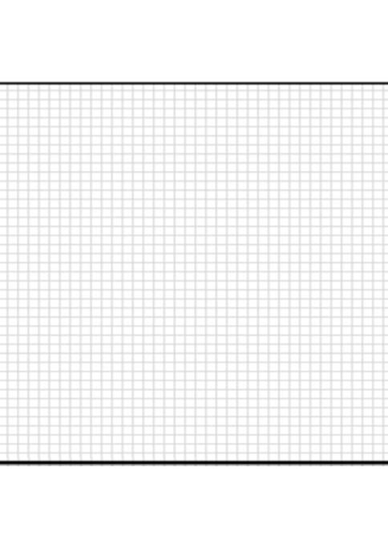**Thumbnail Sketch 1:**
* **A grid paper with black border

  Description automatically generatedThumbnail Sketch 2:**
* **Thumbnail Sketch 3:**
* **Step #4** – Develop a Solution

Decide which design is best and create a full-scale sketch on 11” x 17” graph paper.  Use a ruler to create straight lines.  It must show material thickness and all parts of the bridge.  This sketch will be used as your template for the actual bridge construction. Once the sketch is checked off, your instructor will give you the allotted material and you will build your bridge.

* **Step #5** – Test and Evaluate

It is time to test your bridge!  Remember to weigh your bridge before testing.

* **Step #6** – Present

After testing is completed, calculate the ratio of the bridge weight to the weight your bridge held.  Your instructor will give you the formula.  Measuring units must be the same.  Present your results to the class.

# REFLECTION QUESTIONS:

# Describe the performance of your bridge. What were its strengths? What were its weaknesses?

# Describe the performance of the bridge that held the most weight in the class. What structure shapes were used?

# Describe a bridge that you found to be unique or surprising? How did it perform?

# GRADING RUBRIC:

|  |  |  |  |  |
| --- | --- | --- | --- | --- |
|  | Indicator  not demonstrated | Indicator  partially demonstrated | Indicator adequately demonstrated | Indicator  effectively  demonstrated |
| **Design Brief & Refection Questions**        Points /4 | **Incomplete**  Less   than 50%  complete    1 | **Inadequate**  Mostly complete; Criterion not met        2 | **Adequate**  Criterion met;  more attention  to neatness or  detail needed    3 | **Exceptional**  Meets or exceeds expectations; high effort, attention to detail    4 |
| **Sketches**          Points /4 | **Incomplete**  Incomplete or   missing more than  one constraint requirement    1 | **Inadequate**  Mostly  complete;  Criterion not  fully met      2 | **Adequate**  Sketches and summaries are complete and meet constraint  requirements    3 | **Exceptional**  Excellent details in sketches, and labels      4 |
| **Model Build**              Points __ /4 | **Incomplete**  Incomplete;  bridge  unable  to test    1 | **Inadequate**  Bridge  differs greatly from sketches      2 | **Adequate**  Bridge  mostly matches sketches    3 | **Exceptional**  Creative or innovative bridge    4 |
| **Effort & Teamwork**  **(If Applicable)** | **Incomplete**  Team member refused to participate | **Inadequate**  Frequent   reminders needed from teacher and teammates to stay on task | **Adequate**  Very minimal prompting needed from teacher or teammates to stay on task | **Exceptional**  Team completed all tasks using  effective  teamwork strategies |
| Points /4 | 1 | 2 | 3 | 4 |