Balsa Glider

UNIT: Transportation Technologies

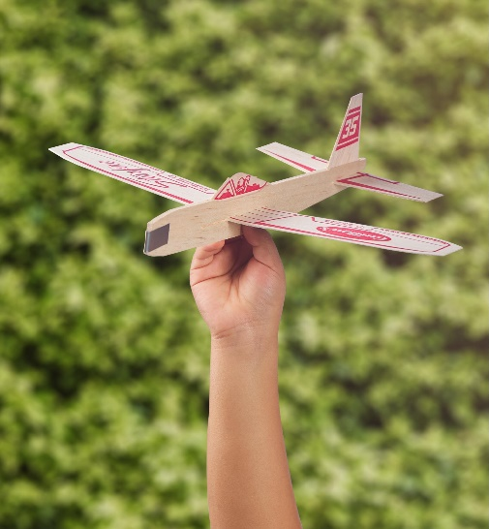THE PROBLEM:

We need to change the design of a balsa wood glider to fly a longer distance or to stay in the air for a longer amount of time. To do this we’re going to look at a control model and examine the four forces on an aircraft: lift, thrust, drag, and weight. We are then going to modify multiple gliders in an effort to improve either hang time or distance traveled.

Requirements / Constraints:

1. Write down the changes you plan to make before you make them.
2. Write down why you think your plan will be beneficial.
3. Scientifically measure the difference your modifications have made.

**MATERIALS:**

* Balsa wood glider kit
* Sandpaper
* Glue
* Tape

# TOOLS:

* Heavy-Duty Scissors
* Stopwatch
* Measuring Tape

# DIRECTIONS:

Be sure to check off each step ☑ as you progress.

* **Step#1** – Read through the design brief.
* **Step#2** – Listen as your teacher reviews constraints, the materials, and specific testing procedures. If necessary, write down any additional constraints.
* **Step#3** – Using the stopwatch and measuring tape, establish the control distance and hang time on an unmodified glider kit. Have at least three trials and find the average of them for both numbers. Write this information in the space provided.
* **Step #4** – Brainstorm some ideas for how you can change your wings and discuss these ideas with your group. Write and sketch your ideas in the space provided.
* **Step #5** – Once your group has determined which idea you will use, sketch your final solution in the space provided, and write down why you think the modifications will help.
* **Step #6** – Construct and modify your gliders.
* **Step #7** – Test your modified gliders in the same manner as the original glider, through measuring the time and distance in three separate trials and finding the averages. Write your data in the space provided.
* **Step #8** – Discuss the results with your group and write a brief presentation to share with your classmates. Talk about why you chose your design and how it did or did not work as expected. Listen as other groups present their designs.
* **Step #9** – Read the reflection questions and write your answers in complete sentences.

# CONTROL DATA:

Write down the distances and hang times for three trials of an unmodified glider. Find the average distance and average hang time.

**GENERATE IDEAS:**

Draw pictures of your ideas here.

**FINAL SOLUTION**

Draw a picture of your group’s final designs here. Write down the distances and hang times for three trials of each glider. Find the average distance and average hang time for each design and write it next to the appropriate design.

**REFLECTION:**

Answer the following questions in complete sentences.

1. What was the most effective modification for time? Why?
2. What was the most effective modification for distance? Why?
3. If you were to perform this activity again, what would you have done differently?
4. What was one thing your group did especially well?