EGG-cellent Landing

UNIT: Transportation Technologies

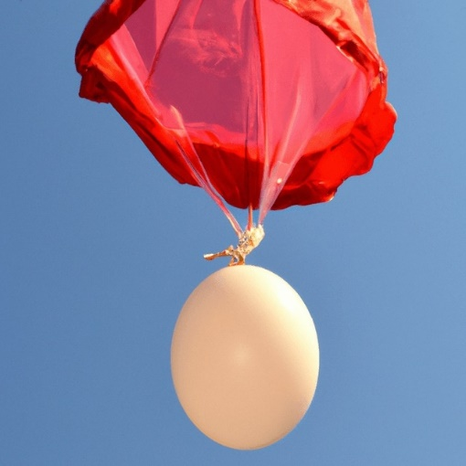THE PROBLEM:

Build an egg lander that will carry an egg safely to the ground when dropped on a hard surface.

Constraints:

1. Protect the egg from the initial impact and any irregular bouncing that occurs after.
2. Keep the egg in a sealed bag at all times.
3. Secure the egg to the lander.
4. Test at various heights.

**MATERIALS:**

* Zip-lock sandwich bag
* Styrofoam cups
* Foam sheets
* Balloons
* Tape
* Egg

# TOOLS:

* Scissors

# DIRECTIONS:

Be sure to check off each step ☑ as you progress.

* **Step#1** – Read the design brief.
* **Step#2** – Listen as your teacher reviews constraints, the materials, and specific testing procedures. If necessary, write down any additional constraints or materials.
* **Step#3** – Brainstorm some ideas and discuss them with your group. Write and sketch these ideas in the space provided and include the materials you would need for your designs.
* **Step #4** – After your group determines which idea to use, sketch your final solution in the space provided and write down the materials you will need.
* **Step #5** – Construct your lander.
* **Step #6** – Present your lander to your teacher and get your egg. Keep the egg in a sealed bag to prevent it from making a mess if it breaks. Test your lander at different heights.

**Note: Follow your teacher’s directions for testing.**

* **Step #7** – Write a brief presentation to give to the class. Talk about why you chose your design and the results. Listen as other groups present their designs.
* **Step #8** – Read the reflection questions and write down your answers in complete sentences.

**GENERATE IDEAS:**

Draw pictures of your ideas here. Be sure to include the materials you will need.

|  |
| --- |
|  |
| Materials Required for Building: |

**FINAL SOLUTION**

Draw a picture of your group’s final solution here.

**REFLECTION:**

Answer the following questions in complete sentences.

1. How much did you feel your ideas impacted the final group design?
2. Did your group make revisions as you were building? If so, what?
3. Explain what happened to your egg at each height.
4. If you could add any different material to your lander, what would you add and why?
5. After seeing how your lander worked, what would you do differently if you were to make another lander?