UNIT: CATAPULT

MOTION MATH- MEASURE ACCELERATION & MOMENTUM
Your Mission:
You’re a motion scientist on a speed-testing team! Your job is to launch different objects, measure how far and fast they go, and calculate their speed, acceleration, and momentum. Use real data to uncover how motion and mass work together in the world of physics!

Focus: Speed, Acceleration & Momentum
Materials:
- Launcher (from Station 1 or same style)
- Cotton ball
- Heavier test objects (small eraser, foil ball, coin, etc.)
- Ruler or tape measure (2 meters or more)
- Stopwatch or timer
- Tape (to mark distances)
- Calculator
- Recording sheet or data table

STUDENT DIRECTIONS:
🧪 Set Up:
STEP 1: Choose your projectile:
  - Start with a cotton ball (light mass).
  - You'll test different masses later!
STEP 2: Set up your launcher (from Station 1 or use the same kind):
  - Make sure it’s stable and ready to fire in a straight line.

STEP 3: Mark a start line and use tape or a ruler to create a measuring track (at least 2 meters long if possible).

⏱️ Collect Motion Data:

STEP 4: Measure Distance:
  - Use a tape measure or ruler to mark where the projectile lands.
  - Record how far it traveled (meters or centimeters).
STEP 5: Measure Time:
  - Use a stopwatch or timer to record how long the projectile is in motion (from launch to landing).
  - Have one student time while another launches.
STEP 6: Repeat 3 times for accuracy. Then change mass (e.g., small eraser, aluminum foil ball, or coin) and repeat.
✏️ Do the Math:

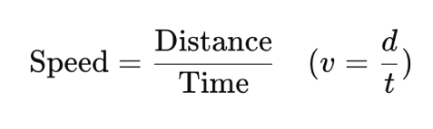
STEP 7: Estimate Average Speed (v):

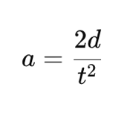
Calculate Acceleration (a):
Use this formula:

Calculate Momentum (p):
First, record the estimated mass of your object in kg (e.g., 0.01 kg for a cotton ball).
Then:
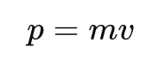

DATA TABLE TEMPLATE:
Object | Mass (kg) | Distance (m) | Time (s) | Speed (m/s) | Acceleration (m/s²) | Momentum (kg·m/s)
Cotton ball | 0.01
Heavier Object | 0.05

REFLECTION:

1. How did changing the mass of the projectile affect the speed and momentum?
→ ___________________________________________________________

2. Was more pull-back (tension) always better for distance or speed? Why or why not?
→ ___________________________________________________________

3. What patterns do you notice in how mass, speed, and momentum are connected?
→ ___________________________________________________________

Standards Alignment

NGSS: HS-PS2-1, HS-PS2-2 STEL: STEL 1H, STEL 3I, STEL 4G, STEL 5G, STEL 8G CCSS: CCSS.MATH.CONTENT.HSN.Q.A.1–3, CCSS.MATH.CONTENT.HSA.CED.A.1–2, CCSS.MATH.CONTENT.HSS.ID.B.6, CCSS.MATH.CONTENT.HSS.ID.C.7

