UNIT: CATAPULT

GRAPHING ENERGY
Your Mission:
You’re a physics data analyst in the Energy Lab! Your task is to launch a cotton ball, measure how fast it travels, and calculate how much kinetic energy it has. Then, use your data to discover how speed and energy are connected. Let’s turn motion into math!

Focus: Speed, Kinetic Energy & Data Patterns
Materials:
- Catapult
- Stopwatch
- Measuring tape
- Graph paper (optional)

STUDENT DIRECTIONS:
Step 1: Set up your station.
- Place the catapult on a flat surface.
- Measure and mark a straight distance (e.g., 1 meter) using the measuring tape.

Step 2: Launch the projectile.
- Place a cotton ball in the catapult.
- Launch it and start the stopwatch as soon as the cotton ball is released.
- Stop the stopwatch when the cotton ball reaches the target distance or hits the ground.
- Record the time it took.

Step 3: Measure the distance.
- If the cotton ball didn’t travel exactly 1 meter, use the measuring tape to record the actual distance it traveled.

Step 4: Calculate the speed.
Use the formula:
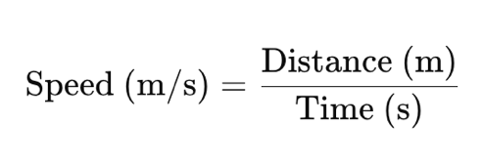

Record your result in the data table.
Step 5: Calculate kinetic energy (KE).
Use the formula:
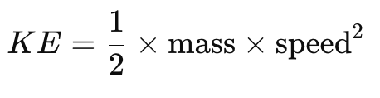

- The cotton ball’s mass is approximately 0.0005 kg.
- Calculate and record the KE in joules (J).
Step 6: Repeat for 3 trials.
- Complete at least 3 launches.
- Record the distance, time, speed, and KE for each trial.
Trial | Distance (m) | Time (s) | Speed (m/s) | KE (J)
1
2
3
Step 7 (Optional): Graph your results.
- On graph paper, plot Speed (x-axis) and KE (y-axis) for your 3 trials.
- Observe the shape of the curve and how KE changes as speed increases.

What do you notice?
- On graph paper, plot Speed (x-axis) and KE (y-axis) for your 3 trials.
- Observe the shape of the curve and how KE changes as speed increases.

Standards Alignment
NGSS: MS-PS3-1 STEL: STEL 1F, STEL 4F, STEL 5D, STEL 7E, STEL 8E CCSS: CCSS.MATH.CONTENT. 6.RP.A.3, CCSS.MATH.CONTENT. 6.EE.B.6, CCSS.MATH.CONTENT.7.EE.B.3 & 7.EE.B.4, CCSS.MATH.CONTENT. 8.F.B.5, CCSS.MATH.CONTENT. 8.SP.A.1 & 8.SP.A.3

