⚡ Station 4: Graphing Energy
🔬 NGSS: MS-PS3-1 – Kinetic Energy & Speed Relationship
Goal: Measure the projectile's speed and calculate kinetic energy (KE).

🚀 YOUR MISSION:
You’re a physics data analyst in the Energy Lab! Your task is to launch a cotton ball, measure how fast it travels, and calculate how much kinetic energy it has. Then, use your data to discover how speed and energy are connected. Let’s turn motion into math!

🎯 FOCUS:
Speed, Kinetic Energy & Data Patterns

Materials at this station:
- Catapult
- Stopwatch
- Measuring tape
- Graph paper (optional)

✅ Student Directions:
Step 1: Set up your station.
- Place the catapult on a flat surface.
- Measure and mark a straight distance (e.g., 1 meter) using the measuring tape.
Step 2: Launch the projectile.
- Place a cotton ball in the catapult.
- Launch it and start the stopwatch as soon as the cotton ball is released.
- Stop the stopwatch when the cotton ball reaches the target distance or hits the ground.
- Record the time it took.
Step 3: Measure the distance.
- If the cotton ball didn’t travel exactly 1 meter, use the measuring tape to record the actual distance it traveled.
Step 4: Calculate the speed.
Use the formula:
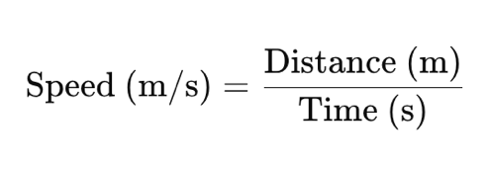

Record your result in the data table.
Step 5: Calculate kinetic energy (KE).
Use the formula:
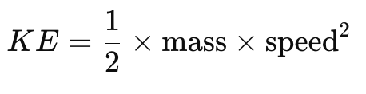

- The cotton ball’s mass is approximately 0.0005 kg.
- Calculate and record the KE in joules (J).
Step 6: Repeat for 3 trials.
- Complete at least 3 launches.
- Record the distance, time, speed, and KE for each trial.
Trial | Distance (m) | Time (s) | Speed (m/s) | KE (J)
1
2
3
Step 7 (Optional): Graph your results.
- On graph paper, plot Speed (x-axis) and KE (y-axis) for your 3 trials.
- Observe the shape of the curve and how KE changes as speed increases.

✏️ What do you notice?
→ What happens to KE as speed increases?
→ ___________________________________________________________

⚡ Station 4: Graphing Energy
🔬 NGSS Connection: MS-PS3-1 – Construct and interpret graphical displays of data to describe the relationships of kinetic energy to the mass of an object and to the speed of an object.

✅ ITEEA STEL Standards – Middle School
- STEL 1F – Technological systems include inputs, processes, and outputs.
→ Students input energy through the catapult, observe the process of motion, and record the output as kinetic energy.
- STEL 4F – The engineering design process involves testing and refining designs.
→ Students conduct repeated trials to improve measurement accuracy and energy understanding.
- STEL 5D – Data is used to evaluate technological systems.
→ Data collected from speed and distance is used to calculate and evaluate kinetic energy.
- STEL 7E – Mathematics is used to analyze, interpret, and predict outcomes.
→ Students calculate speed and kinetic energy, then graph results to observe mathematical trends.
- STEL 8E – Applying science, math, and engineering concepts helps solve real-world problems.
→ Learners apply physics formulas to analyze projectile motion and energy transfer.

✅ Common Core Math Standards – Middle School
- 6.RP.A.3 – Use ratio and rate reasoning to solve real-world and mathematical problems.
→ Students use distance/time to calculate speed (a rate).
- 6.EE.B.6 – Use variables to represent numbers and write expressions.
→ Students substitute values into speed and kinetic energy equations.
- 7.EE.B.3 & 7.EE.B.4 – Solve multi-step real-life and mathematical problems using numerical and algebraic expressions and equations.
→ Students perform multiple calculations involving distance, time, speed, and KE.
- 8.F.B.5 – Describe qualitatively the functional relationship between two quantities.
→ Students graph the relationship between speed and KE and interpret the curve.
- 8.SP.A.1 & 8.SP.A.3 – Investigate patterns of association in bivariate data.
→ By graphing speed and kinetic energy, students observe trends and associations between variables.

💡 Summary:
This station bridges physics and math by asking students to calculate speed and kinetic energy, then represent their findings graphically. It supports systems thinking, mathematical modeling, and data analysis, all key practices in both ITEEA and Common Core standards for middle school.

