UNIT: ELECTRICAL CIRCUITS

ACT-Based Science: Ohm’s Law Investigation (Data Analysis & Graphing)

These hands-on science activities align with ACT Science College and Career Readiness Standards (CCRS) and reinforce key skills like data interpretation, experimental design, and scientific reasoning—all while deepening students’ understanding of electric circuits.
ACT Skills Practiced:
- Interpreting data tables & graphs
- Identifying patterns & relationships
- Applying scientific formulas

Objective:
Students will collect and analyze data to determine the relationship between voltage, current, and resistance using Ohm’s Law (V=IR).

Materials:
- Batteries (9V)
- Resistors (various ohm values)
- Wires & alligator clips
- Multimeters (to measure voltage & current)
- Data table worksheet
STUDENT DIRECTIONS:
Goal: Determine the mathematical relationship between voltage, current, and resistance using Ohm’s

STEP 1: Build a Simple Circuit
- Gather your battery, one resistor (start with 10Ω), wires, and multimeter.
- Connect the resistor in series with the battery using alligator clips.
- Attach the multimeter in series to measure current (I) in amperes (A).
- Switch the multimeter mode to voltage (V) and connect it in parallel with the resistor to measure voltage across it.
- Double-check your connections with your teacher before turning on the circuit.

STEP 2: Collect and Record Data
- Once your circuit is complete and safe, measure:
  - The voltage across the resistor (should be ~9V).
  - The current flowing through the circuit.
- Record the data in the table below.
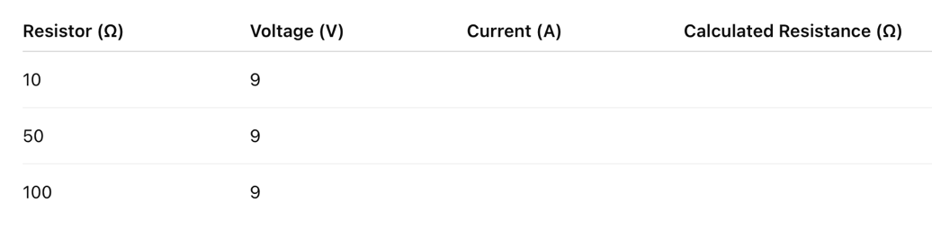
- Repeat steps using different resistor values (50Ω and 100Ω).

Hint: Use the Ohm’s Law equation to calculate resistance if needed: R = V / I

STEP 3: Graph Your Data
- On graph paper or using a digital tool:
  - X-axis = Current (I)
  - Y-axis = Voltage (V)
- Plot all three data points from your table.
- Draw a best-fit line.
- Label your axes and add a title: “Voltage vs. Current in a Simple Circuit”

STEP 4: Analyze Your Results
Answer these questions in complete sentences:
- What pattern do you notice between voltage and current in your graph?
→ ____________________________________________________________________________
→ ____________________________________________________________________________
- What happens to current when resistance increases?
→ ____________________________________________________________________________
→ ____________________________________________________________________________
- Does your data follow Ohm’s Law? Why or why not?
→ ____________________________________________________________________________
→ ____________________________________________________________________________
- What could explain any errors or differences in your measurements?
→ ____________________________________________________________________________
→ ____________________________________________________________________________

ACT-Style Data Table:
Resistor (Ω) | Voltage (V) | Current (A) | Calculated Resistance (Ω)
10Ω | 9V | 0.9A | ?
50Ω | 9V | 0.18A | ?
100Ω | 9V | 0.09A | ?
Discussion Questions:
- Based on your graph, what relationship do you observe between voltage and current?
- How does increasing resistance affect current flow?
- Does your data support Ohm’s Law? Why or why not?
ACT-Style Multiple Choice Question:
- Which of the following best describes the relationship between voltage and current in a circuit with a fixed resistance?
- Exponential
- Quadratic
- Linear
- Random

🌟 Why These ACT-Based Science Activities Matter
- Prepares students for ACT Science by reinforcing data analysis, graph interpretation, and experimental design.
- Develops STEM inquiry skills—helping students think like scientists and engineers.
- Connects electrical circuits to real-world applications, from home wiring to renewable energy technologies.

