UNIT: ELECTRICAL CIRCUITS

ACT-Based Science: Renewable Energy & Circuit Efficiency (Scientific Evaluation & Experimental Design)

These hands-on science activities align with ACT Science College and Career Readiness Standards (CCRS) and reinforce key skills like data interpretation, experimental design, and scientific reasoning—all while deepening students’ understanding of electric circuits.
ACT Skills Practiced:
- Evaluating competing explanations
- Designing experiments
- Interpreting real-world applications

Objective:
Students will test the efficiency of solar-powered circuits and analyze how environmental factors (e.g., shade, angle, and circuit design) impact energy output.

Materials:
- Small solar panels (1-5V output)
- Multimeters
- LED lights
- Wires & resistors

STUDENT DIRECTIONS:

Goal:
Investigate how environmental conditions affect the efficiency of solar-powered circuits by measuring voltage output under different scenarios.

STEP 1: Build a Basic Solar Circuit
- Connect the solar panel to the multimeter using alligator clips to measure voltage across the panel.
- Place the panel under direct sunlight at a 90° angle (straight up, facing the sun).
- Record the voltage output.
- Add the LED light or motor into the circuit as a load.
- Observe whether the LED turns on or motor spins. Record your observation.

STEP 2: Test the Impact of Panel Angle
- Use a protractor or estimate angles to tilt the panel to the following positions: 90°, 45°, 30°, and 10°.
- At each angle:
  - Record the voltage output.
  - Observe the brightness of the LED or speed of the motor (qualitatively).
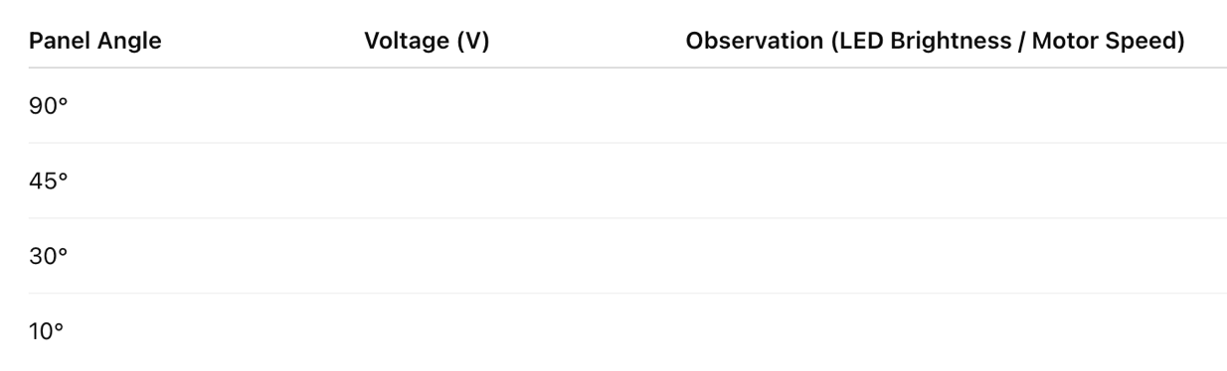
  - Repeat the test at least twice and average your readings for accuracy.
STEP 3: Compare Circuit Designs: Series vs. Parallel
- Build two different circuits using two LEDs or two loads:
  - One in series
  - One in parallel
- Keep the solar panel angle constant at 90°.
- Measure voltage and current in each circuit.
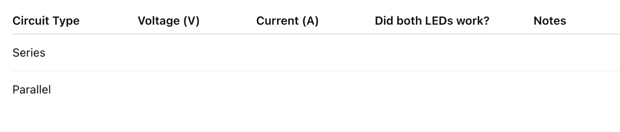
- Record observations on which design worked better and why.

STEP 4: Analyze the Data
Create two graphs:
- Voltage vs. Panel Angle
- Circuit Efficiency Comparison (Series vs. Parallel)

Graphing Tips:
- Use the x-axis for panel angle or circuit type.
- Use the y-axis for voltage output.
- Title your graphs and label all axes.

Discussion Questions

Write answers in complete sentences:
- What trend did you observe between panel angle and voltage?
→ ____________________________________________________________________________
→ ____________________________________________________________________________
- Why do you think the panel produced more voltage at certain angles?
→ ____________________________________________________________________________
→ ____________________________________________________________________________
- Which circuit setup was more efficient—series or parallel? Why?
→ ____________________________________________________________________________
→ ____________________________________________________________________________
- What real-world applications rely on maximizing solar panel efficiency?
→ ____________________________________________________________________________
→ ____________________________________________________________________________
- What variable would you test next if you repeated this experiment?
→ ____________________________________________________________________________
→ ____________________________________________________________________________

ACT- Style Data Analysis Question:
A student tested how panel angle affects solar output. Their data is below:
Panel Angle | Voltage Output (V)
90° (Direct Sunlight) | 4.8V
45° | 3.7V
30° | 2.5V
10° | 1.2V

- Which conclusion is best supported by the data?
- The voltage output increases as the panel angle decreases.
- The voltage output is highest when the panel is perpendicular to sunlight.
- The voltage output remains the same regardless of angle.
- Solar panels generate more electricity at lower angles.

🌟 Why These ACT-Based Science Activities Matter
- Prepares students for ACT Science by reinforcing data analysis, graph interpretation, and experimental design.
- Develops STEM inquiry skills—helping students think like scientists and engineers.
- Connects electrical circuits to real-world applications, from home wiring to renewable energy technologies.

