UNIT: ELECTRICAL CIRCUITS

ACT-Based Science: Series vs. Parallel Circuits – Efficiency Test (Experimental Design & Hypothesis Testing)

These hands-on science activities align with ACT Science College and Career Readiness Standards (CCRS) and reinforce key skills like data interpretation, experimental design, and scientific reasoning—all while deepening students’ understanding of electric circuits.
ACT Skills Practiced:
- Designing & conducting experiments
- Evaluating multiple variables
- Interpreting scientific data

Objective:

Students will compare the efficiency and brightness of bulbs in series vs. parallel circuits and analyze which setup is better for practical applications.

Materials:
- Batteries (9V or AA)
- Light bulbs (small LED or incandescent)
- Wires & alligator clips
- Multimeters

STUDENT DIRECTIONS:

Goal:
Compare the brightness, voltage, and current of light bulbs in series vs. parallel circuits. Use data to evaluate which setup is more efficient for real-world applications like home wiring.

Part 1: Build and Test a Series Circuit
- Set up your series circuit:
  - Connect the positive end of the battery to the first light bulb.
  - Connect the second light bulb in line with the first (end-to-end).
  - Connect the circuit back to the negative end of the battery.
  - Make sure the bulbs light up. If not, check connections.
- Observe & record:
  - Look at the brightness of both bulbs. Are they dim or bright?
  - Write down your qualitative observation.
- Measure with the multimeter:
  - Use the multimeter to measure:
    - Voltage across each bulb
    - Current in the entire circuit
  - Record your values in the data table.

Part 2: Build and Test a Parallel Circuit
- Set up your parallel circuit:
  - Connect the positive wire from the battery to both bulbs’ positive terminals (using a Y-shaped wire split).
  - Do the same for the negative wire—connect both bulbs’ negative terminals back to the battery.
  - Ensure both bulbs light up. If not, recheck wiring.
- Observe & record:
  - Compare the brightness of both bulbs.
  - Are they brighter than before? The same? Record your observation.
- Measure with the multimeter:
  - Measure:
    - Voltage across each bulb
    - Total current in the circuit
  - Write values in the table.
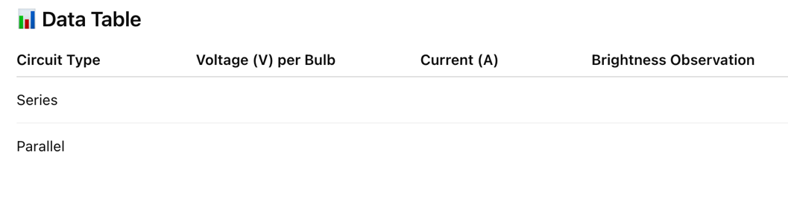

Analysis & Discussion Questions:
Answer these questions in full sentences using your data.
- How does bulb brightness compare between the series and parallel circuits?
→ ____________________________________________________________________________
→ ____________________________________________________________________________
- What did you notice about the voltage across each bulb in both circuits?
→ ____________________________________________________________________________
→ ____________________________________________________________________________
- How did the total current compare between the two circuits?
→ ____________________________________________________________________________
→ ____________________________________________________________________________
- Which circuit design is more efficient and why?
→ ____________________________________________________________________________
→ ____________________________________________________________________________
- Which design is more practical for home wiring? Explain.
→ ____________________________________________________________________________
→ ____________________________________________________________________________
ACT-Style Data Table:
Circuit Type | Voltage (V) per Bulb | Current (A) | Brightness Observation
Series | ? | ? | ?
Parallel | ? | ? | ?
Discussion Questions:
- How does bulb brightness compare between series and parallel circuits?
- How does current differ between the two circuit types?
- Which circuit is more practical for home electrical wiring? Why?

ACT-Style Multiple Choice Question:
- A student observes that light bulbs in a series circuit appear dimmer than those in a parallel circuit. What is the most likely explanation?
- The series circuit provides more voltage to each bulb.
- The parallel circuit provides each bulb with full voltage from the power source.
- The current in the series circuit is higher than in the parallel circuit.
- The series circuit allows for independent bulb operation.

🌟 Why These ACT-Based Science Activities Matter
- Prepares students for ACT Science by reinforcing data analysis, graph interpretation, and experimental design.
- Develops STEM inquiry skills—helping students think like scientists and engineers.
- Connects electrical circuits to real-world applications, from home wiring to renewable energy technologies.

