UNIT: Electrical Circuits

Final Challenge: Build Your Rescue Base System!

Objective:

Design and build a rescue system that uses at least two types of energy (light, sound, or motion) to keep people or animals safe in the jungle!

Materials:

* LED lights
* Buzzers or motors
* Battery packs
* Alligator clips, wire, foil strips
* Switches, mirrors, pressure plates, fans, or paper sensors
* Green paper, cardboard, foam, tape

STUDENT DIRECTIONS:

**Step 1: Plan It Out**

* Think about what you learned from the other activities:
  + Lights can signal or light a path.
  + Buzzers can alert or warn others.
  + Motors or fans can cause motion to scare or signal.
* Decide what your rescue base will do:
  + Help people find their way?
  + Warn animals to stay away?
  + Send a sound or light signal when someone arrives?

**Step 2: Choose Your Energy Types**

Pick at least TWO types of energy for your system:

* Light (LEDs or reflected mirrors)
* Sound (buzzers or alarms)
* Motion (motors, fans, moving parts)

**Step 3: Build It**

* Sketch your system first on the template below. Label each part.
* Then, using your materials, connect your components with batteries and switches.
* Test each part. Does it light up, buzz, or move when activated?

*(Drawing area below: system layout with labeled parts)*

*Example labels: LED, motor, buzzer, switch, battery*

* *Use arrows like: Battery → Wire → Buzzer = Sound!*

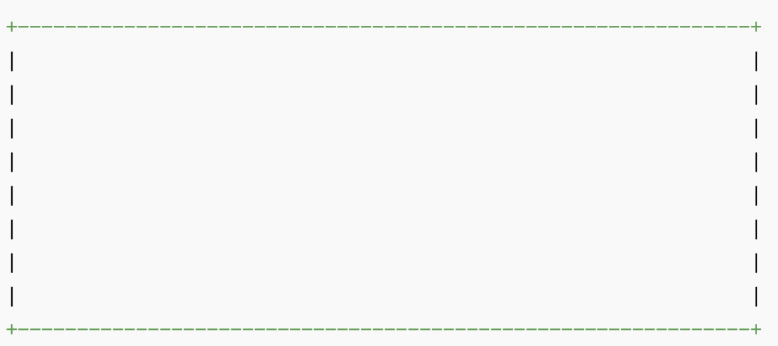

**Step 4: Test & Improve**

* Does everything turn on at the right time?
* Can you combine switches (like a pressure plate + button)?
* Is the system clear and safe?

**Draw Your Jungle Rescue Base System Below:**

* Label where energy moves (example: “Battery → Wire → LED = Light!”)

____________________________________________________________________________________________________________________________________________________________

**Answer These Reflection Prompts:**

* How does your system help keep people or animals safe?

______________________________________________________________________________________________________________________________________________________________

* What did you learn about energy and circuits today?

______________________________________________________________________________________________________________________________________________________________

* If you could add one more feature to your jungle system, what would it be?

______________________________________________________________________________________________________________________________________________________________

Standards Alignment

NGSS: 4-PS3-2, 4-PS3-4 STEL: STEL 1A, STEL 2A, STEL 3A, STEL 4A, STEL 5A, STEL 6A, STEL 7A, STEL 8A CCSS: CCSS.MATH.CONTENT.3.MD.D.8, CCSS.MATH.CONTENT.4.G.A.1, CCSS.MATH.CONTENT.4.MD.A.3, CCSS.MATH.PRACTICE.MP1, CCSS.MATH.PRACTICE.MP4, CCSS.MATH.PRACTICE.MP5, CCSS.MATH.PRACTICE.MP7