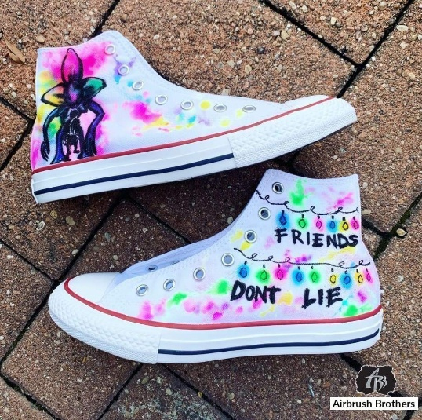

New Shoe Design Market Venture!

UNIT: SHOE DESIGN

You are the owner of a trendy custom shoe company. You are fortunate to work with a variety of brands in creating custom shoes. You have recently been asked to create a one-of-a-kind pair of shoes for a customer.

DIRECTIONS:

1. **SELECT Your Target Market. (Pick one from the 6 options below).**

**Target Market #1:**

1. **WHO**: Your client's name is Anna. She is 16 years old.
2. **WHERE**: She lives in a city and her and her friends use the subway to get to and from school
3. **WHAT**: She loves street culture, graffiti and hip-hop music. You can find her and her friends at local coffee shops hanging out, listening to music and talking about fashion. She is eager to find a pair of shoes that only she has, that shows her love for street fashion/graffiti.

**Target Market #2:**

1. **WHO**: Your client is your best friend the same age as you.
2. **WHERE**: She lives near the mountainside.
3. **WHAT**: Since she loves nature, she always goes on a hike during her free time. She always shares how she loves to see how the trees dance because of the wind.

**Target Market #3:**

1. **WHO**: Your client is your school coach
2. **WHERE**: He loves professional sports. In his free time, he attends games in courts or fields to his favorite teams.
3. **WHAT**:  His love for sports and commitment to the game inspire him to be a better coach every day.

**Target Market #4**

1. **WHO**: Your client is the next up and coming national DJ.
2. **WHERE**: He/She can be found in his/her booth and always loves to take old school music and mix it with the new modern music genres.
3. **WHAT**: He/She is driven by the feeling of how her fans respond to her music. She enjoys the energy and the light shows that comes with it.

**Target Market #5**

1. **WHO**: Your client’s is your best friend’s little brother.
2. **WHERE**: The little brother is fond of watching cartoons and anime at home.
3. **WHAT**: On his free time, he watches his favorite episodes of cartoon characters and anime. His passion is driven behind the stories behind the creativeness of each character super power.

**Target Market #6**

1. **WHO**: Your client’s name is Johnny and is 25 years old. He’s a former college athlete and works in sports marketing.
2. **WHERE**: He lives in an urban city and regularly flies to other cities to cover sports.
3. **WHAT**: He loves all things sports and trendy athleisure styles. You can see him rocking retro Jordan’s and/or other custom shoes like Fruity Pebble Dunks. He relishes on high end suits that match his sneakers. He is looking for flashy new sneakers that he can wear with his new light pink suite.
4. **Create a “mini-Marketing Plan”**

* **Create a slide deck (A student example is located on Projects site)**
* Tell us what Target Market you picked.
* Goal: explain how your Shoe design will meet the needs of your target market?
* **Based on the Target Market, type up the products 4P information.** (P on each slide)

Tips on what your 4 p’s should tell us.

**(Product)**

* Explain ALL the **Feature**s your custom shoes. What will it look like, where on the shoe will your designs be? Be VERY detailed here. Give us details as though **I was** in charge of making it, you are instructing ME. NOTE: It must **relate** to your target market and the theme you are going with. …This is important for BRAND identity

**(Price)**

* How much will you charge for these shoes? **THEN**, list out FACTS that guided you to the price you picked. Is it other custom products or products that are under the umbrella of custom shoes? Then tell me WHY this customer would pay this price for these shoes.

**(Place)**

* I want you to explain WHERE you will sell your shoes AND HOW customers would FIND YOU to buy these shoes? Please realize these are “custom” ordered shoes, so a place like Kohls or Walmart will **not** work, you need to give people the option/ability to customize what they want.

**(Promotion)**

* Create an Instagram Social Media post for your new shoes. Include a picture, content under picture, hashtag and where to get more info on your custom shoes. Use the slide template.

1. **Create your design on the included templates.**

* Get checked off before moving on to step 4.

1. **Create Prototype of Shoes**

* **MAKE a prototype** with the shoes you have been given. Requirements for prototype. There must be design elements on the ENTIRE shoe. This means there should be very little “white” or the original shoe color itself showing. There should be color, shapes and/or images. If you do the outlines in pencil, you MUST go over it with color. The design Must relate to your market for full points.

**New Design Custom Shoes**

**Rubric and Prototype Evaluation**

**Marketing Expert Team: _______________________________________________________________________**

**SLIDES:**

**Product Description** _______/5

* Explained ALL the **Features of your** custom shoes. What will it look like, where on the shoe will your designs be? Be VERY detailed here. Give us details as though we are in charge of making it, you are instructing us. NOTE: It must **relate** to your target market and the theme you are going with. …This is important for BRAND identity

**Price Explanation**  _______/5

* Listed how much will you charge for these shoes? **Then**, list out FACTS that guided you to the price you picked. Is it other custom products or products that are under the umbrella of custom shoes? Then tell me WHY this customer would pay this price for these shoes.

**Place** _______/5

* Communicated, WHERE you will sell your shoes AND HOW customers would FIND YOU to buy these shoes? Please realize these are “custom” ordered shoes, so a place like Kohls or Walmart will not work, you need to give people the option/ability to customize what they want.

**Promotion** _______/5

* Created an Instagram Social Media post for your new shoes. Include a picture, content under picture, hashtag and where to get more info on your custom shoes. Use the slide template.

**PROTOTYPE** _______/30

* Design elements on the **ENTIRE** shoe. Not just on top or in one spot.
* Shoe had shapes and/or images on it.
* The original color/canvas is **covered** appropriately.
* All outlines in pencil have been covered with **color**.
* The design Must relate to your market for full points.

**TOTAL** _______/50