UNIT: UkUlelE

ACT-Based English: Comparing Instrument Design Articles
OBJECTIVE:
Analyze and compare different ukulele designs and their impact on sound quality.

ACT Score Target: 29-33

MATERIALS NEEDED
- Printed or digital copies of the two articles
- Highlighter or pen
- Comparison chart or graphic organizer
- ACT-style question sheet or digital quiz
STUDENT DIRECTIONS:

Goal:

You will read and analyze two informational articles about different ukulele materials—traditional wood and modern carbon fiber. Then, you'll compare their designs and how each one affects sound quality, durability, and overall performance. This activity strengthens your reading comprehension and comparison skills, especially those needed for ACT Reading questions in the 29–33 score range.
Step 1: Read Both Articles Carefully
You will be given two short, non-fiction texts:
- Article 1: Describes traditional wooden ukuleles, including how different types of wood (like koa or mahogany) affect tone, resonance, and visual appeal.
- Article 2: Explains the design and benefits of carbon fiber ukuleles, such as durability and stability in various climates.
As you read, highlight or underline key details that relate to:
- Sound quality
- Material durability
- Weight or feel of the instrument
- Environmental factors (e.g., humidity, temperature)
- Musicians’ preferences
Tip: Look for direct comparisons between the two materials and the author’s tone or perspective on each.

Step 2: Compare the Two Ukulele Types
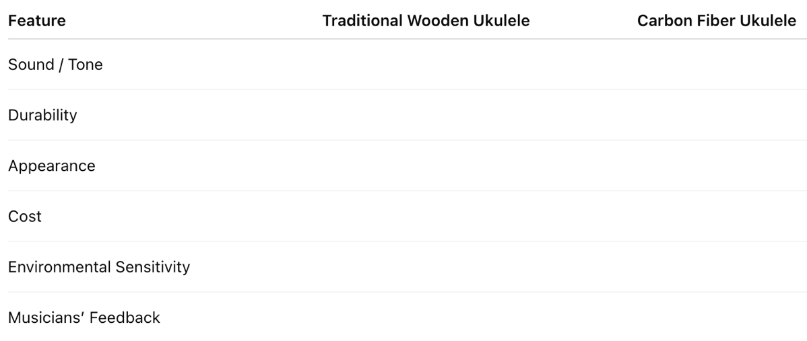
After reading, complete a comparison chart or Venn diagram to organize the following:

In your own words, summarize the strengths and weaknesses of each type of ukulele. Ask yourself:
- Which one is more suitable for traveling musicians?
- Which offers a richer or warmer tone?
- What do professionals prefer, and why?
Step 3: Answer Comprehension Questions
Now, answer ACT-style multiple-choice questions about the articles. These will test your ability to:
- Identify main ideas and supporting details
- Make comparisons and draw conclusions
- Interpret vocabulary in context
- Understand author purpose or tone

ACT-Style Question:
- According to the articles, why do some musicians prefer carbon fiber ukuleles over wooden ones?
- Carbon fiber ukuleles are heavier, making them more stable.
- They are less affected by humidity and temperature changes.
- Carbon fiber produces a softer, less resonant tone.
- Wooden ukuleles have better durability than carbon fiber ones.

