UNIT: UkUlelE

ACT-Based Math: Calculating Ukulele String Frequency

Objective:

Use the wave equation to determine the frequency of ukulele strings.
ACT Score Target: 28-32

Formula: f = v/λ, where
- f = frequency (Hz)
- v = wave speed (m/s)
- λ = wavelength (m)

MATERIALS NEEDED
- Ukulele (or stringed instrument for measurement)
- Ruler or measuring tape
- Calculator
- Reference chart or app with standard ukulele tuning
- Student worksheet or notebook

STUDENT DIRECTIONS:
Goal:
You will apply the wave equation to calculate the frequency of sound produced by a ukulele string and compare your results to real-world musical tuning. This activity builds skills in applying formulas, unit conversions, and interpreting wave behavior—all aligned with the ACT Math section for scores in the 28–32 range.
Step 1: Measure the String
- Use a ruler or measuring tape to find the length of an open ukulele string (from nut to saddle).
Example: A string might measure 0.33 meters (33 cm).
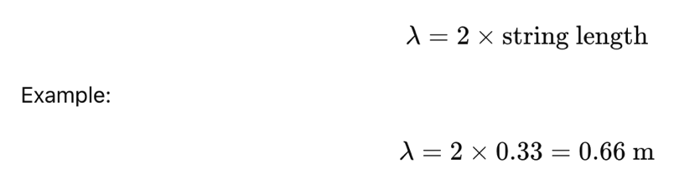
- Remember, for the fundamental frequency, the wavelength is twice the length of the string:

Step 2: Use the Wave Equation
- Use the speed of sound in air if the question doesn’t specify another medium:
  - 
  - Or use the provided wave speed in string material if given (e.g., 400 m/s in the ACT-style question).
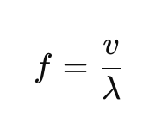
- Plug your values into the formula:

Step 3: Compare with Real Ukulele Frequencies
- Use a tuning chart or app to find the standard tuning frequencies for ukulele strings (like G4 = 392 Hz, C4 = 261.6 Hz, E4 = 329.6 Hz, A4 = 440 Hz).
- Compare your calculated frequency to the closest standard note.
✅ Is your result close to a real tuning value? What factors might cause small differences (e.g., string tension, temperature)?

ACT-Style Question:
- A ukulele string is 0.65 m long, and the speed of sound in the string is 400 m/s. What is the frequency of the fundamental harmonic?
- 307.7 Hz
- 615.4 Hz
- 1230.8 Hz
- 2461.6 Hz

