UNIT: UkUlelE

ACT-Based Math: Scale & Proportion in Ukulele Design

Objective:

Use ratios and proportions to create scale models.
ACT Score Target: 20-23

STUDENT DIRECTIONS:
Goal:
You will use ratios and proportions to measure, compare, and create scale models of a real ukulele. This activity helps you understand how changes in size affect physical properties like length, volume, and potentially sound—skills aligned with ACT Math standards in the 20–23 score range.

Step 1: Measure the Real Ukulele
- Use a ruler or measuring tape to measure the full length of a real ukulele from top to bottom.
Example: Your ukulele is 60 cm long.
- Also record measurements of other parts:
  - Body width (widest part)
  - Neck length
  - Sound hole diameter (optional)

Step 2: Choose a Scale for Your Model
- Decide on a scale to reduce the size of your model.
For example:
  - A 1:2 scale means your model will be half the size of the real ukulele.
  - A 1:3 scale means your model will be one-third the size.
- Use your chosen scale ratio to calculate the new dimensions.
Example: If the real ukulele is 60 cm long and you’re using a 1:3 scale:

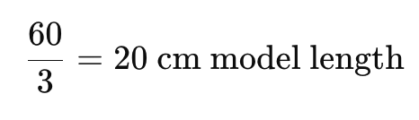

Step 3: Apply Proportions to Other Dimensions
- Use the same scale ratio to reduce all other measured parts (body width, neck, etc.).
- Optional Challenge: Use the cube of the scale factor to estimate changes in volume:
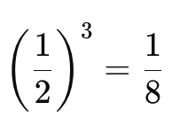
  - If your scale is 1:2, the volume of the model would be:

  - So, the model is 1/8 the volume of the original.
- Reflect: How might changing the size of the ukulele affect the sound it produces?

Step 4: Build or Sketch Your Scale Model
- Use paper, cardboard, or software to sketch or construct your scaled ukulele.
- Label all scaled dimensions.
- Submit your model, sketch, or diagram along with your calculations.

ACT-Style Question:
- If a ukulele is 60 cm long, what would its length be at a 1:3 scale?
- 10 cm
- 20 cm
- 30 cm
- 40 cm

