UNIT: UkUlelE

ACT-Based Math: String Tension & Algebraic Relationships

Objective:

Solve algebraic equations related to string tension.
ACT Score Target: 33-36
Equation: T = (4 × L² × f² × m), where
- T = tension (N)
- L = string length (m)
- f = frequency (Hz)
- m = mass per unit length (kg/m)
STUDENT DIRECTIONS:
Goal:
Use an advanced algebraic formula to calculate the tension in a ukulele string based on its length, frequency, and mass per unit length. This will help you connect math to physics and real-world music applications—targeted for students aiming for an ACT Math score of 33–36.
📏 Step 2: Plug in the Values
You’ll be given different values for L, f, and m, like:
- L = 0.6 m
- f = 440 Hz
- m = 0.0002 kg/m
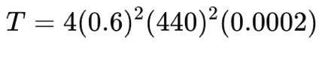
Insert those into the formula:

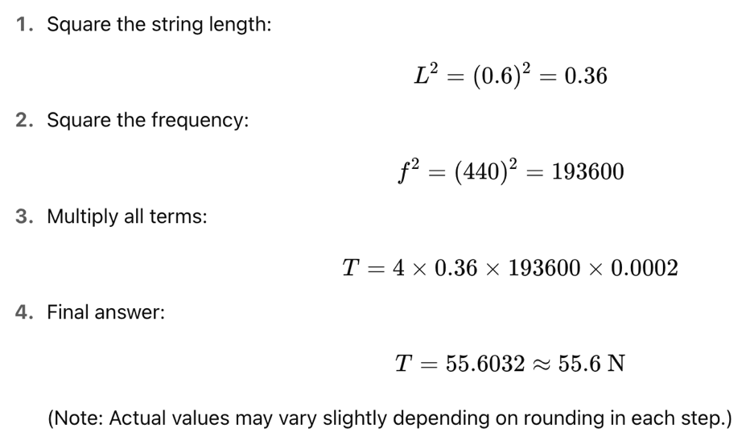
Step 3: Solve Step by Step

✏️ Step 4: Apply It
Use this formula to:
- Calculate tension for different string types and sizes.
- Compare the effect of changing frequency or length.
- Analyze how musicians tune strings by changing tension.
ACT-Style Question:
- If a ukulele string is 0.6 m long, with a frequency of 440 Hz and a mass of 0.0002 kg/m, what is its tension?
- 15.4 N
- 30.8 N
- 61.6 N
- 123.2 N

